# IPSTCoder Information: True

Test Result: Success

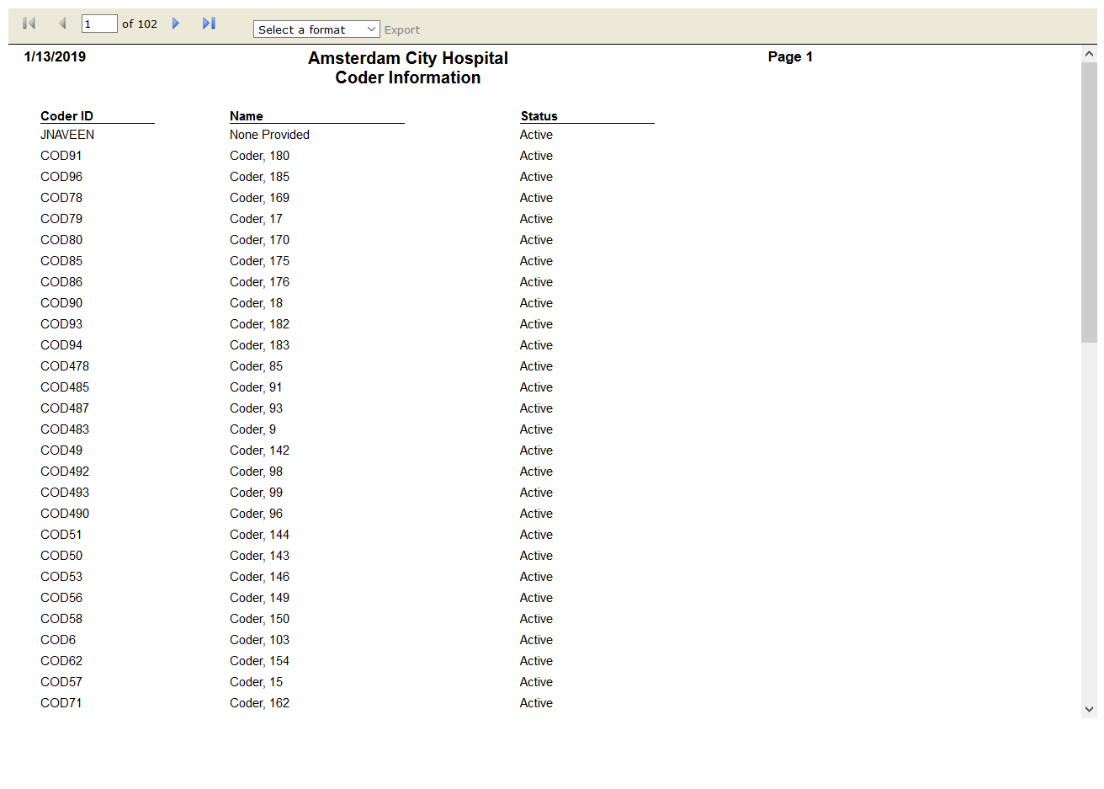

# OPSTFrequency Summary: True

Test Result: Success

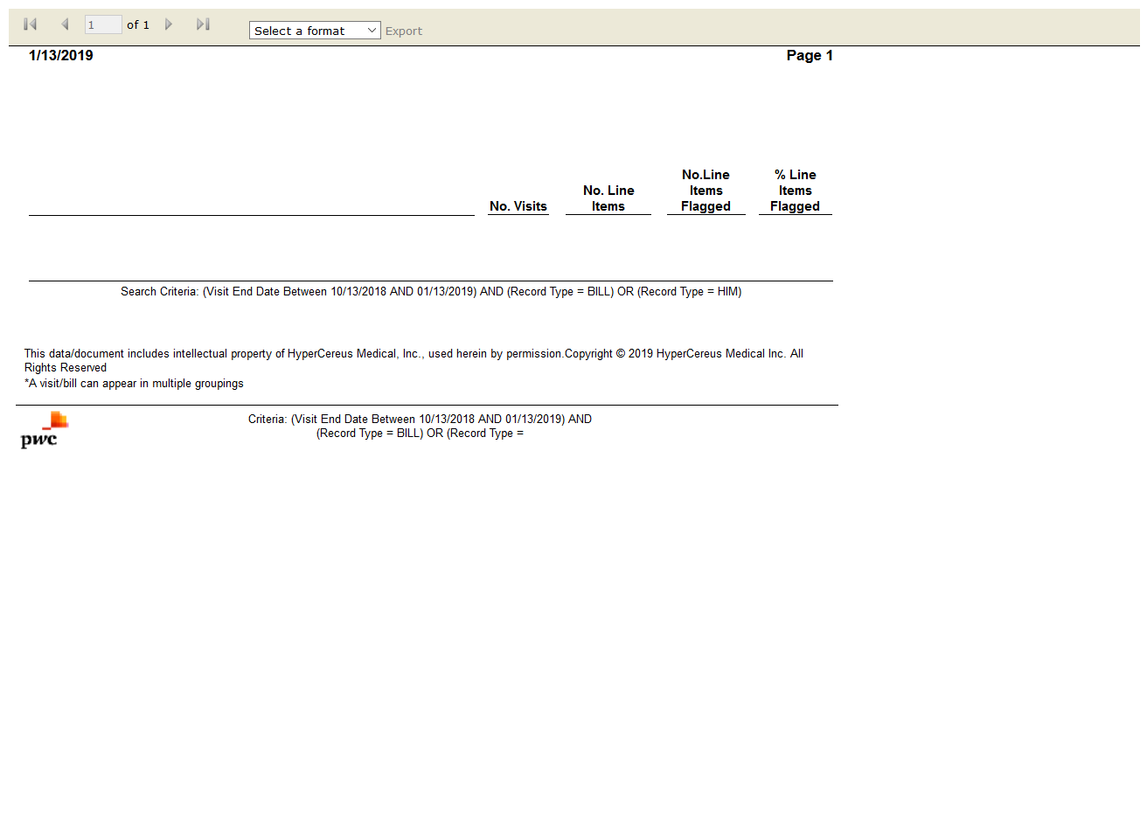

# OPSTReview Worksheet: True

Test Result: Success

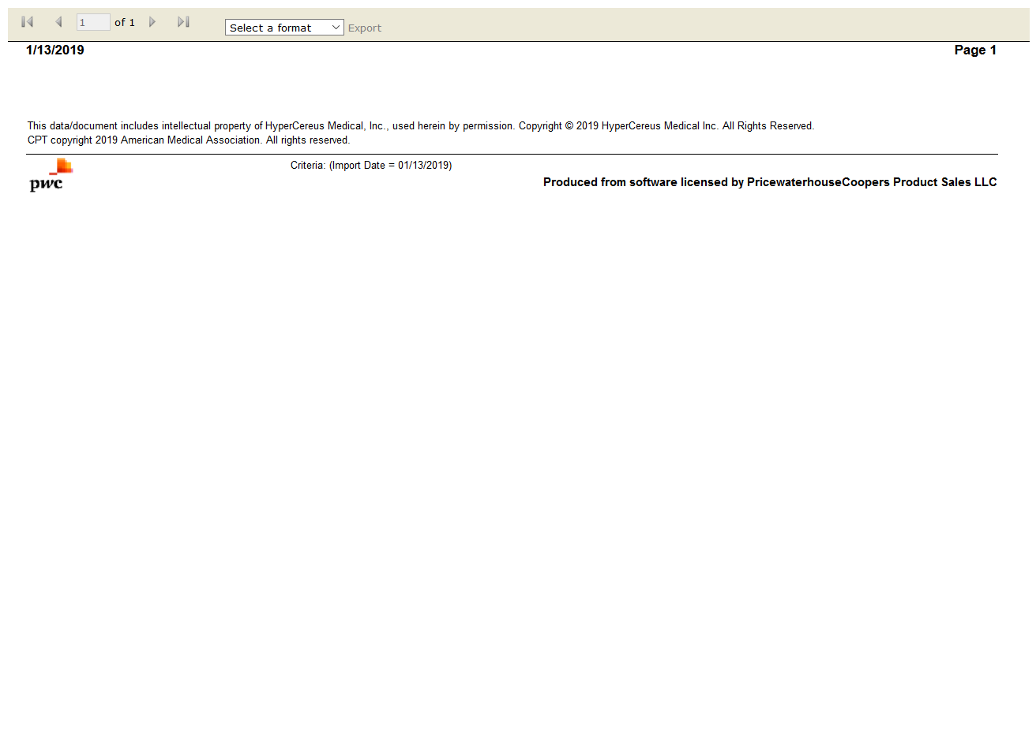

# OPSTVisits Processed on Import: True

Test Result: Success

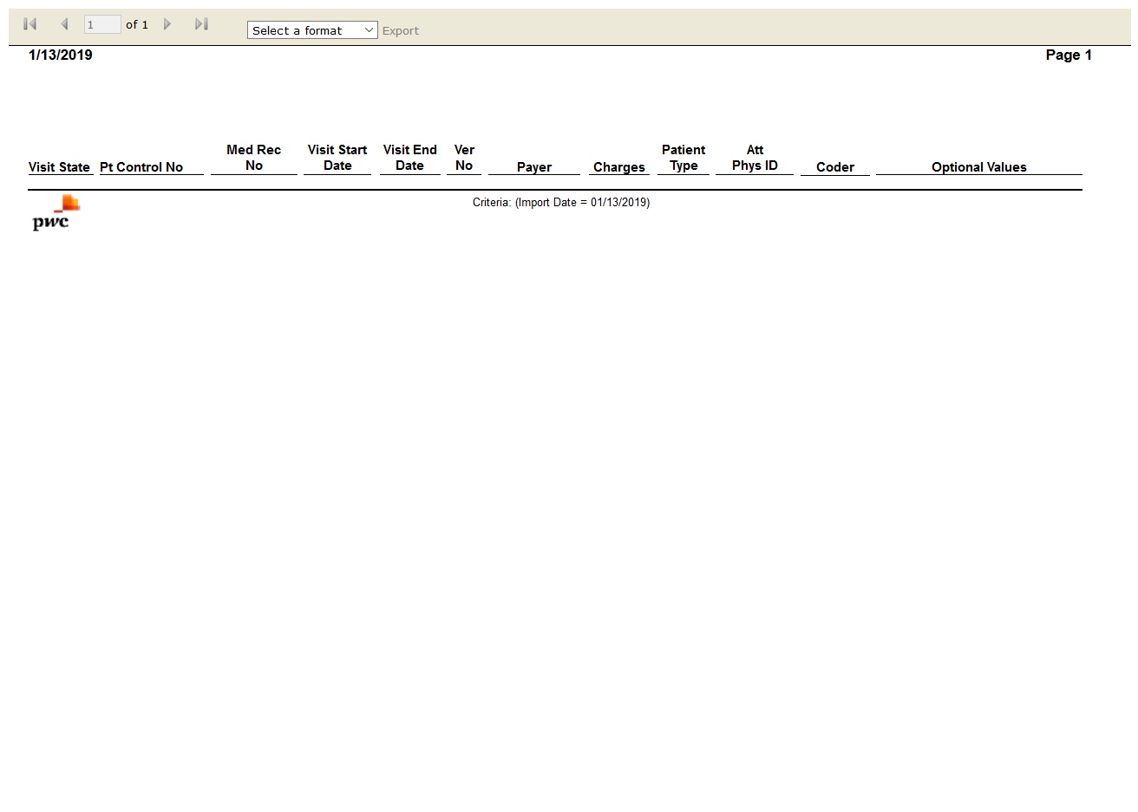

# OPSTCoder Profile: True

Test Result: Success



# OPSTEvaluation & Management Clinical Profile: False

Test Result: Message: Unable to locate element: //span[contains(text(),"Standard Reports")]



# OPSTSMART Results Summary: True

Test Result: Success

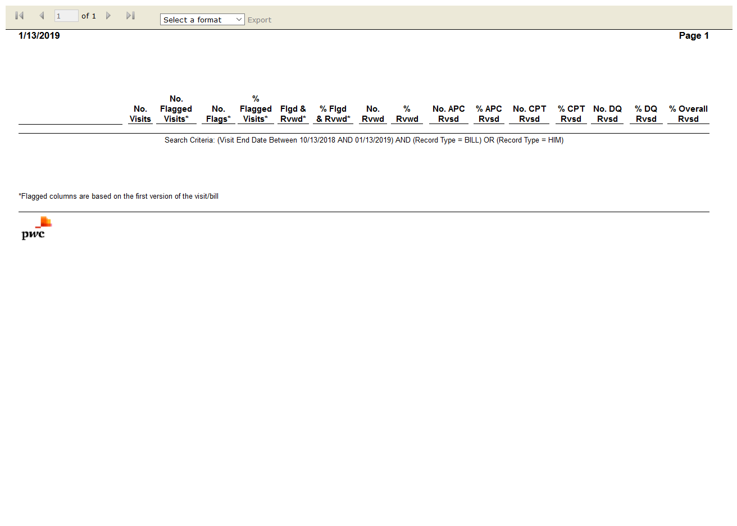

# OPSTVisit Change Results: False

Test Result: Message: Unable to locate element: Visit Change Results

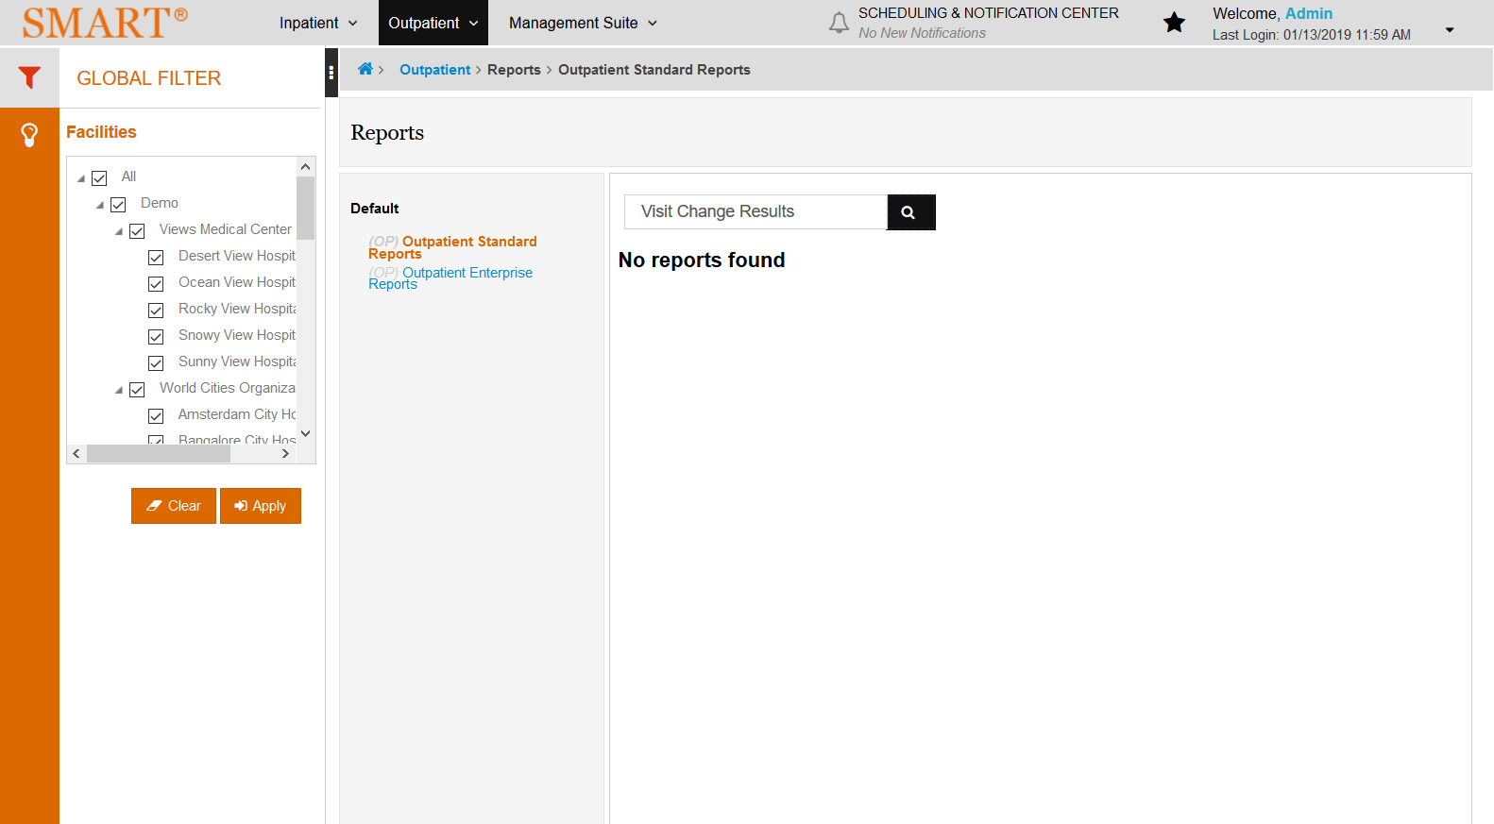

# OPSTVisit Selection Summary: False

Test Result: Message: Unable to locate element: Visit Selection Summary

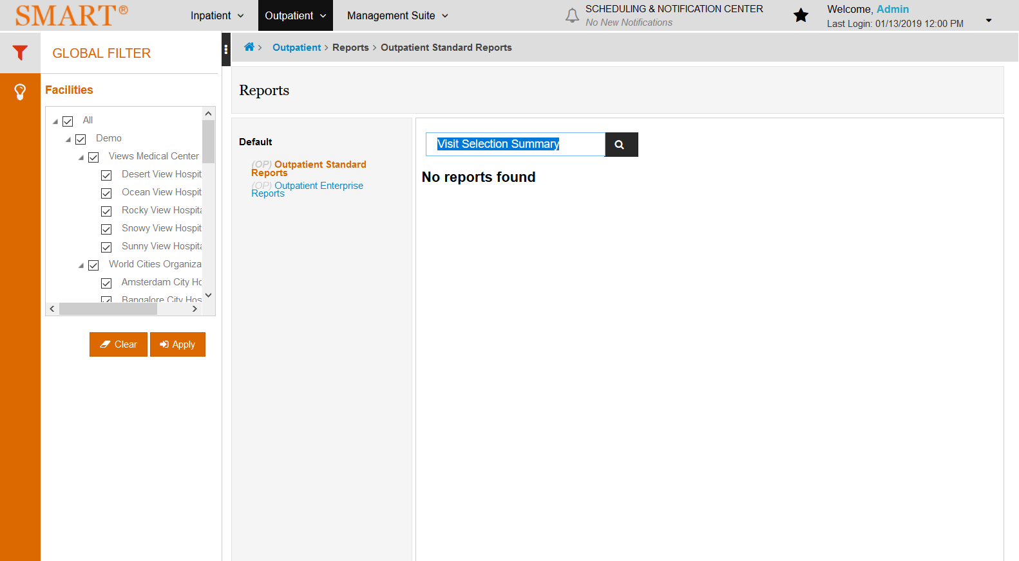

# OPSTVisit Summary: True

Test Result: Success

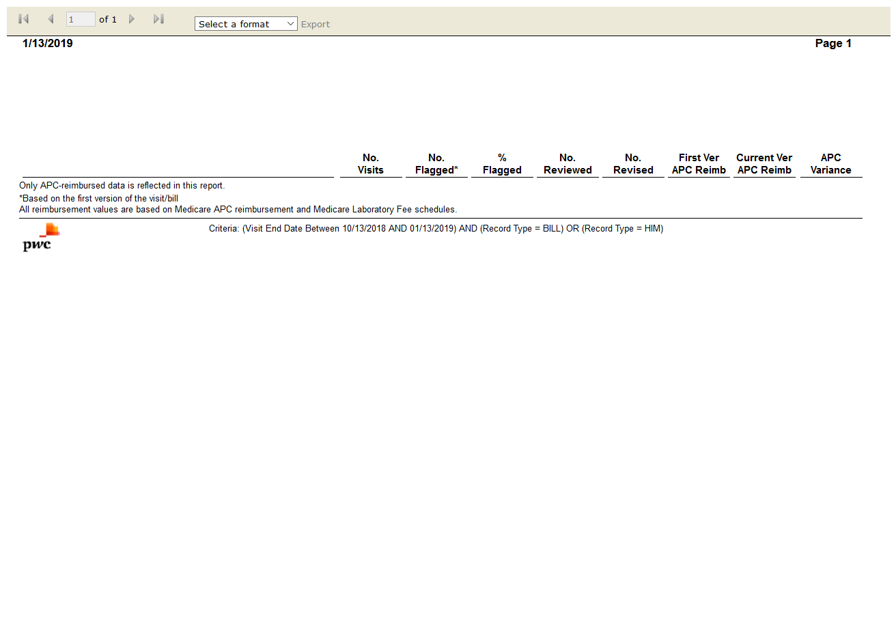

# OPSTAPC Reimbursement Visit Summary: True

Test Result: Success



# IPSTCase Listing: True

Test Result: Success

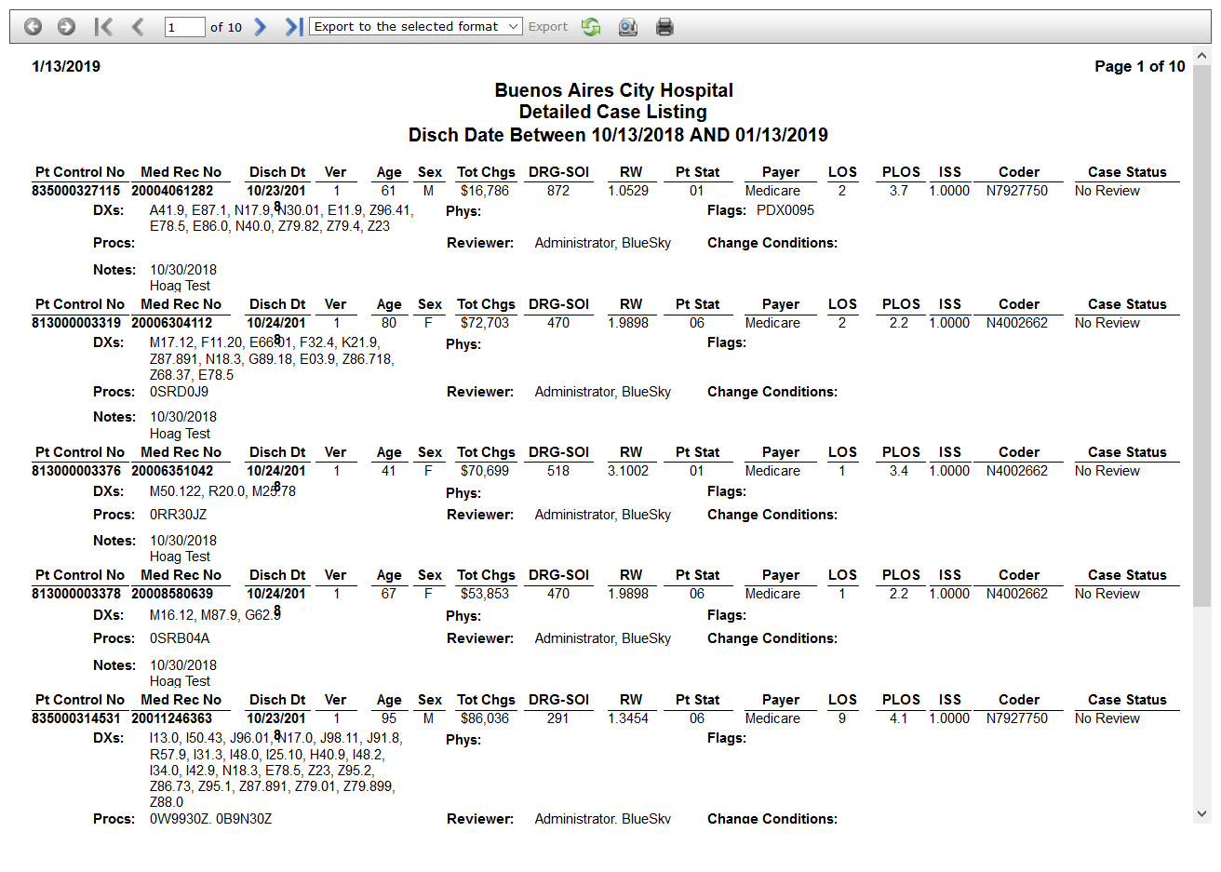

# OPSTDiscrepancy Analysis: True

Test Result: Success

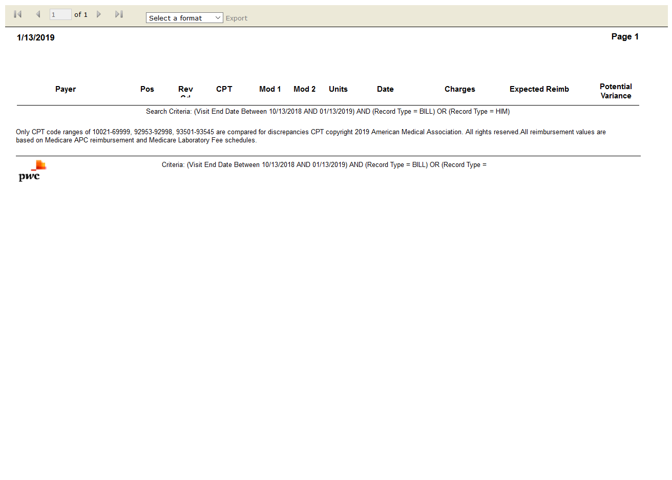

# OPSTEstimated Line Item Reimbursement Impact Summary by Body System: False

Test Result: Message: Unable to locate element: Estimated Line Item Reimbursement Impact Summary by Body System

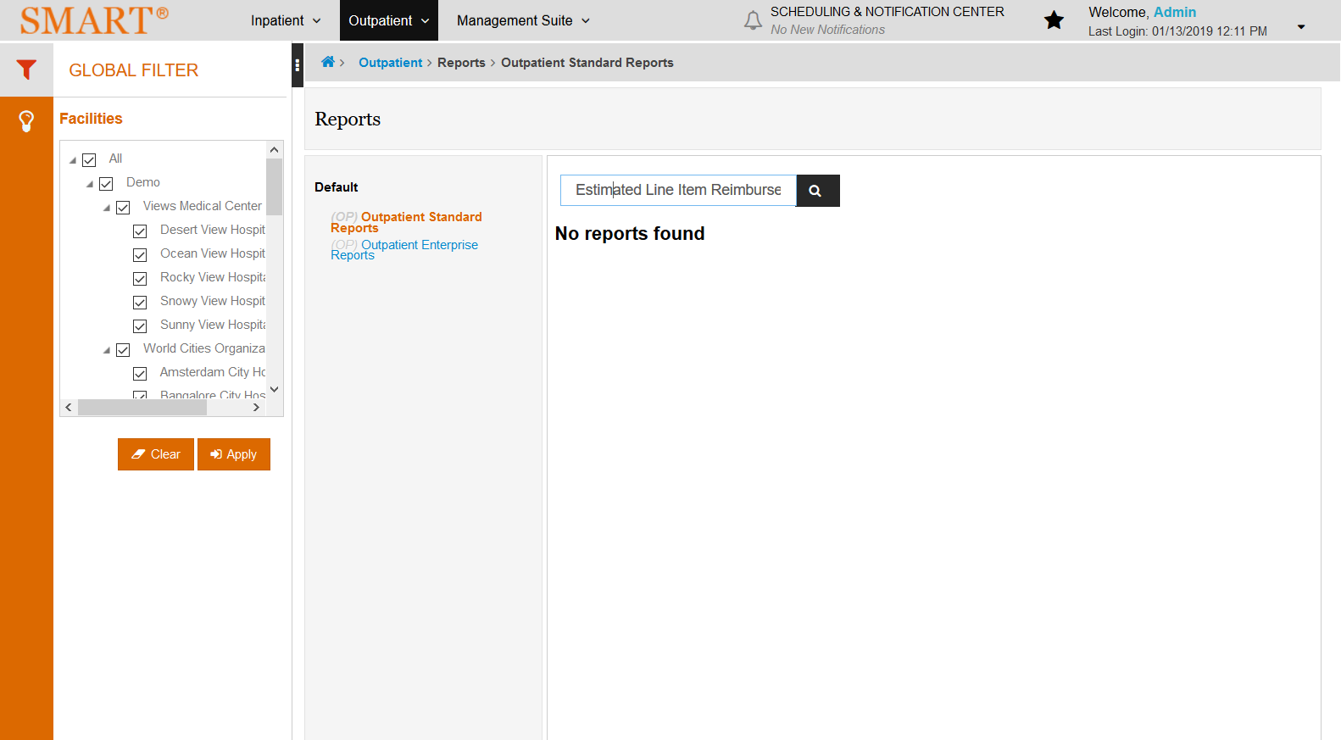

# OPSTEstimated Reimbursement Impact Summary: False

Test Result: Message: Unable to locate element: Estimated Reimbursement Impact Summary

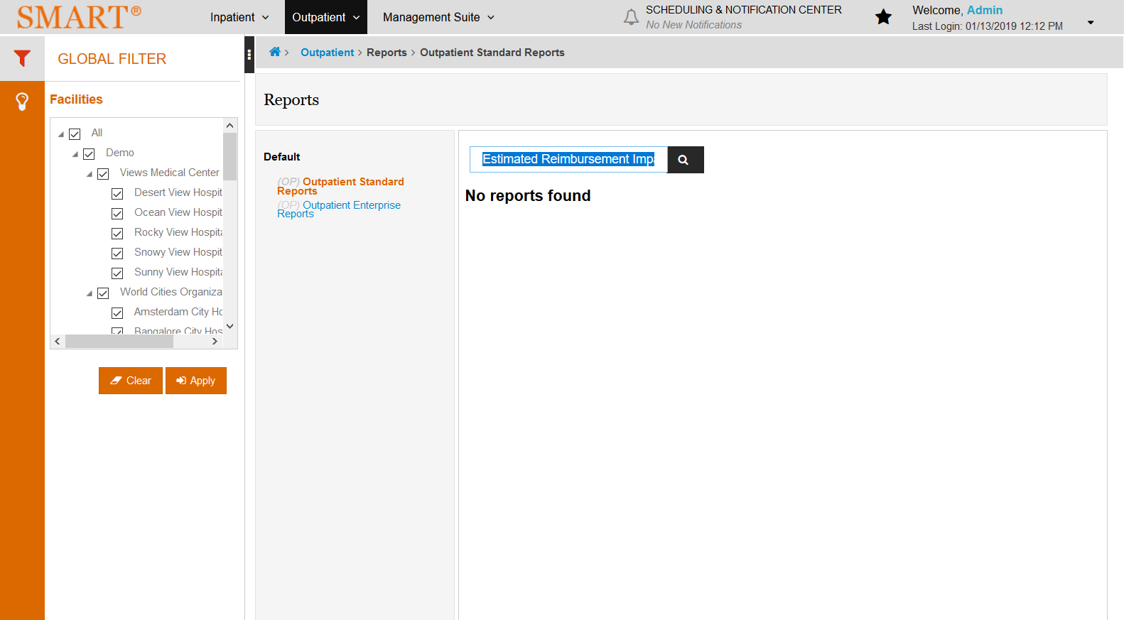

# OPSTReimbursement Change Summary: True

Test Result: Success

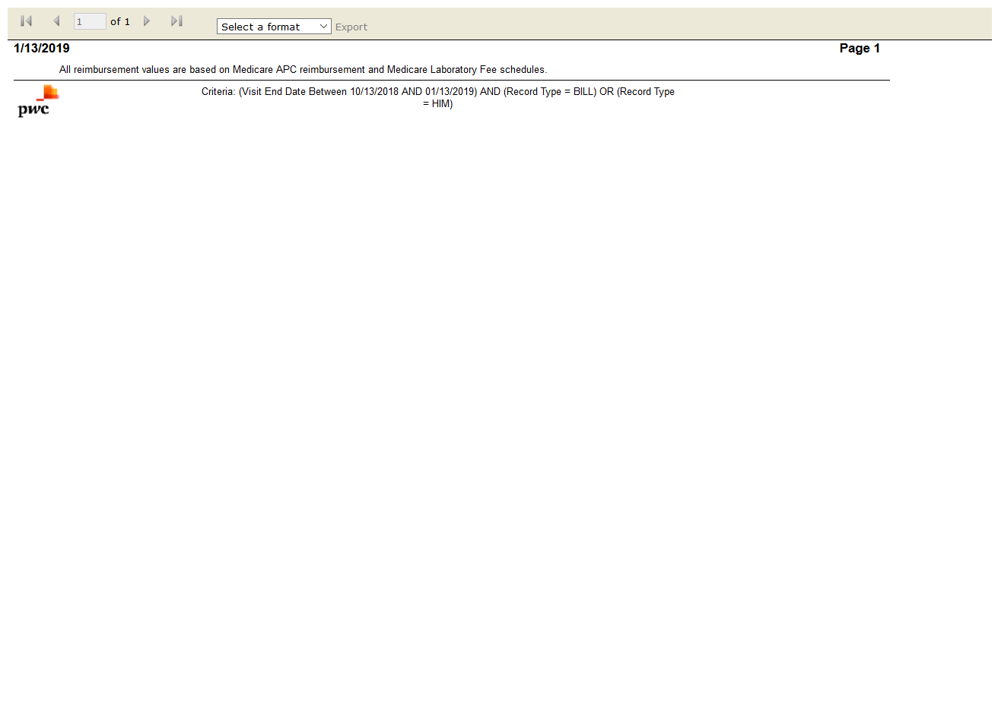

# OPSTReimbursement Version Detail: True

Test Result: Success

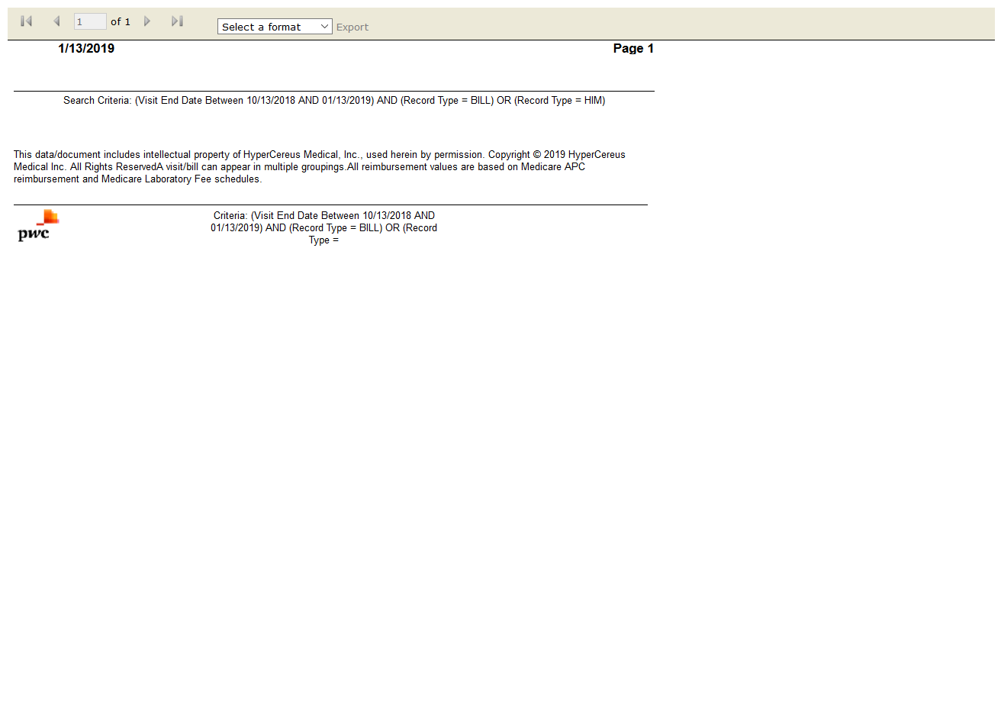

# OPSTSMART Reimbursement Activity by Year: True

Test Result: Success

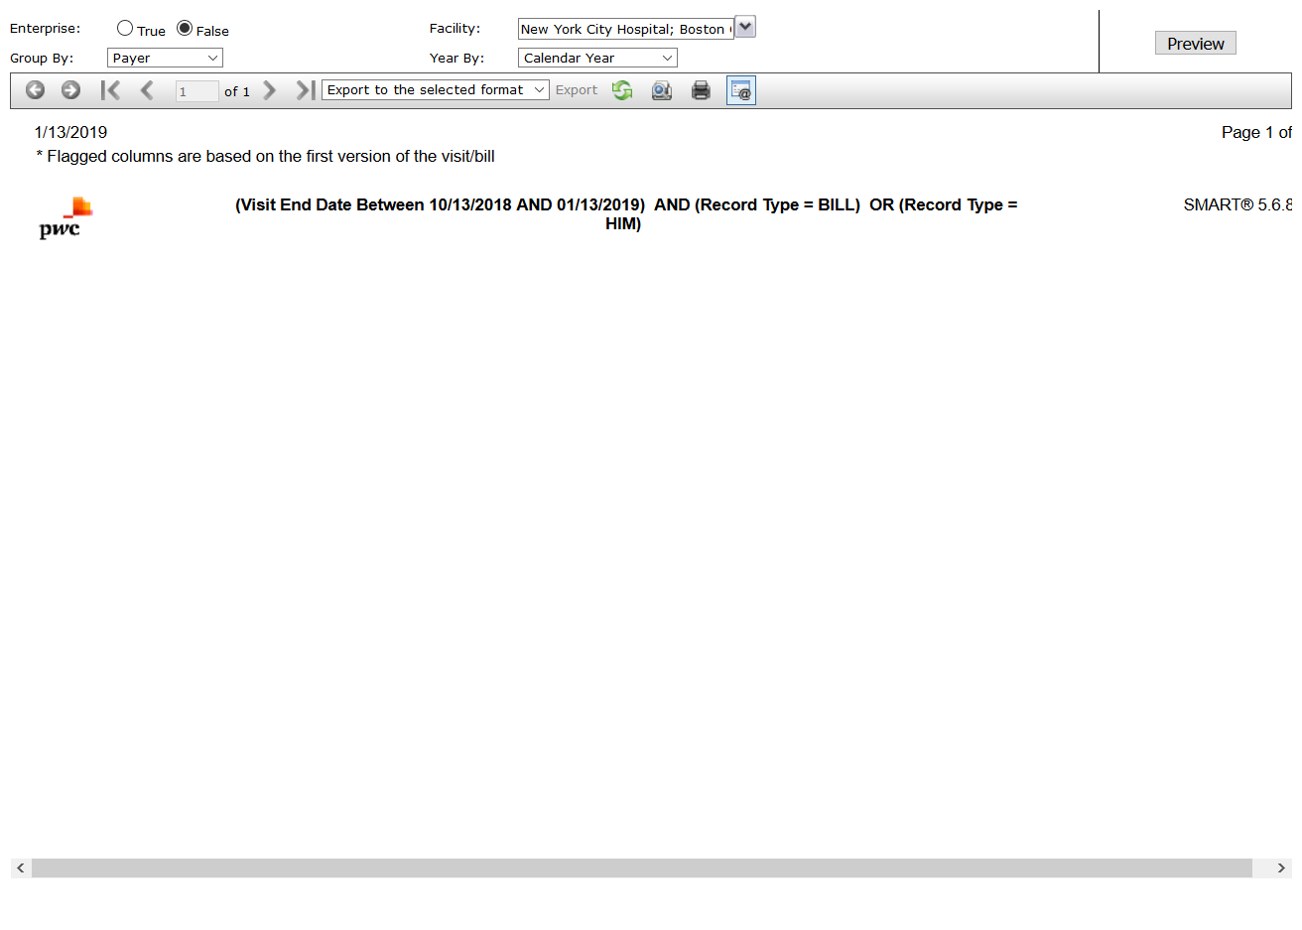

# OPSTVisit Reimbursement Summary: True

Test Result: Success

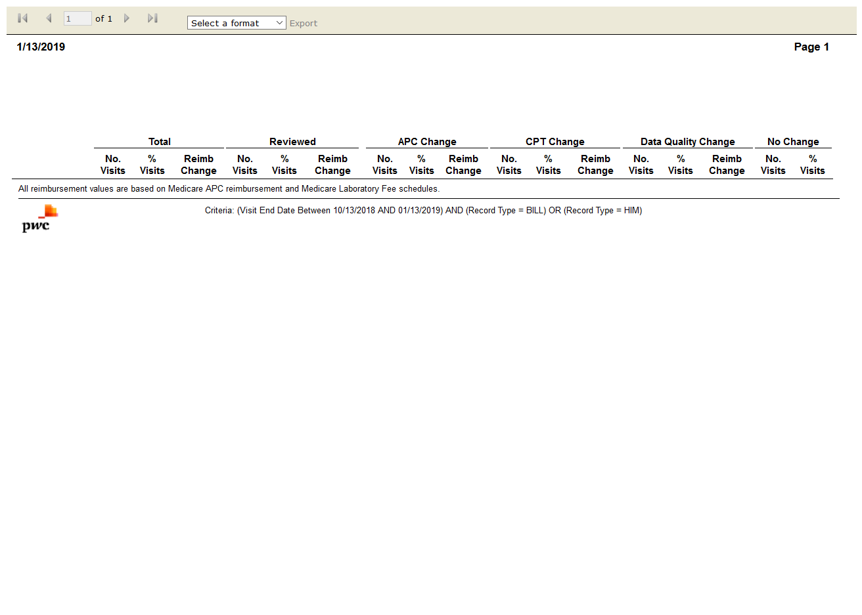

# OPSTBrief Visit Listing: True

Test Result: Success

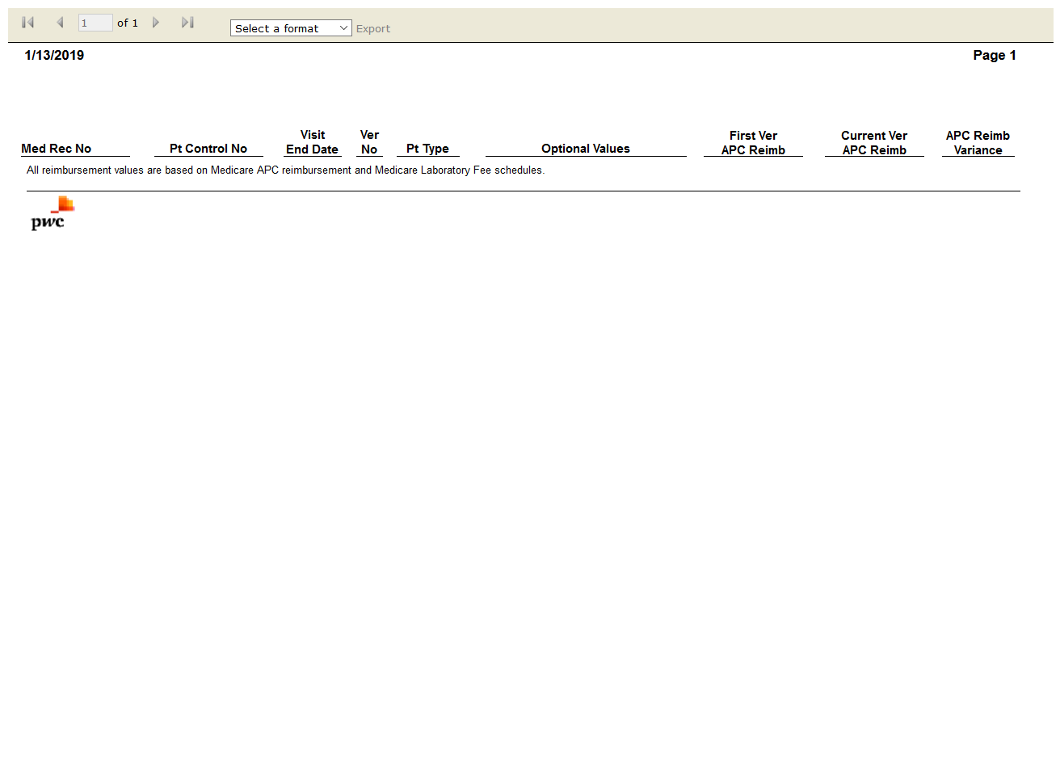

# OPSTDetailed Visit Listing: True

Test Result: Success

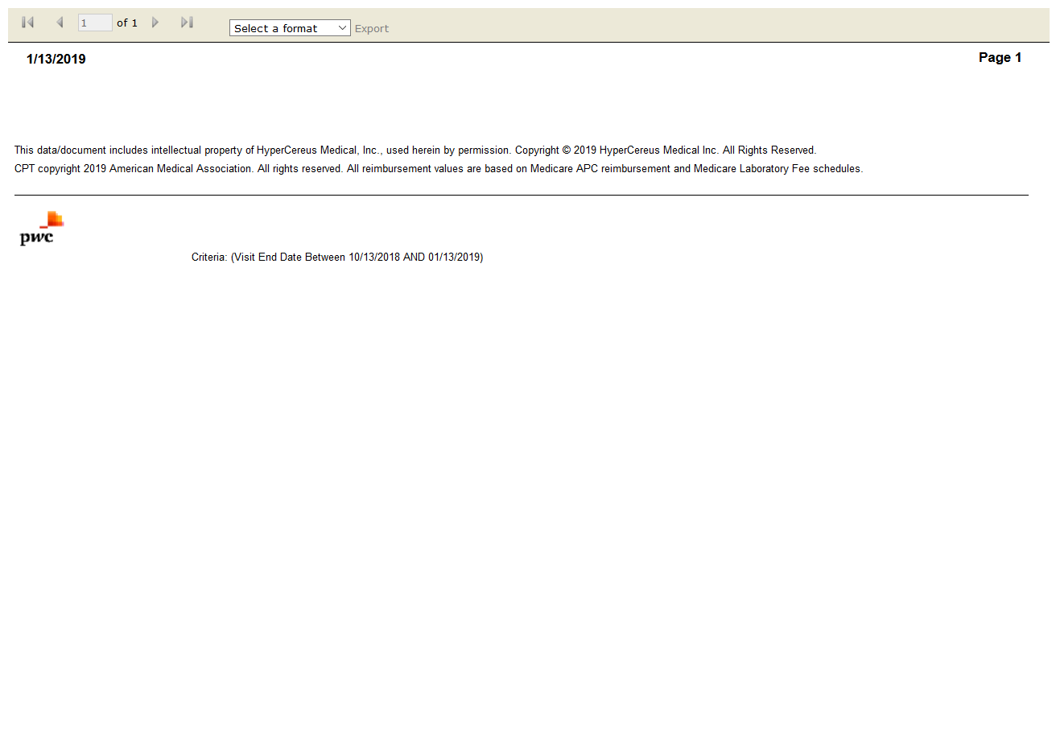

# OPENFlag Comparison: True

Test Result: Success

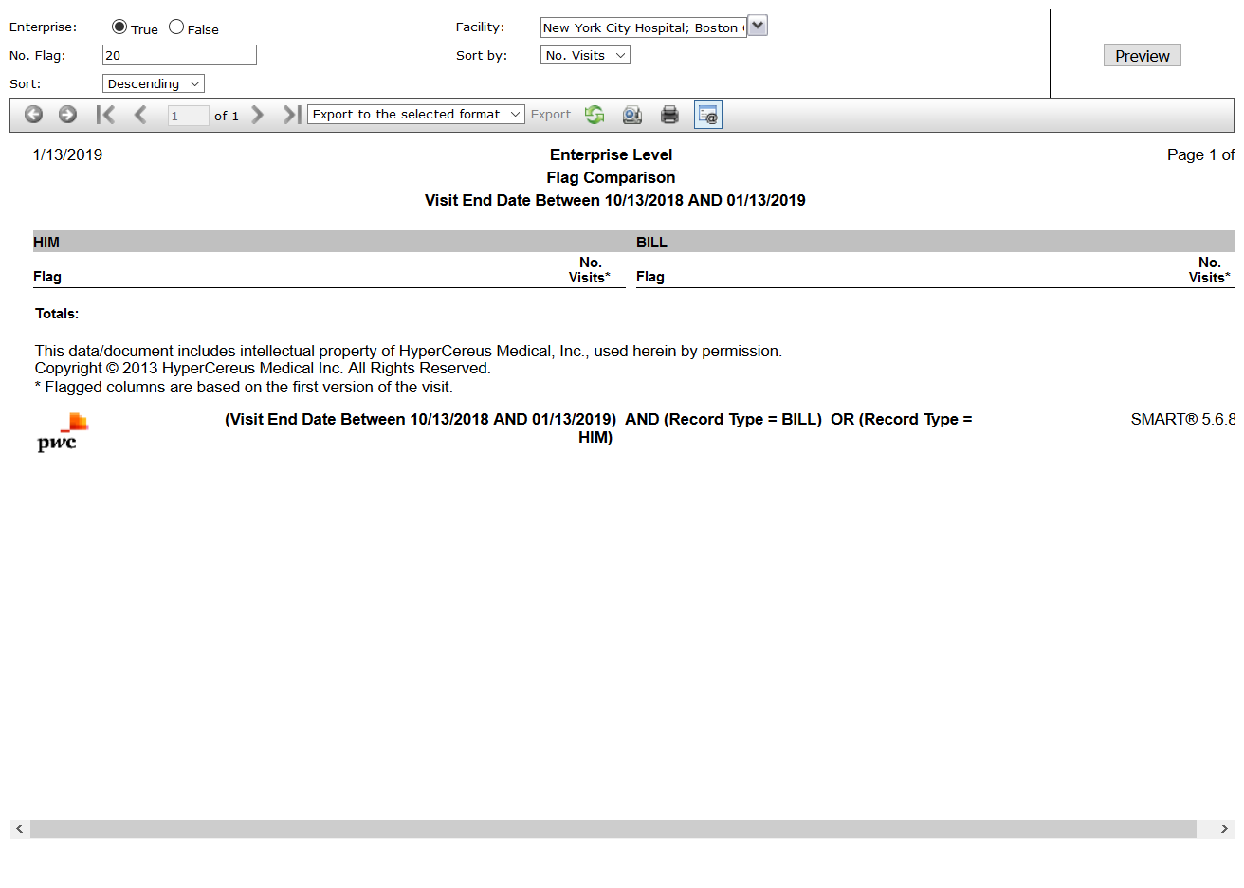

# IPSTCase Version Comparison: True

Test Result: Success

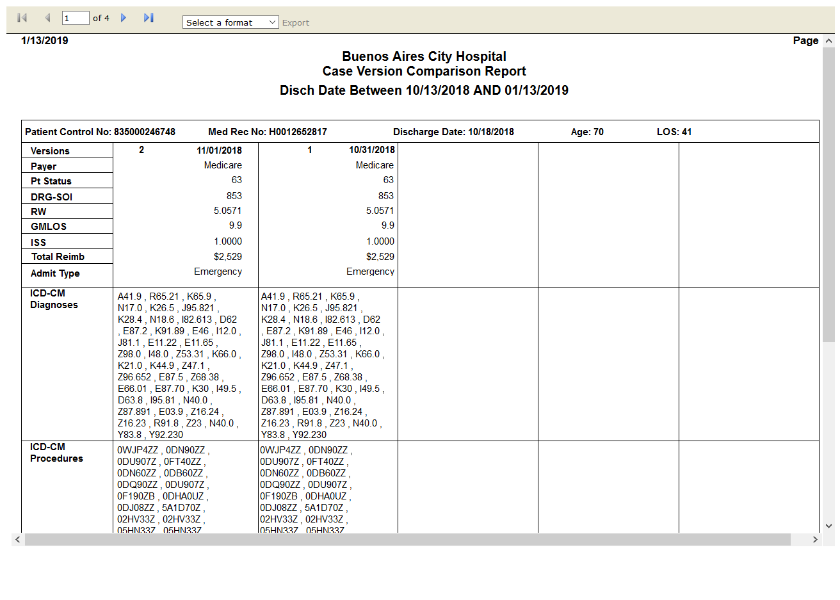

# OPENMedicare Medical Necessity Flags: True

Test Result: Success

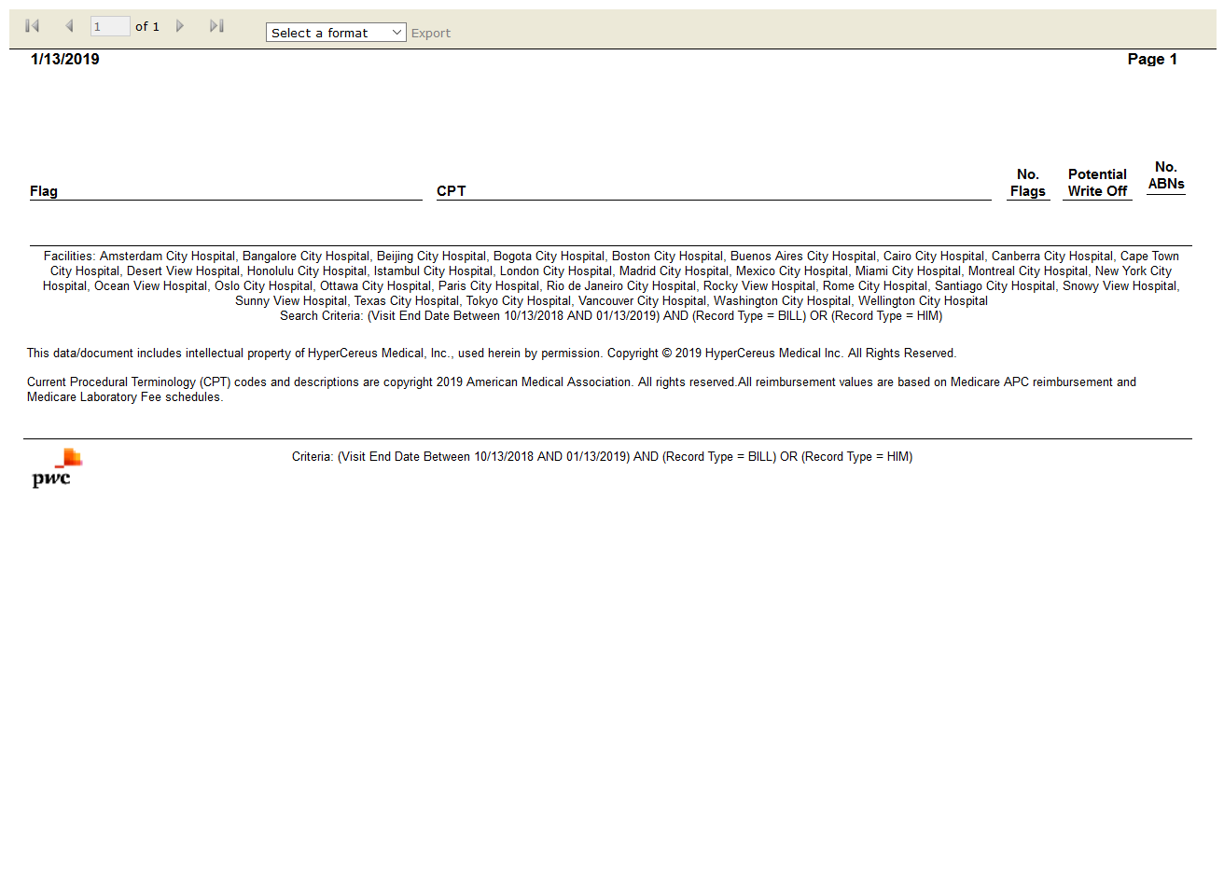

# OPENSMART Results Summary: True

Test Result: Success

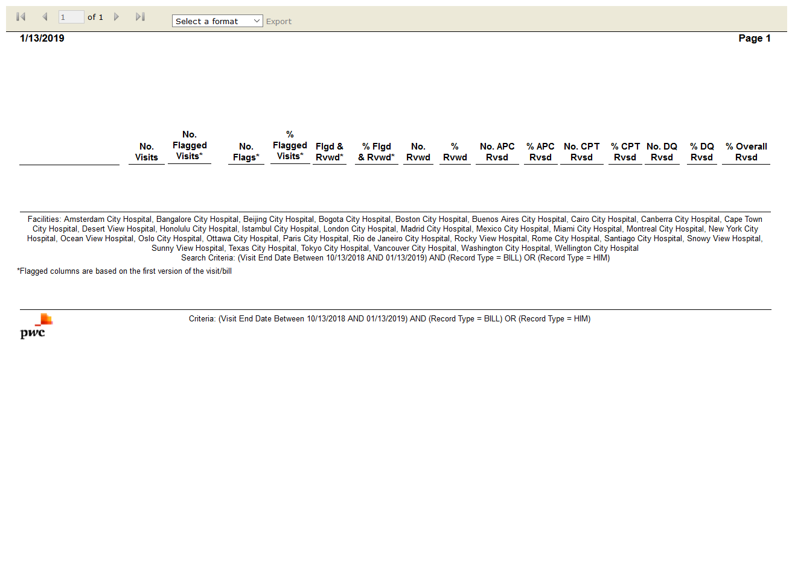

# OPENReimbursement Change Summary: True

Test Result: Success

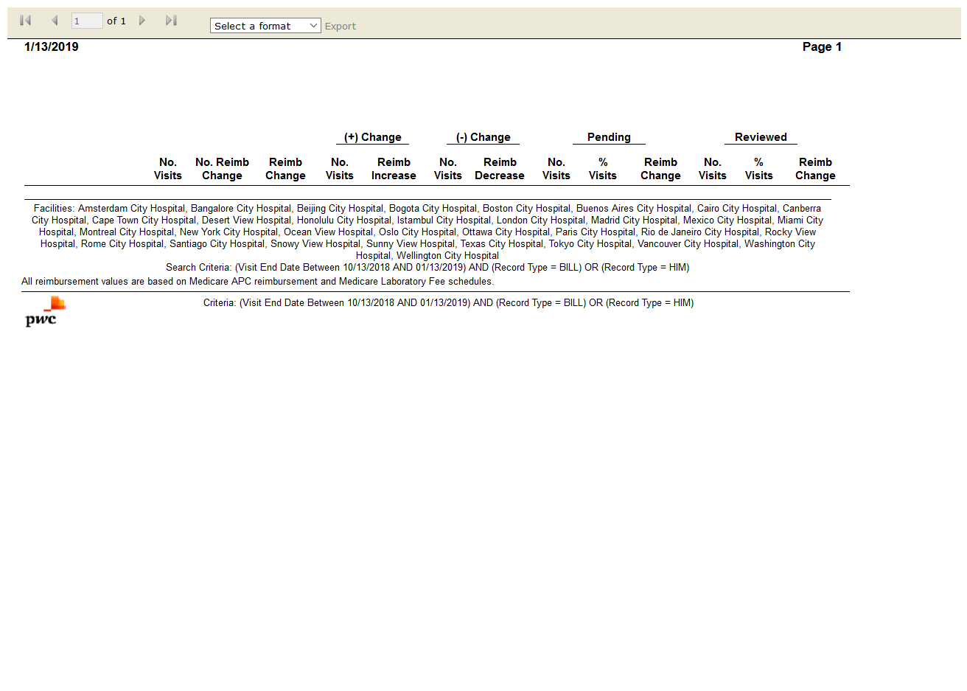

# OPENSMART Reimbursement Activity by Year: True

Test Result: Success

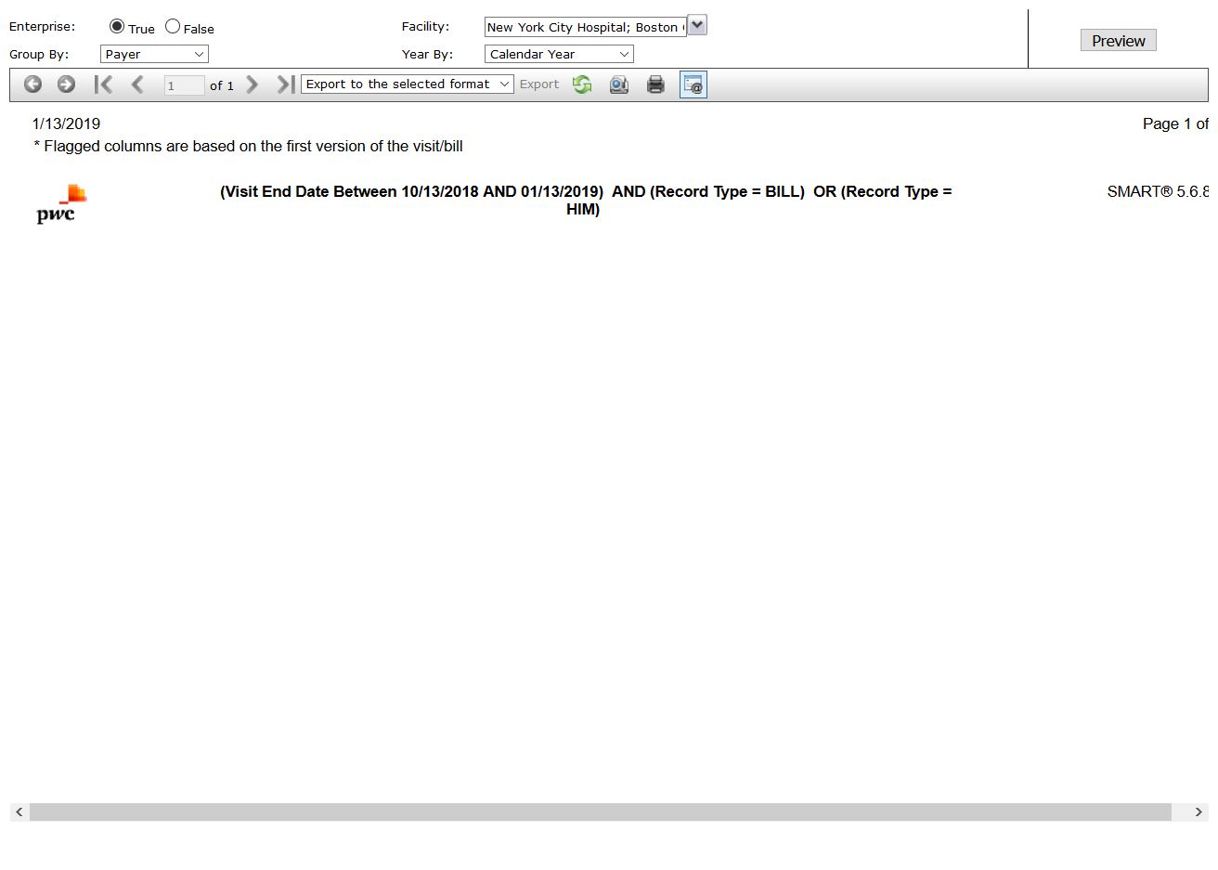

# OPENVisit Reimbursement Summary: True

Test Result: Success

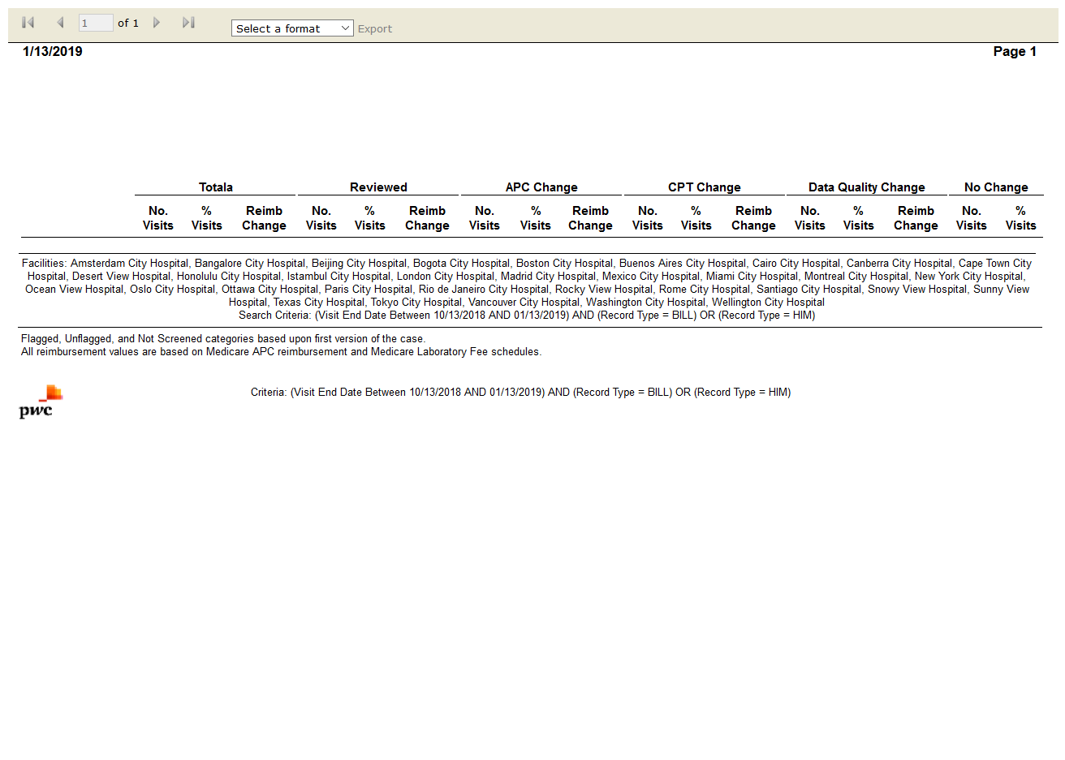

# IPSTDetailed Case Listing: True

Test Result: Success



# IPSTCase Mix Index (CMI) Analysis: True

Test Result: Success



# IPSTCase Mix Index (CMI) Comparison: True

Test Result: Success

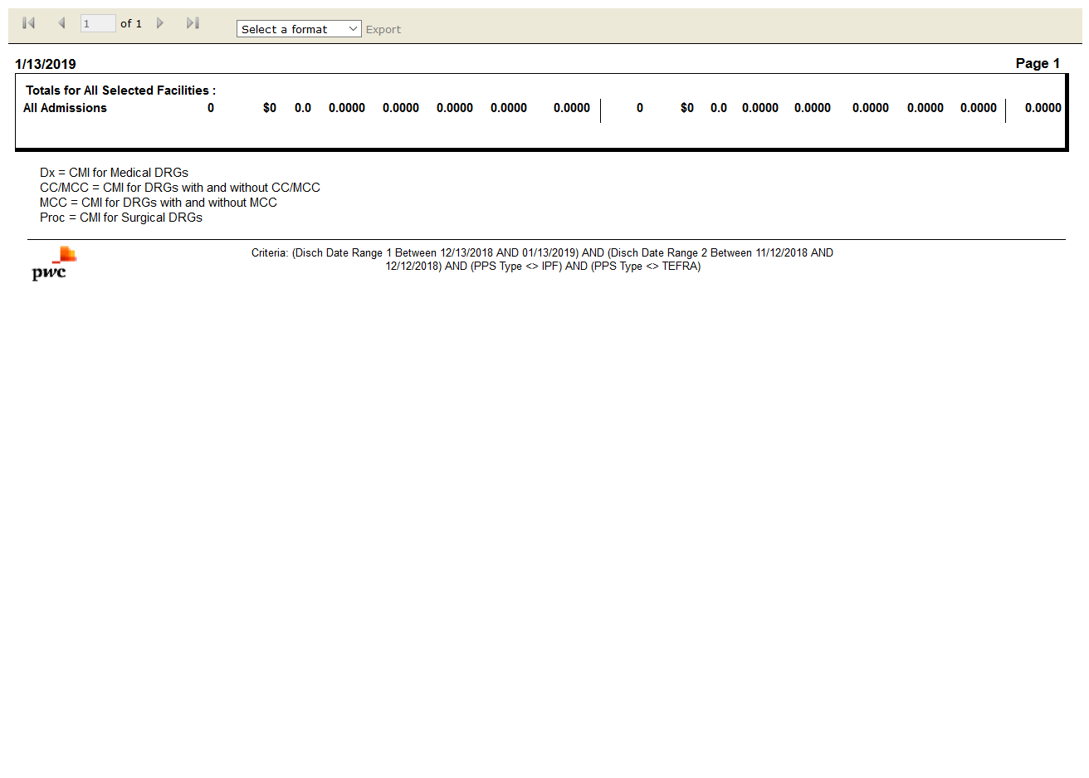

# IPSTCase-Mix by Payer by Month: True

Test Result: Success

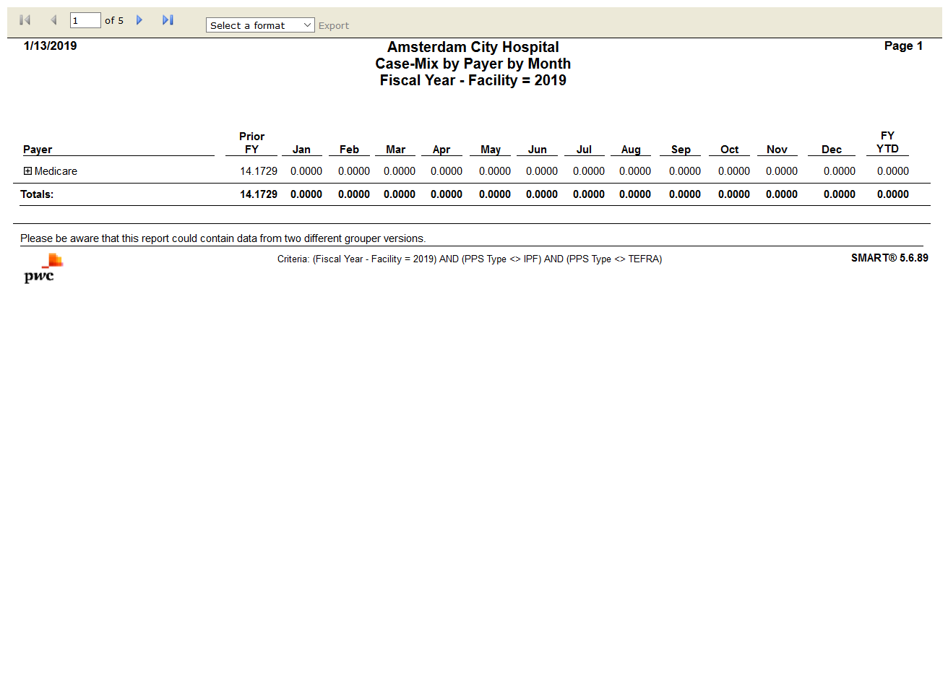

# IPSTMedicare Case-Mix by Month: True

Test Result: Success

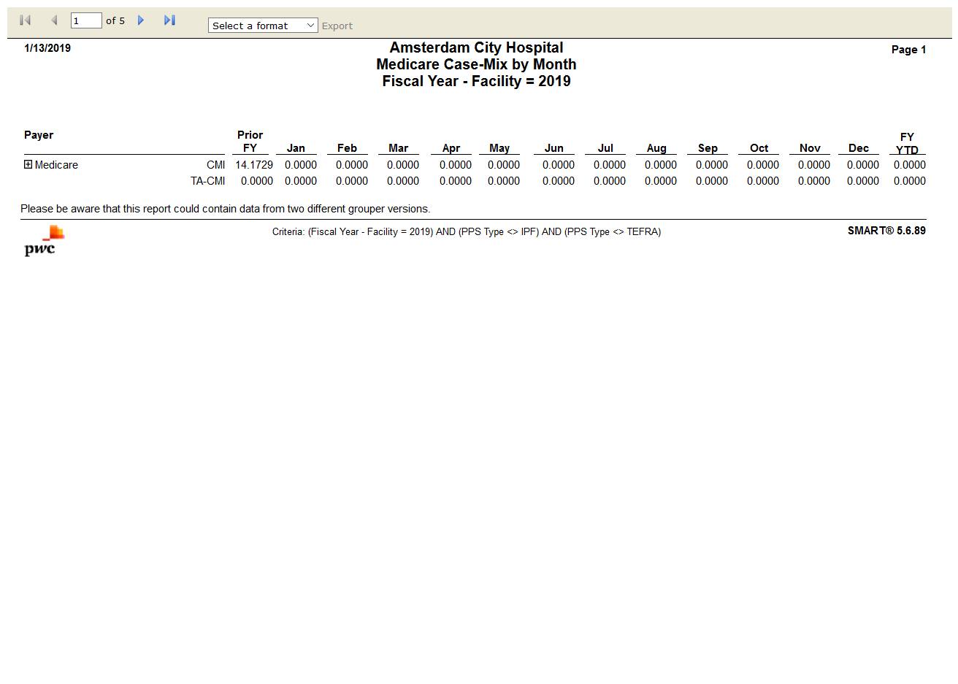

# IPSTAttending Physician Frequency by DRG: True

Test Result: Success

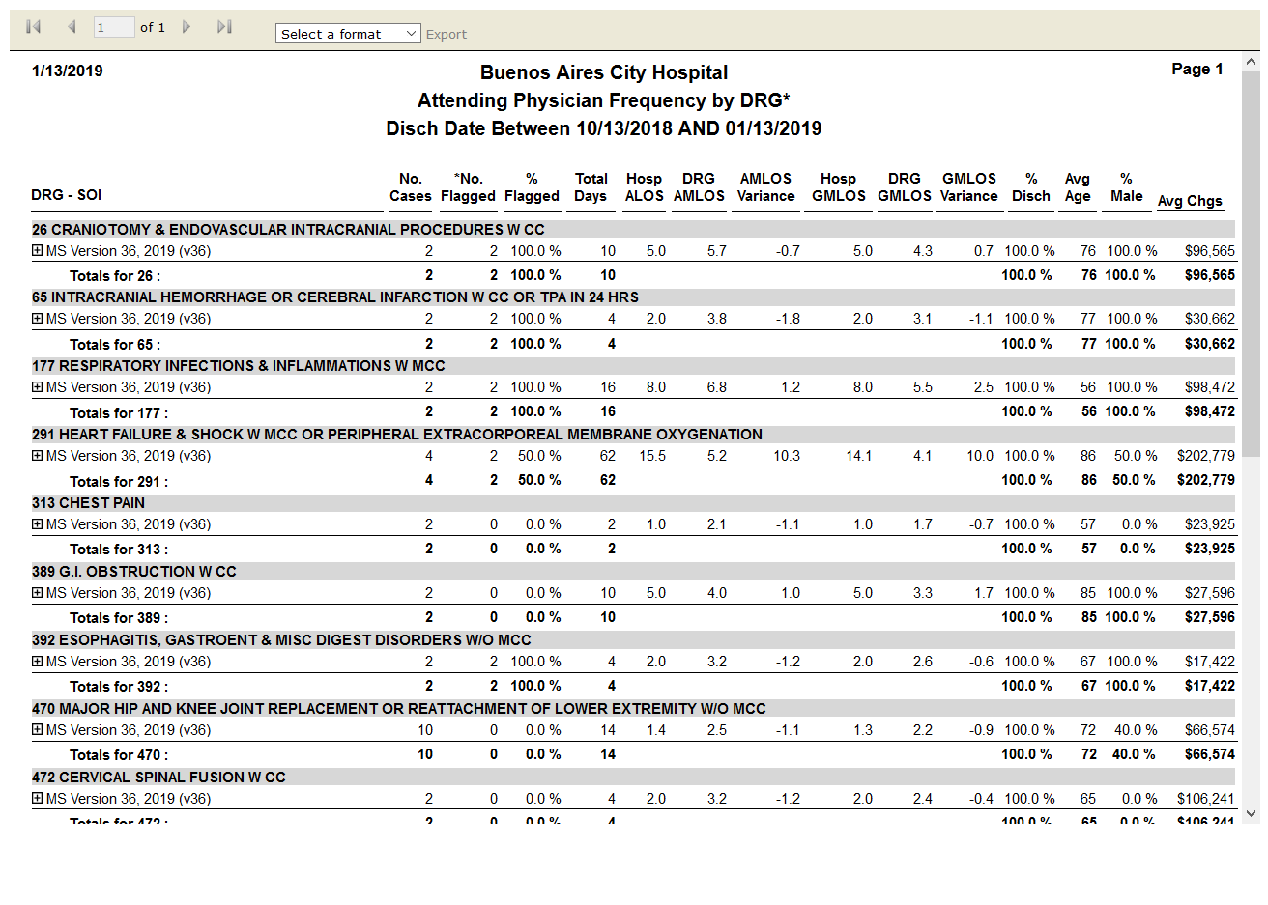

# IPSTDischarges by Grouper Version - DRG: True

Test Result: Success

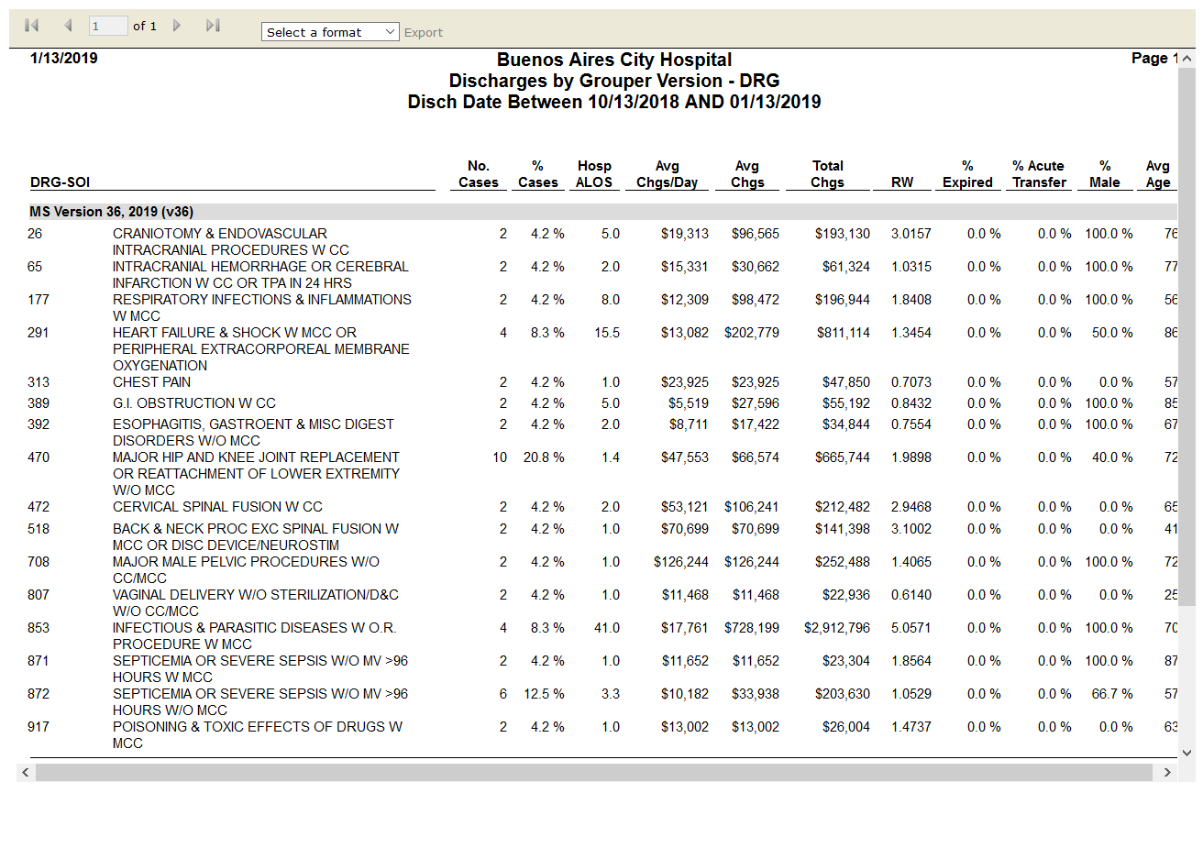

# IPSTDRG Change Condition Detail: False

Test Result: module 'common.settings' has no attribute 'error_report_generate'

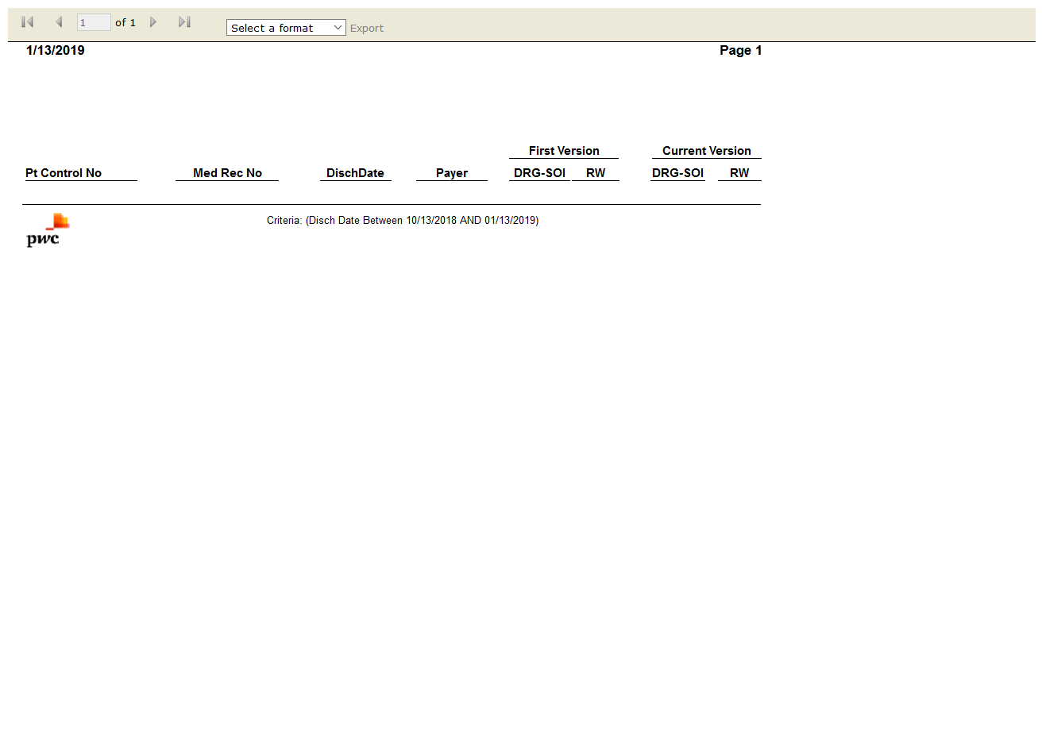

# IPSTFlag Management Setting Audit: False

Test Result: Success



# IPSTDRG Change Impact: True

Test Result: Success

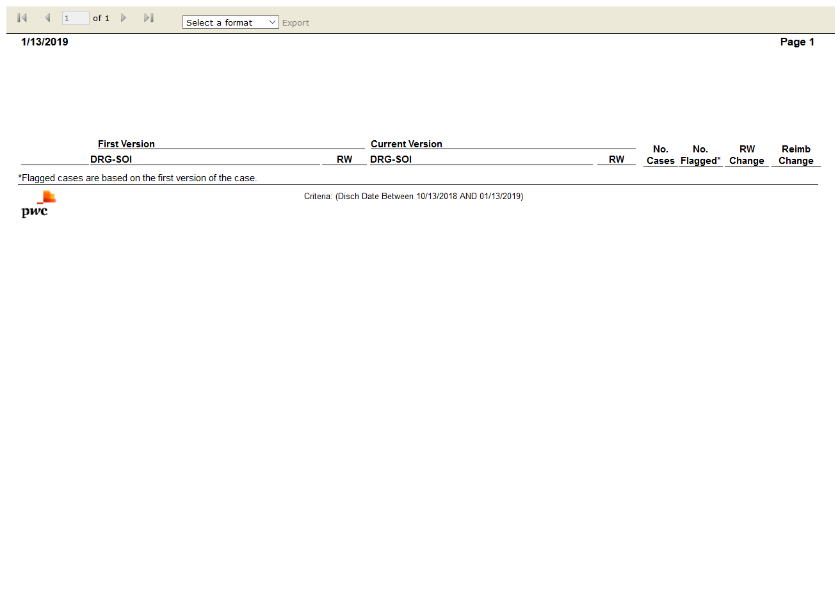

# IPSTDRG Clinical Profile: True

Test Result: Success

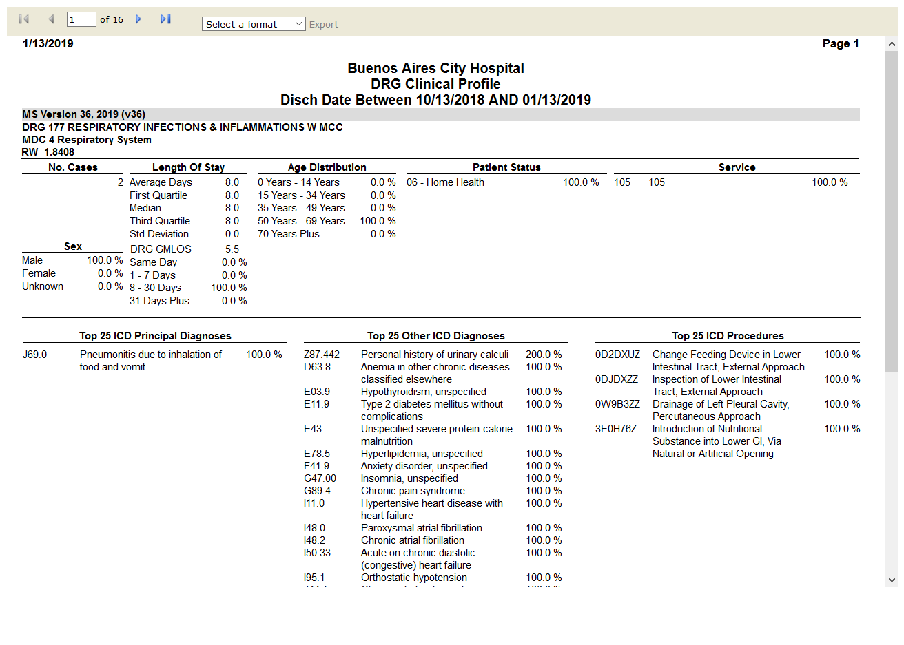

# IPSTDRG Contribution to CMI: True

Test Result: Success

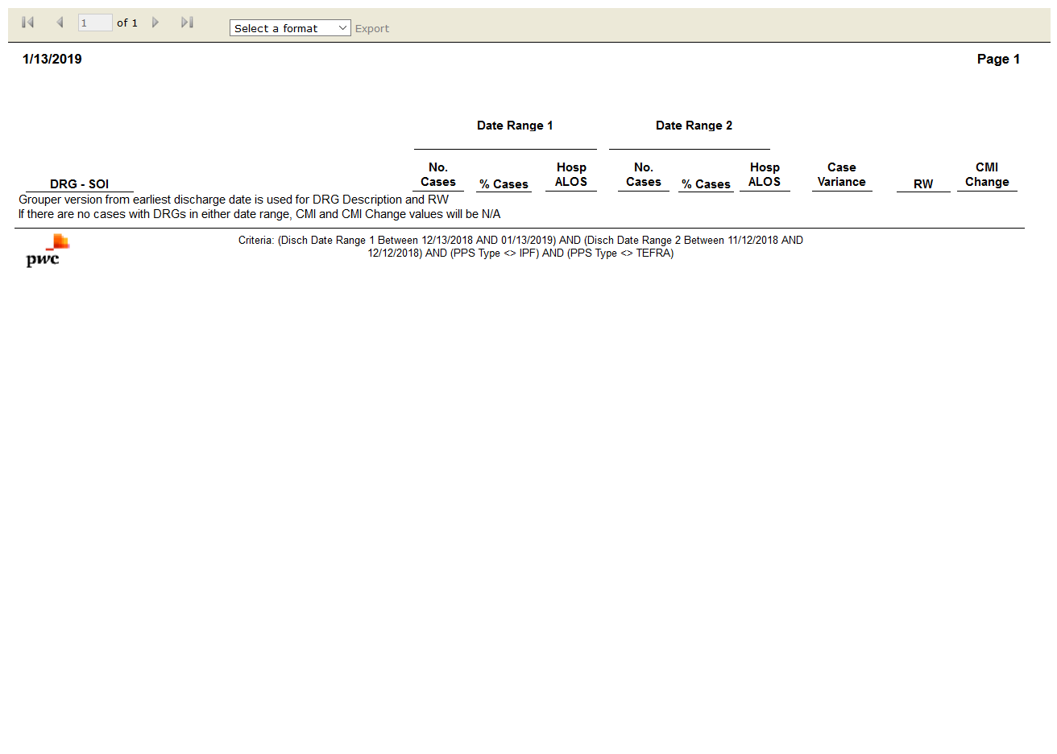

# IPSTDRG Frequency: True

Test Result: Success

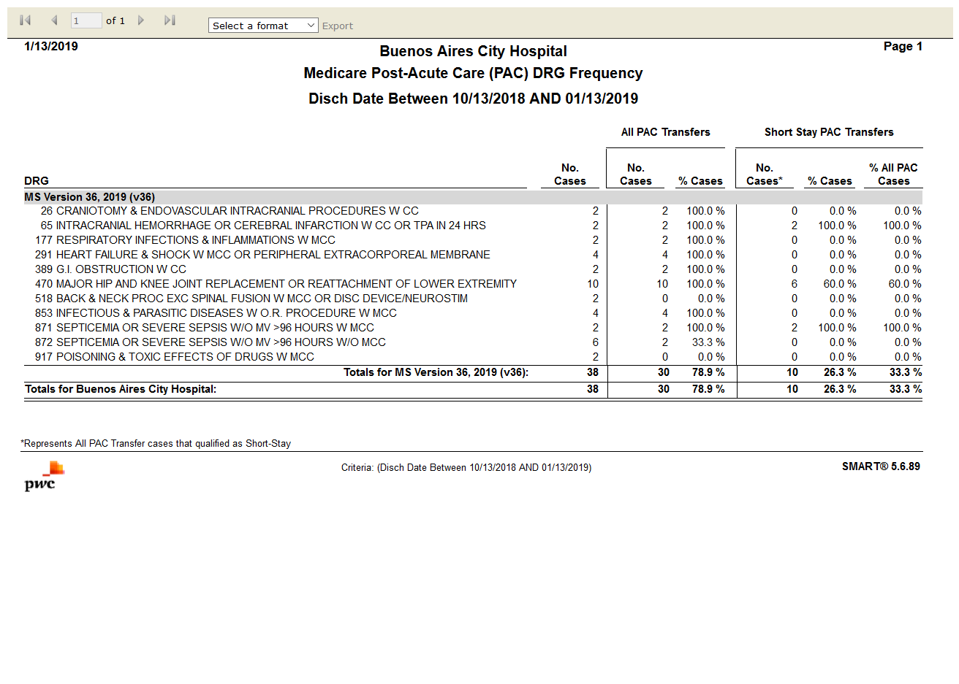

# IPSTDRG Illness Severity Score Comparison: False

Test Result: Message: Unable to locate element: DRG Illness Severity Score Comparison

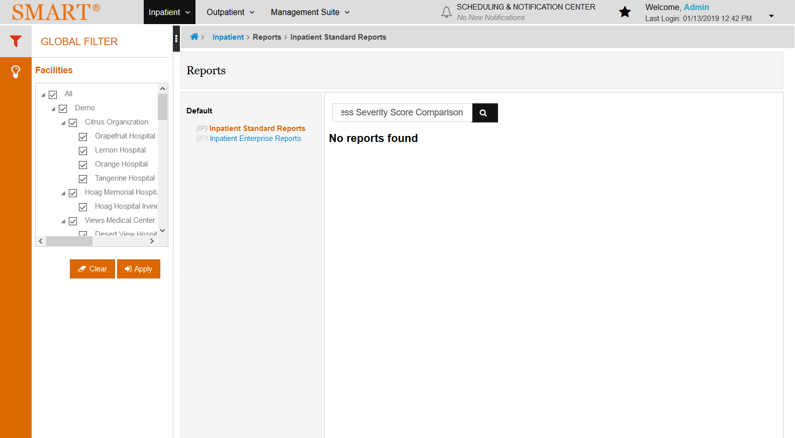

# IPSTDRG Summary by Grouper Version - MDC: True

Test Result: Success

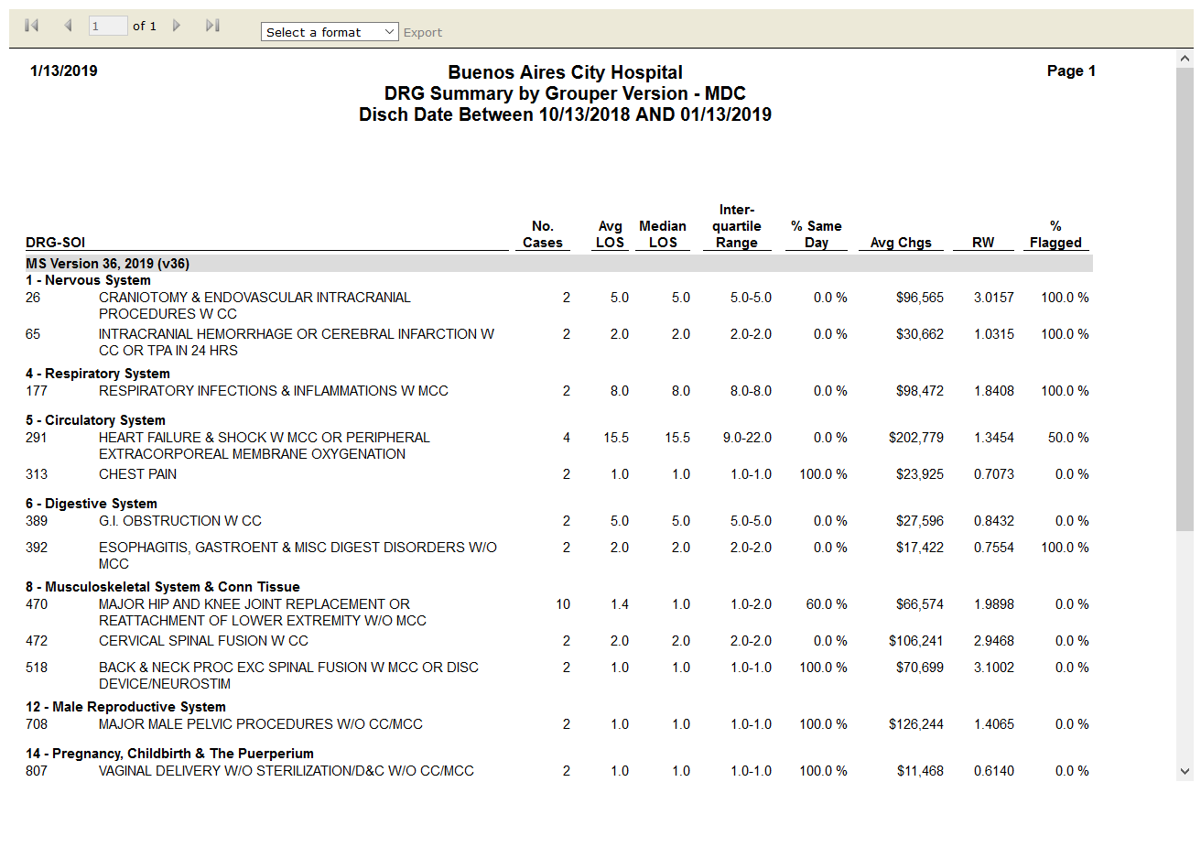

# IPSTMedicare Post-Acute Care (PAC) DRG Frequency: True

Test Result: Success



# IPSTSummary by Primary Flag: True

Test Result: Success

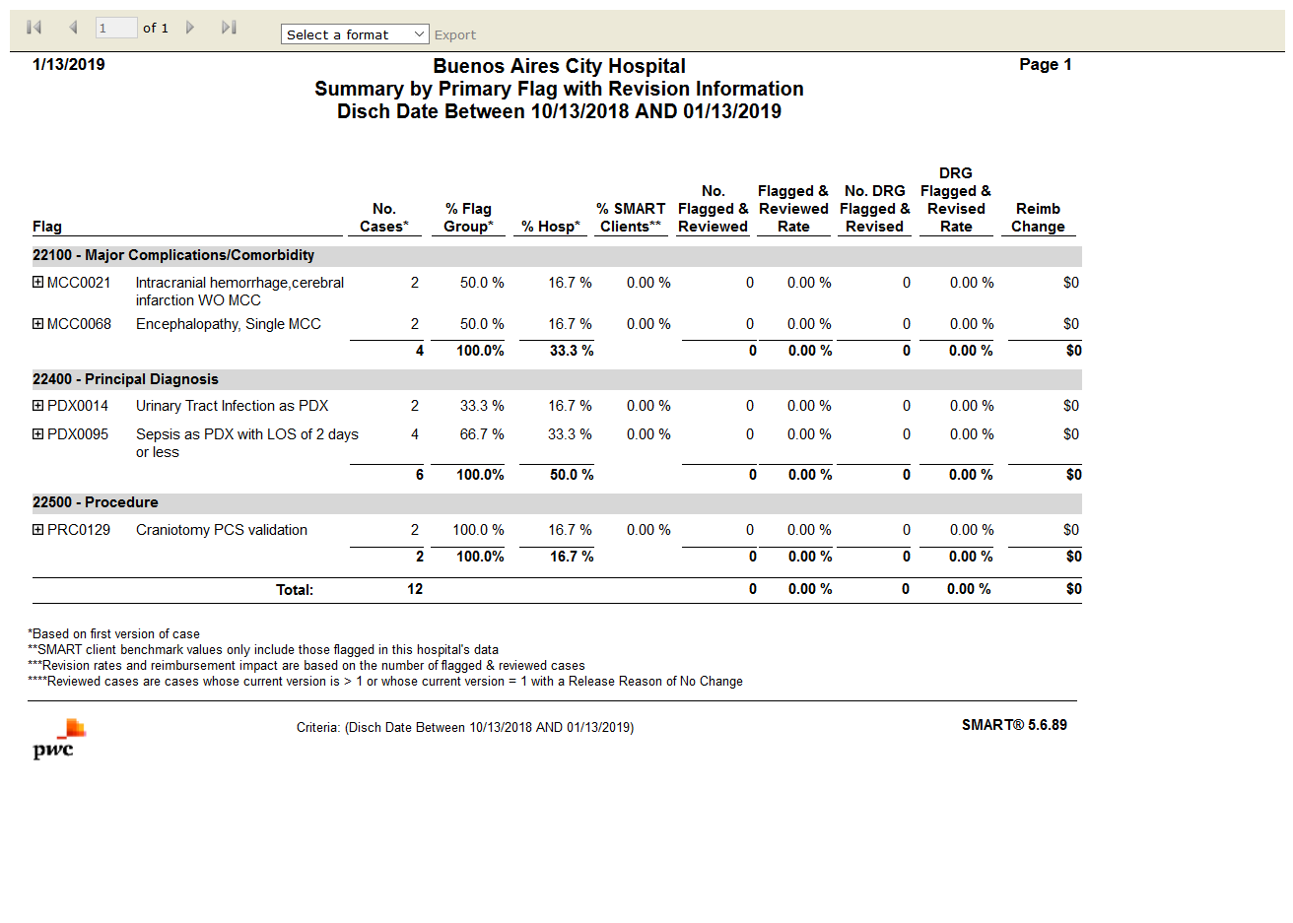

# IPSTSummary by Primary Flag with Revision Information: True

Test Result: Success



# IPSTFrequency: True

Test Result: Success

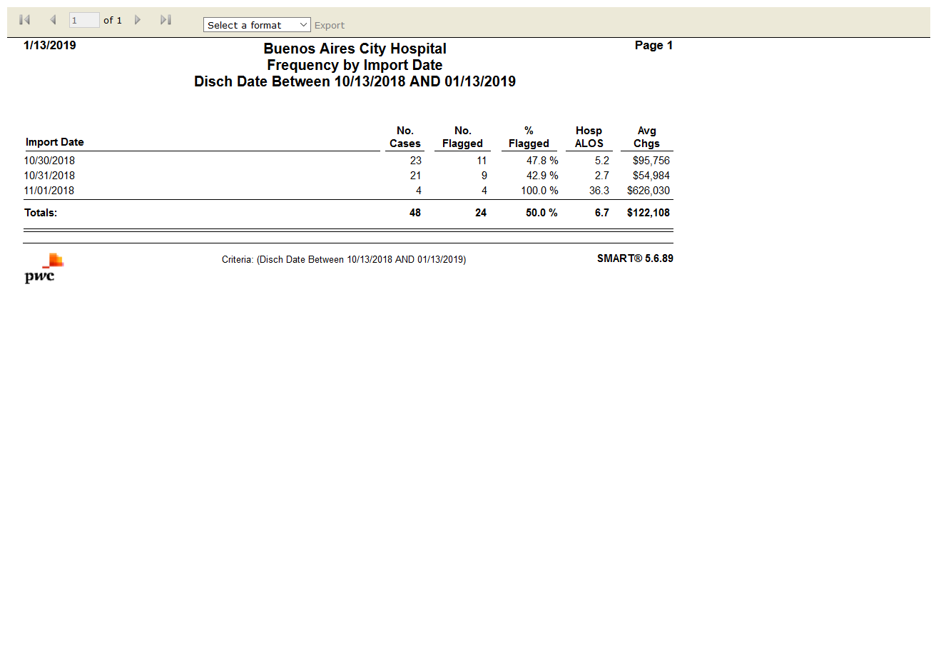

# IPSTSecurity Administration Information by Role: False

Test Result: list index out of range

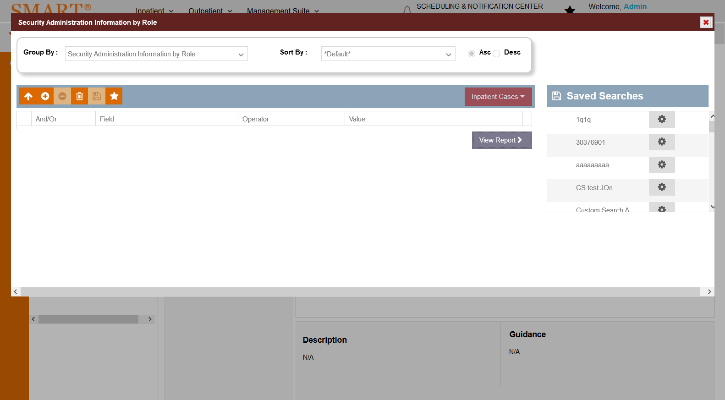

# IPSTDiagnosis Analysis by Present on Admission(POA): False

Test Result: Message: Timeout loading page after 300000ms



# IPSTDiagnosis Code Usage by Payer: False

Test Result: Message: Timeout loading page after 300000ms



# IPSTMedicare Hospital-Acquired Conditions: False

Test Result: Message: Timeout loading page after 300000ms



# IPSTPresent on Admission(POA) Comparison: False

Test Result: Message: Timeout loading page after 300000ms



# IPSTPrincipal Procedures: False

Test Result: Message: Timeout loading page after 300000ms



# IPSTTop 50 Diagnoses by Present on Admission(POA): False

Test Result:

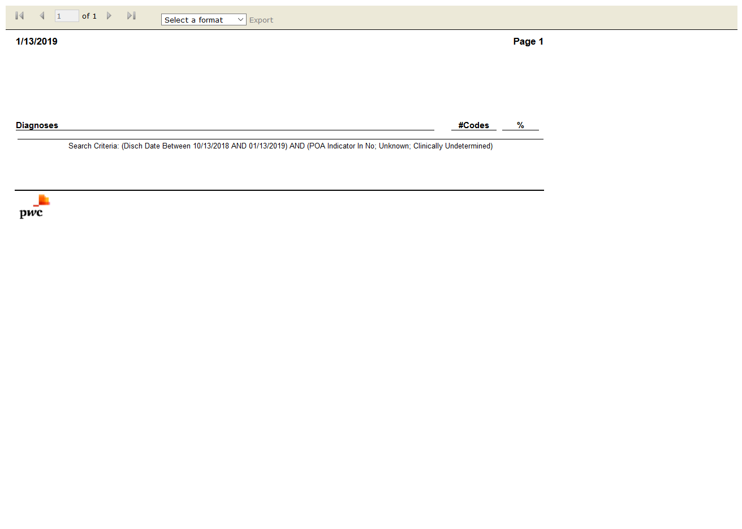

# IPSTCases Processed on Import: True

Test Result: Success

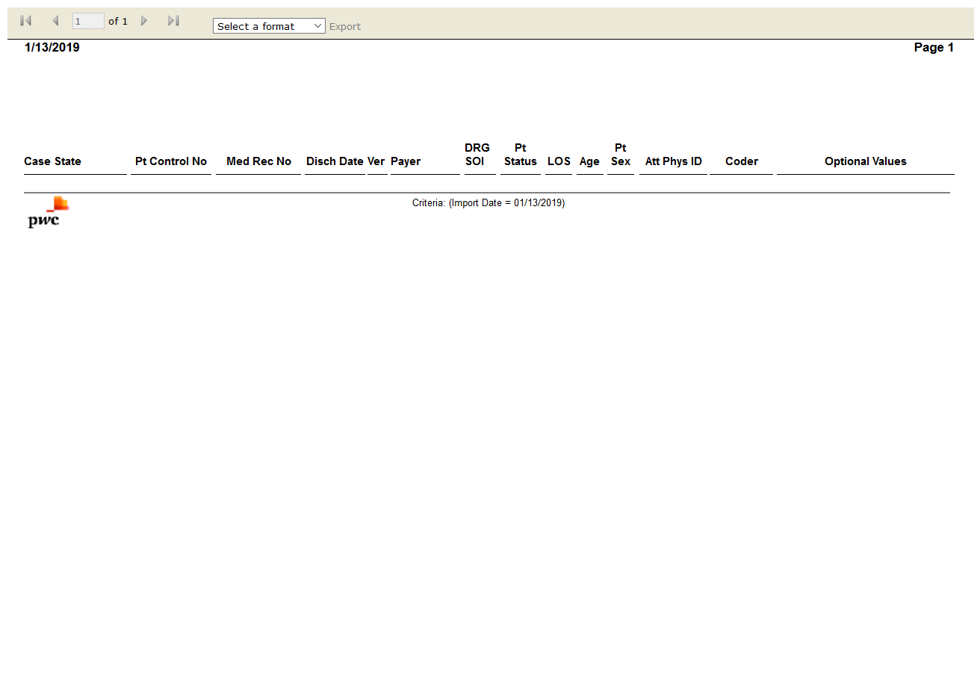

# IPSTData Validation: False

Test Result: Message: Unable to locate element: [id="btnViewReport"]

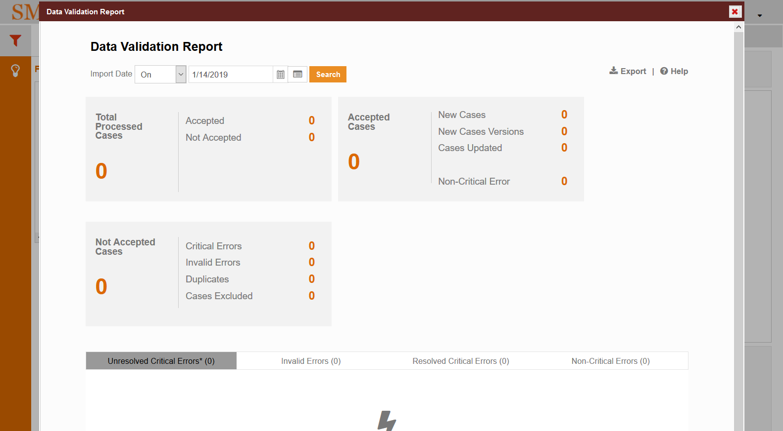

# IPSTFrequency: True

Test Result: Success



# IPSTInpatient Flag Information: False

Test Result: list index out of range

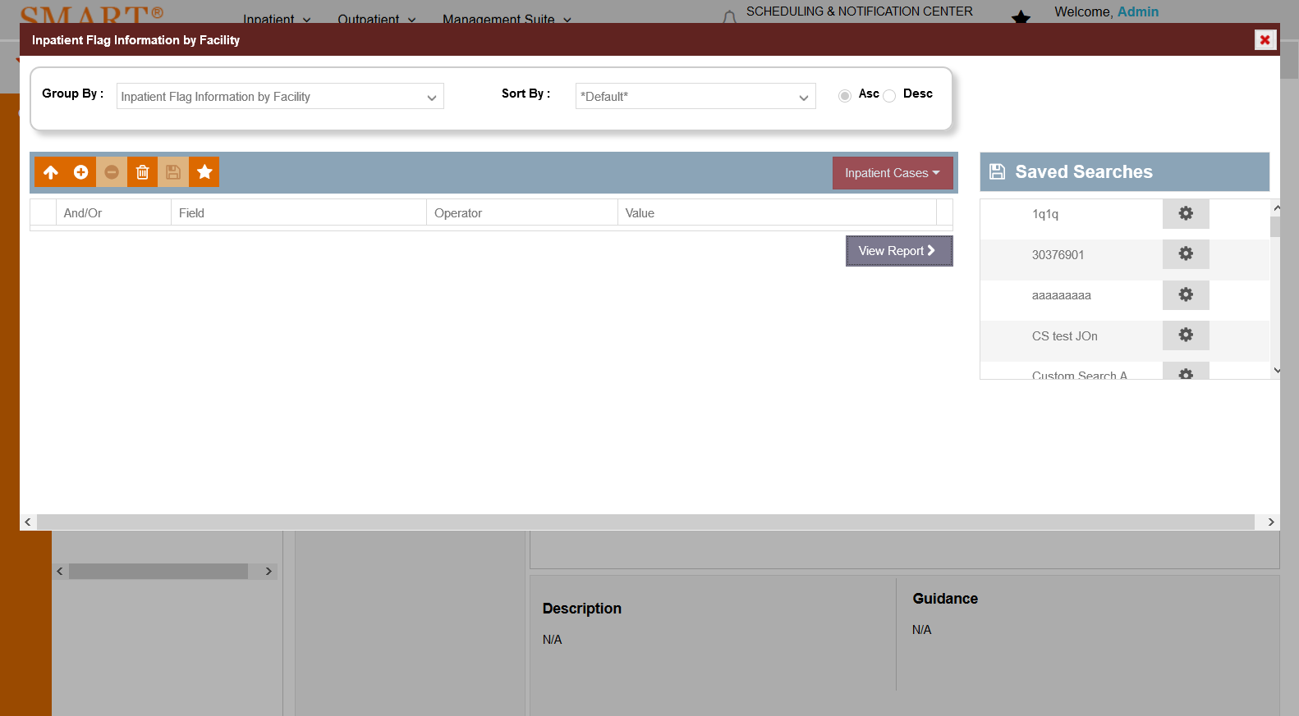

# IPSTIP Worksheet: True

Test Result: Success

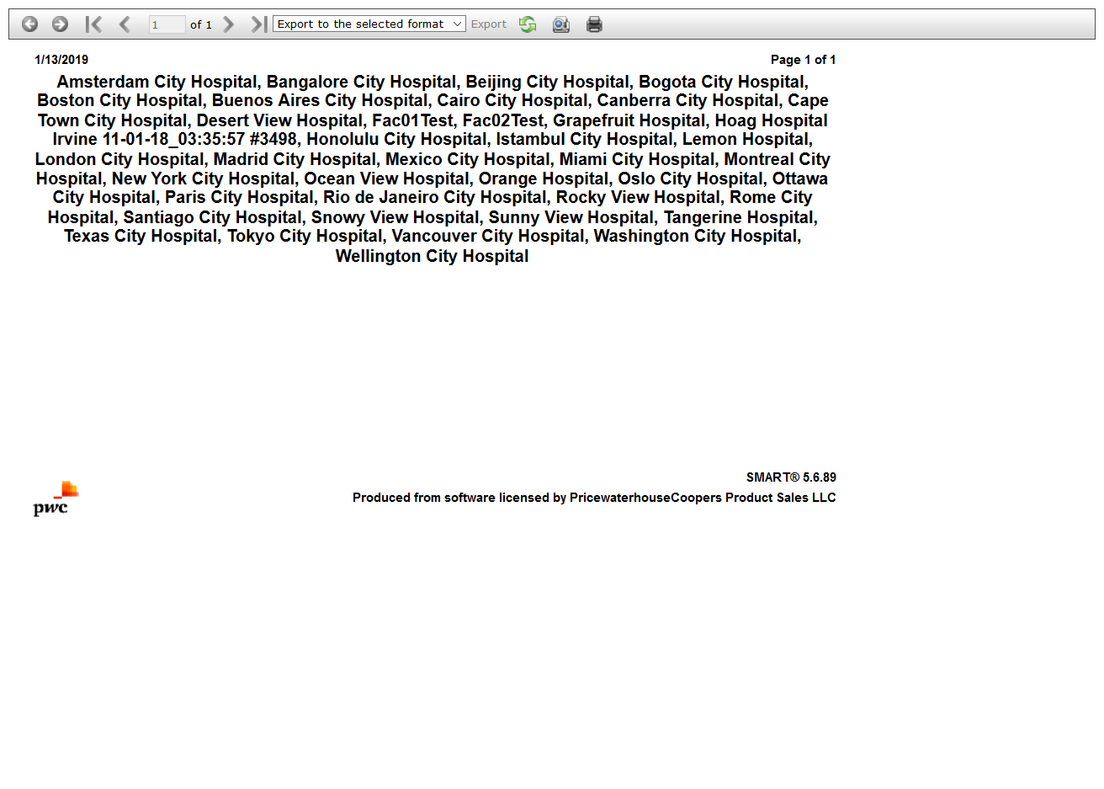

# IPSTAverage Length of Stay by Payer by Month: True

Test Result: Success

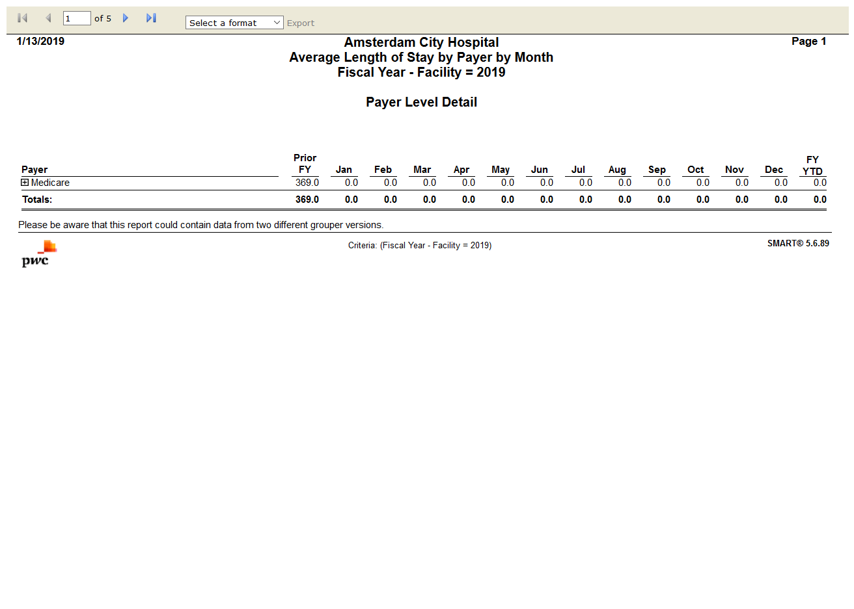

# IPSTCase Change Results: True

Test Result: Success

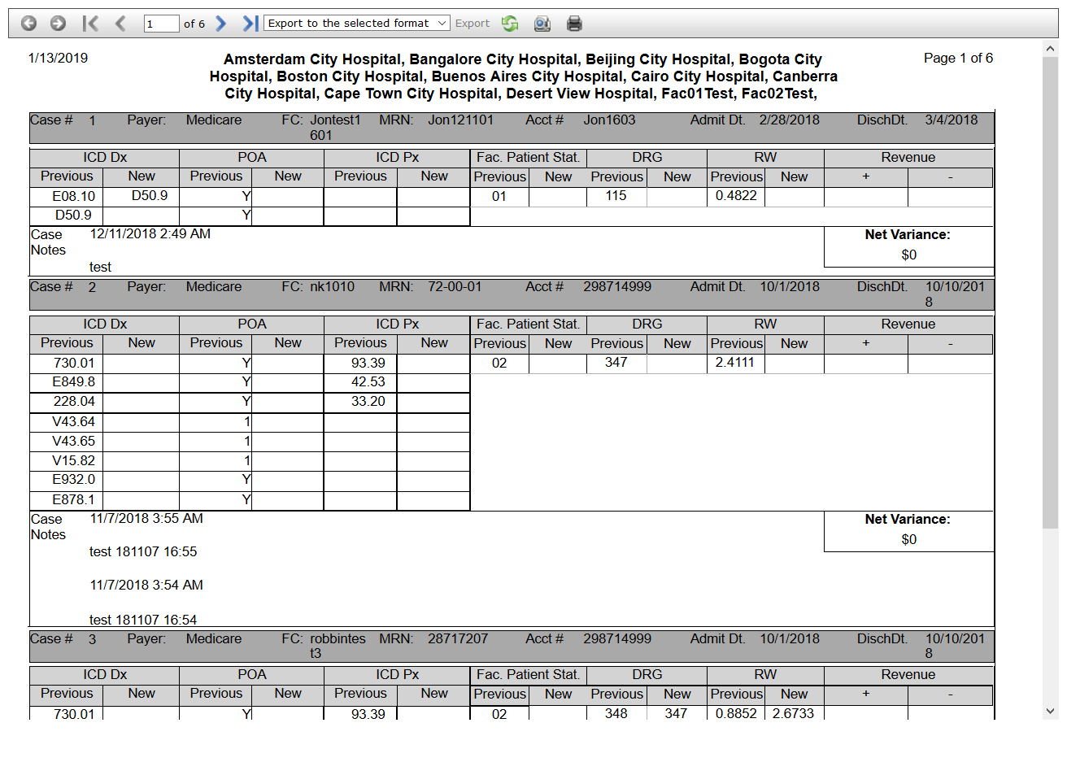

# IPSTCoding-DRG Accuracy Analysis: True

Test Result: Success

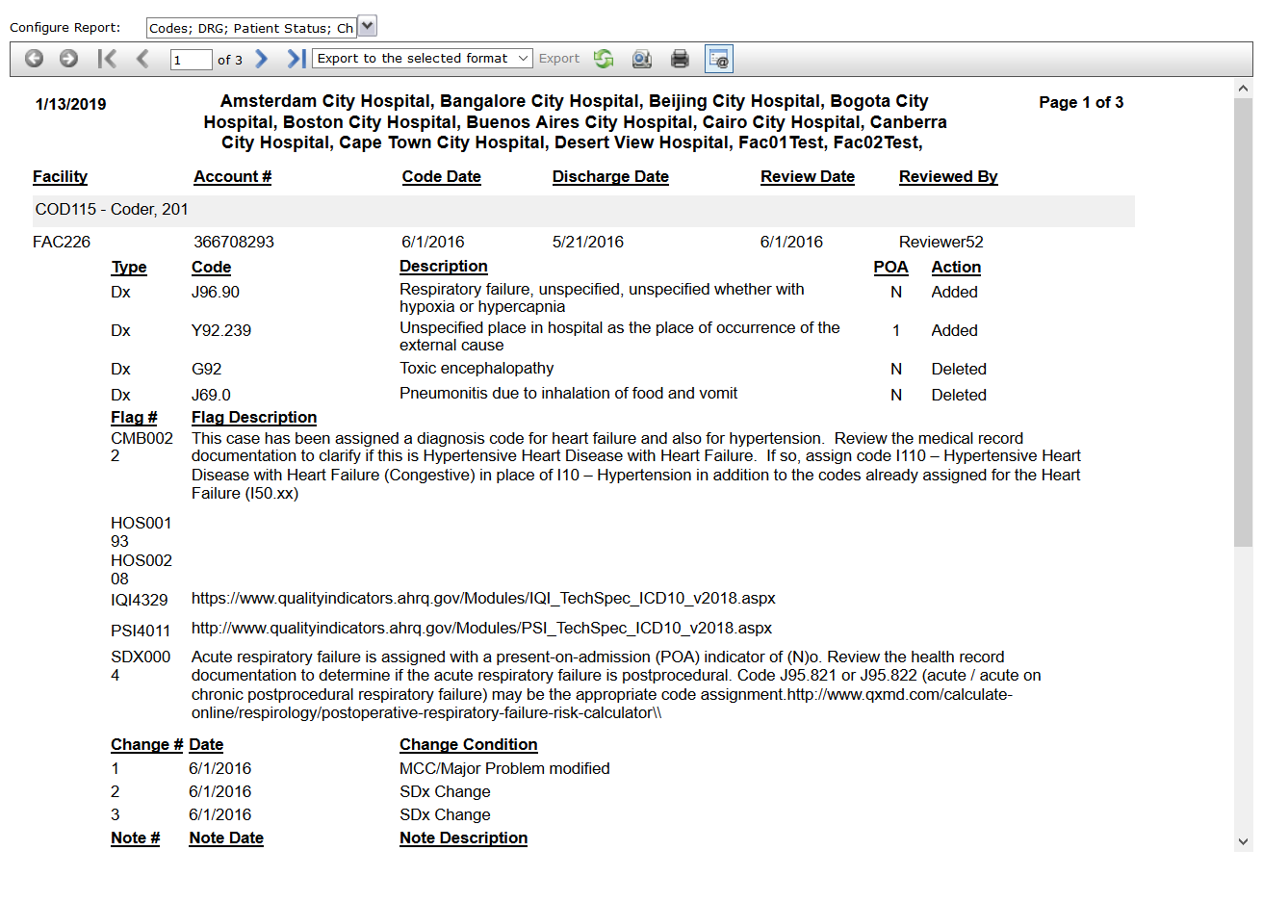

# IPSTCoding-DRG Review Summary: True

Test Result: Success

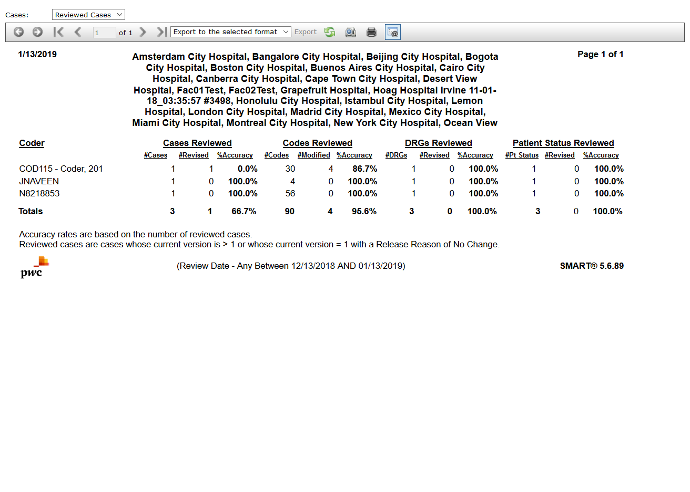

# IPSTIllness Severity Score by Payer by Month: False

Test Result: Message: Unable to locate element: llness Severity Score by Payer by Month

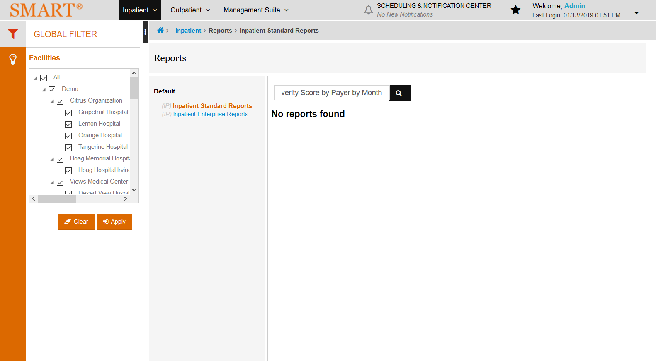

# IPSTPerformance Metrics: True

Test Result: Success

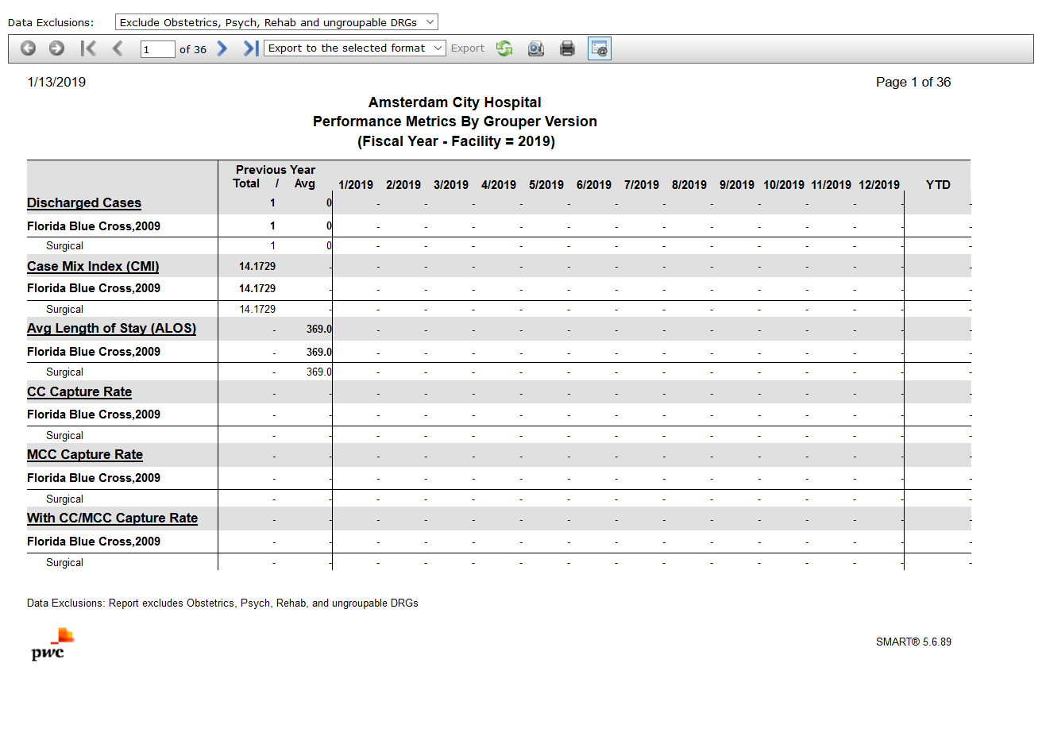

# IPSTProfile: False

Test Result: Success



# IPSTReadmissions: True

Test Result: Success

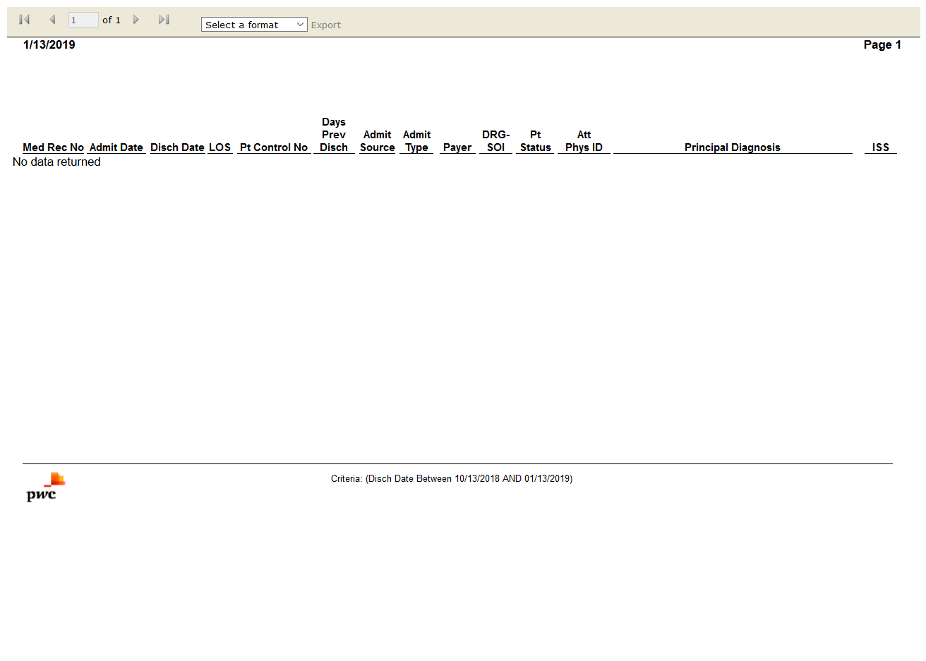

# IPSTSMART Case Review Results: True

Test Result: Success

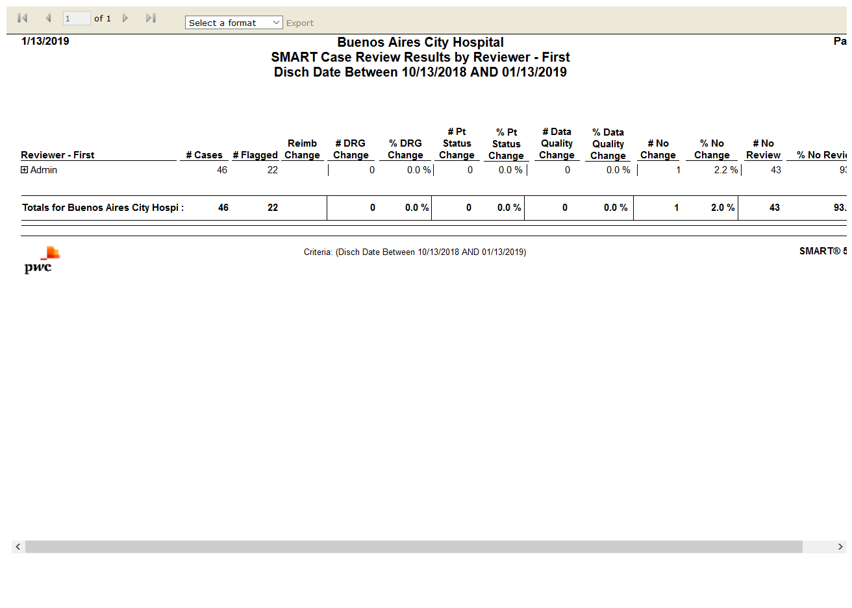

# IPSTInpatient Flag Information by Facility: False

Test Result: list index out of range



# IPSTSMART Report Card: True

Test Result: Success

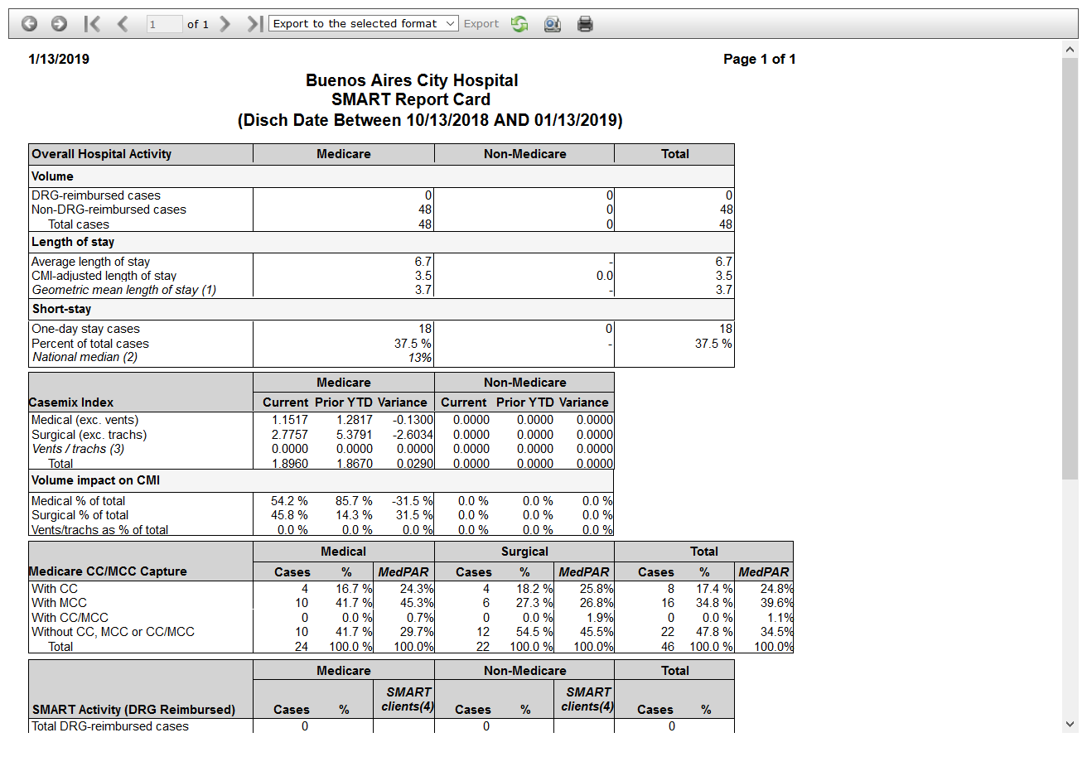

# IPSTSMART Results Summary: True

Test Result: Success

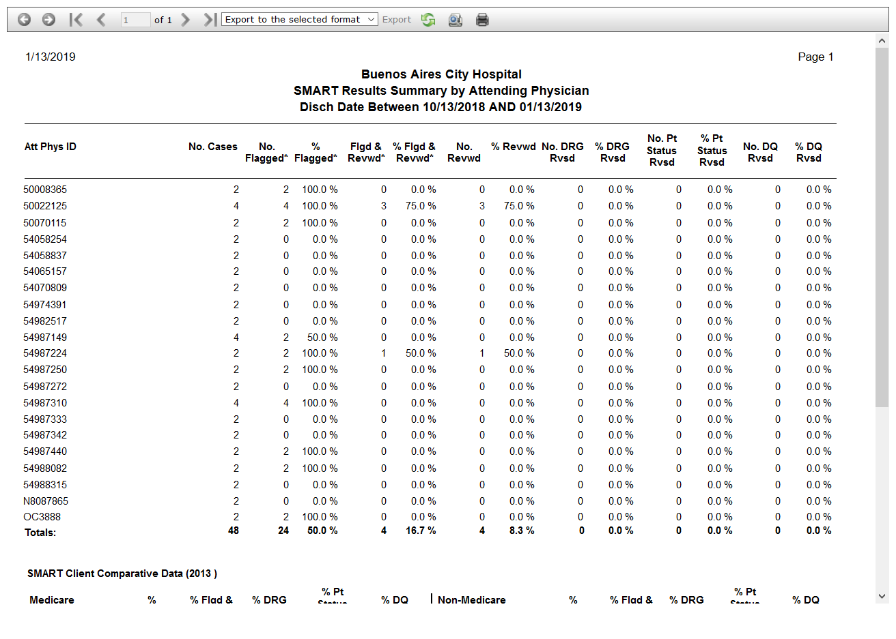

# IPSTCase Status Reimbursement Detail: True

Test Result: Success

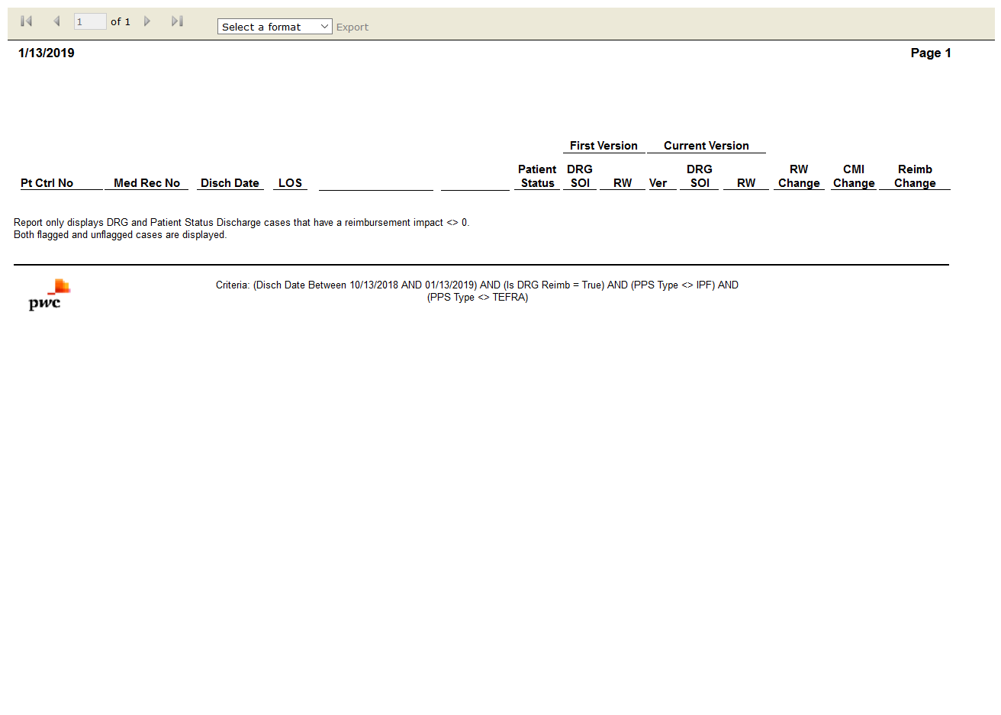

# IPSTCase Status Reimbursement Summary: True

Test Result: Success

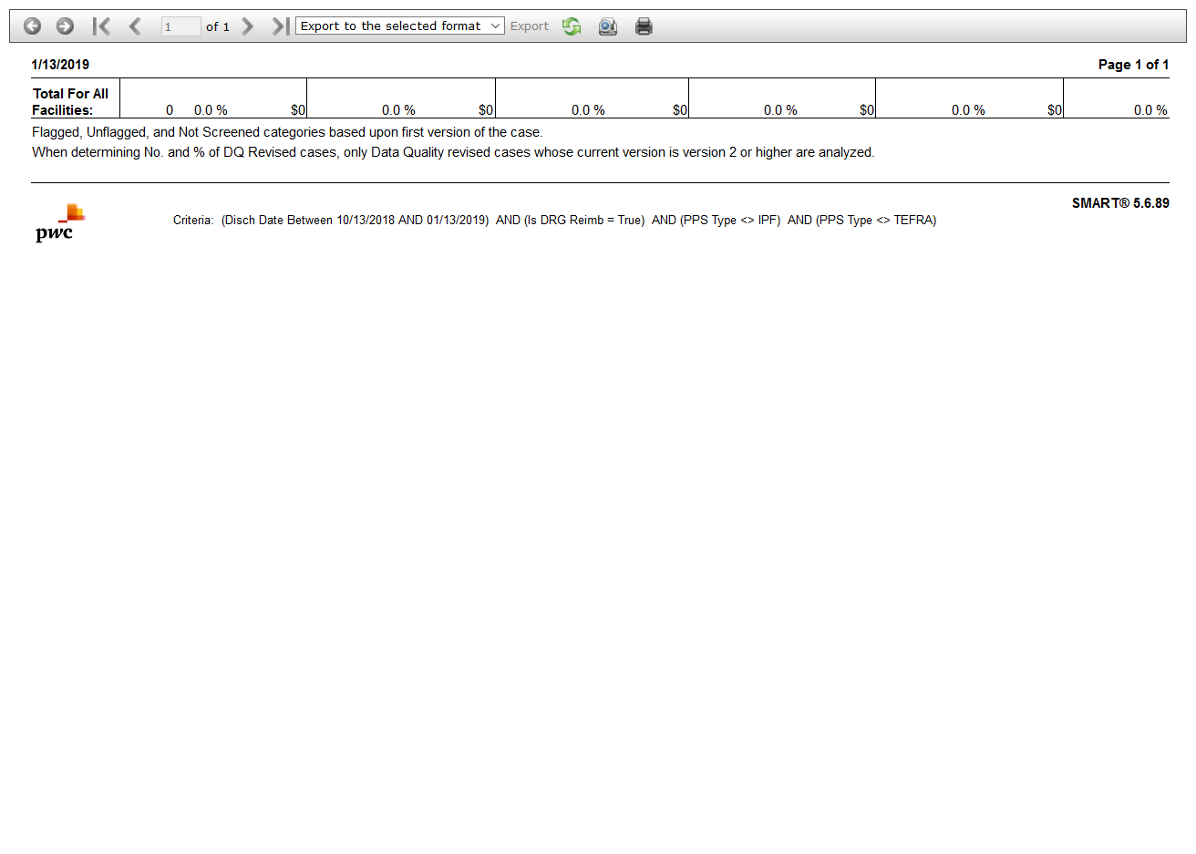

# IPSTCMI Reimbursement Summary by Attending Physician: True

Test Result: Success

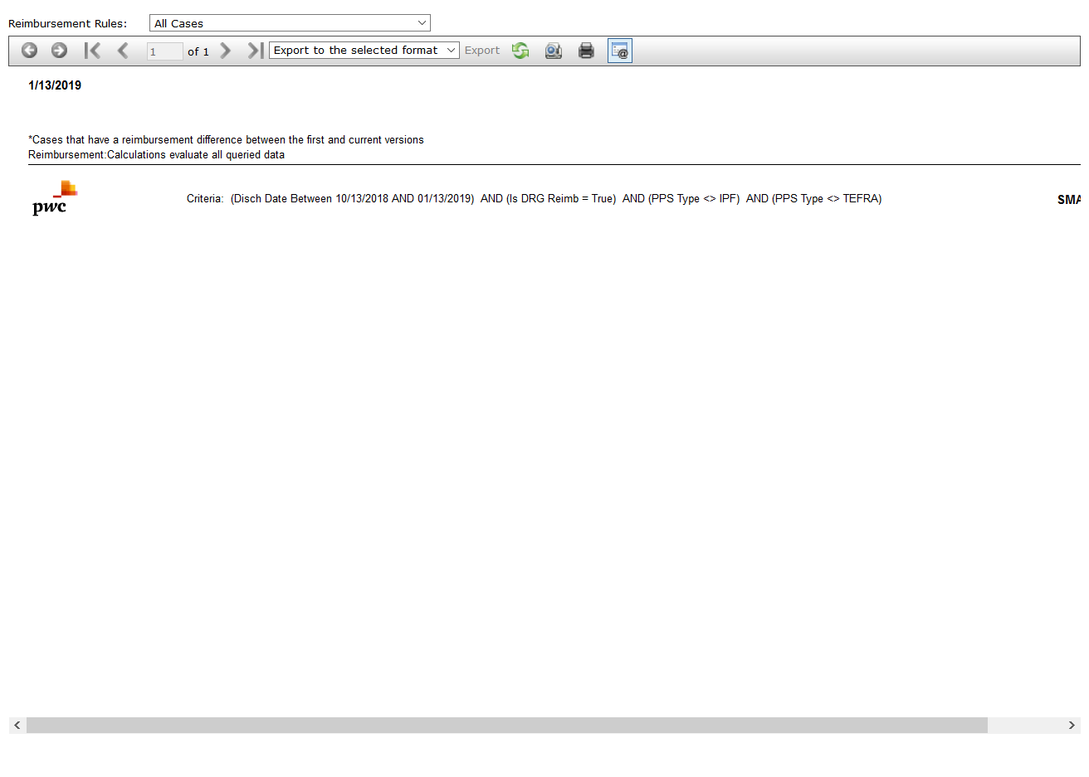

# IPSTGrouper Version Reimbursement Detail: True

Test Result: Success

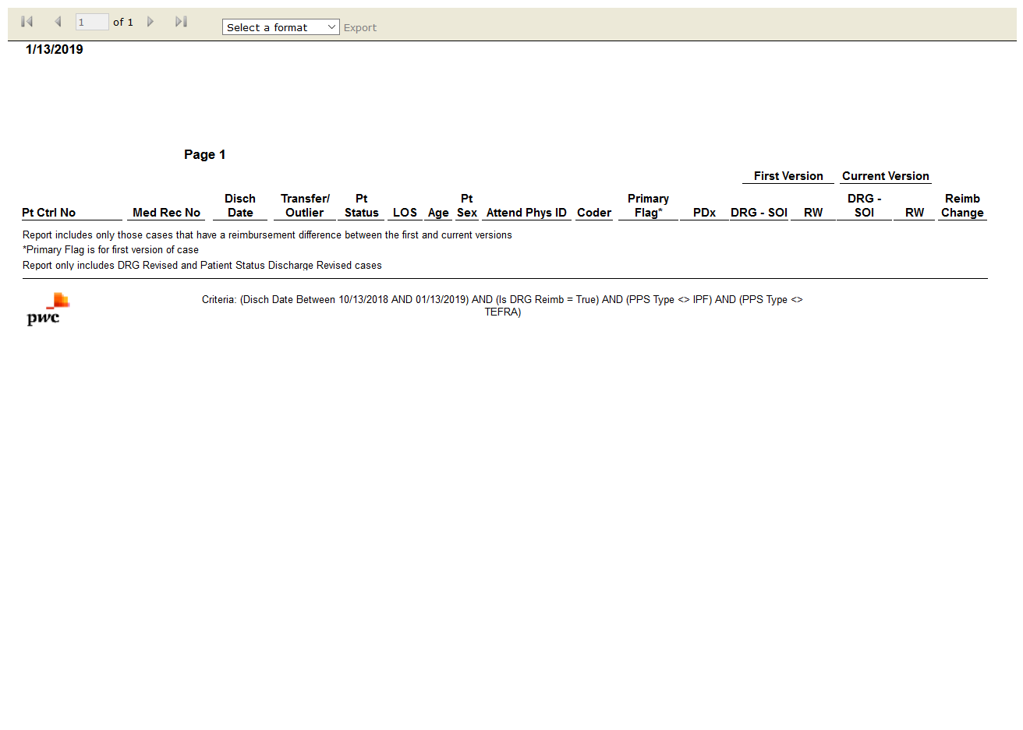

# IPSTMedicare HAC Potential Impact: False

Test Result: Message: Unable to locate element: Medicare HAC Potential Impact

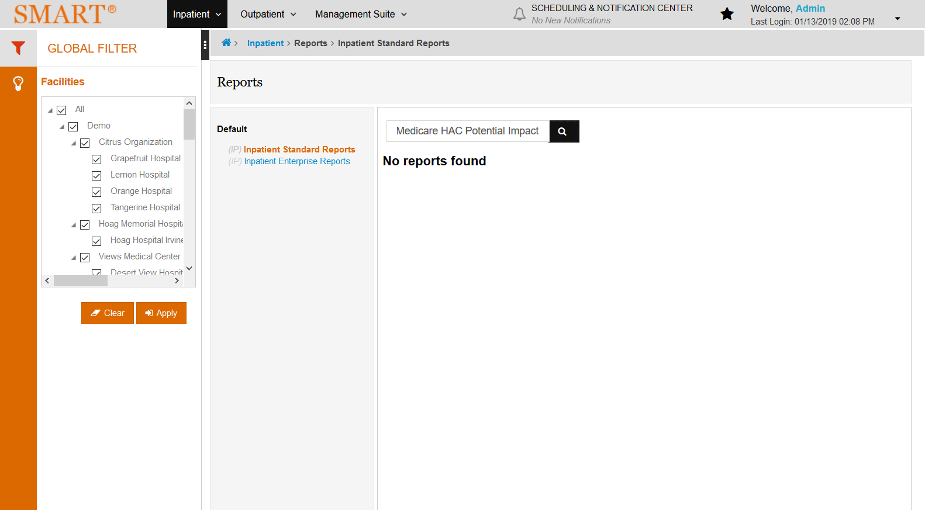

# IPSTMedicare Post-Acute Care (PAC) DRG Reimbursement: True

Test Result: Success

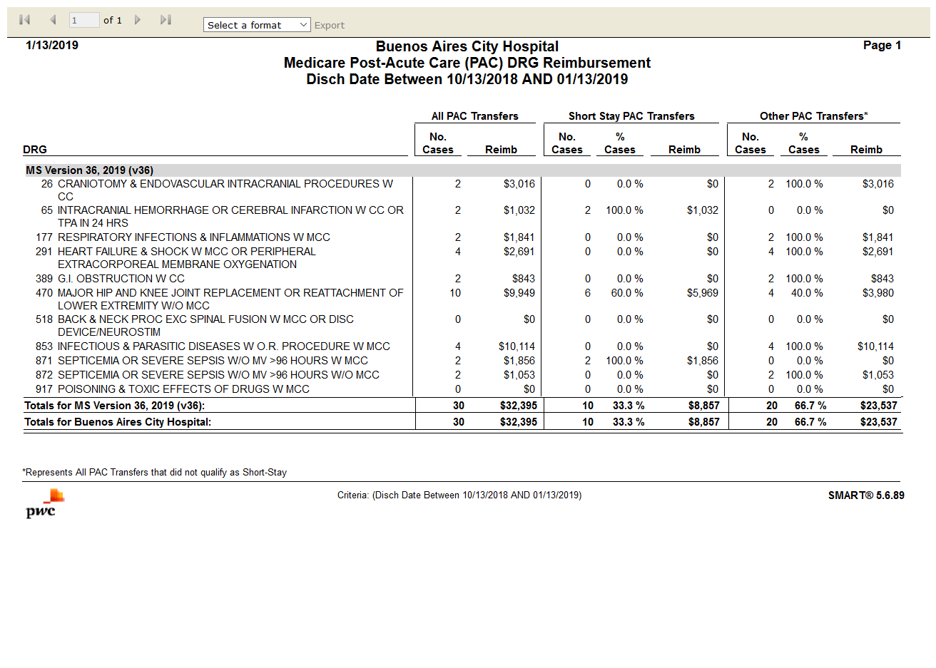

# IPSTMedicare Post-Acute Care (PAC) Reimbursement Comparison: True

Test Result: Success

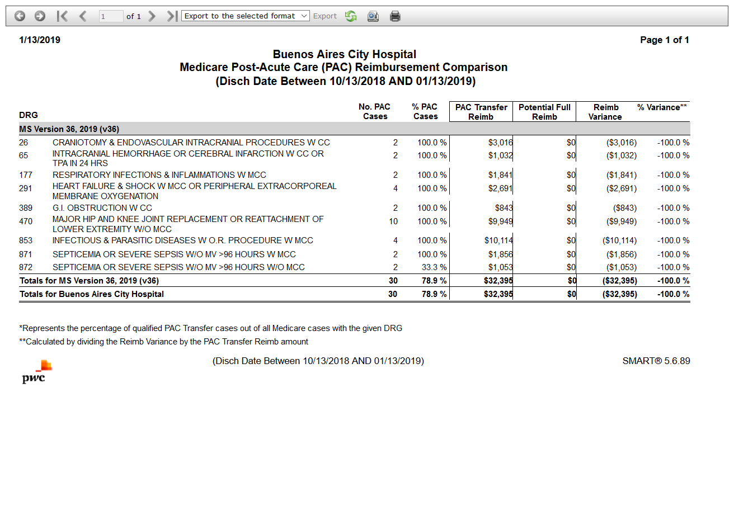

# IPSTReimbursement Change Summary: True

Test Result: Success

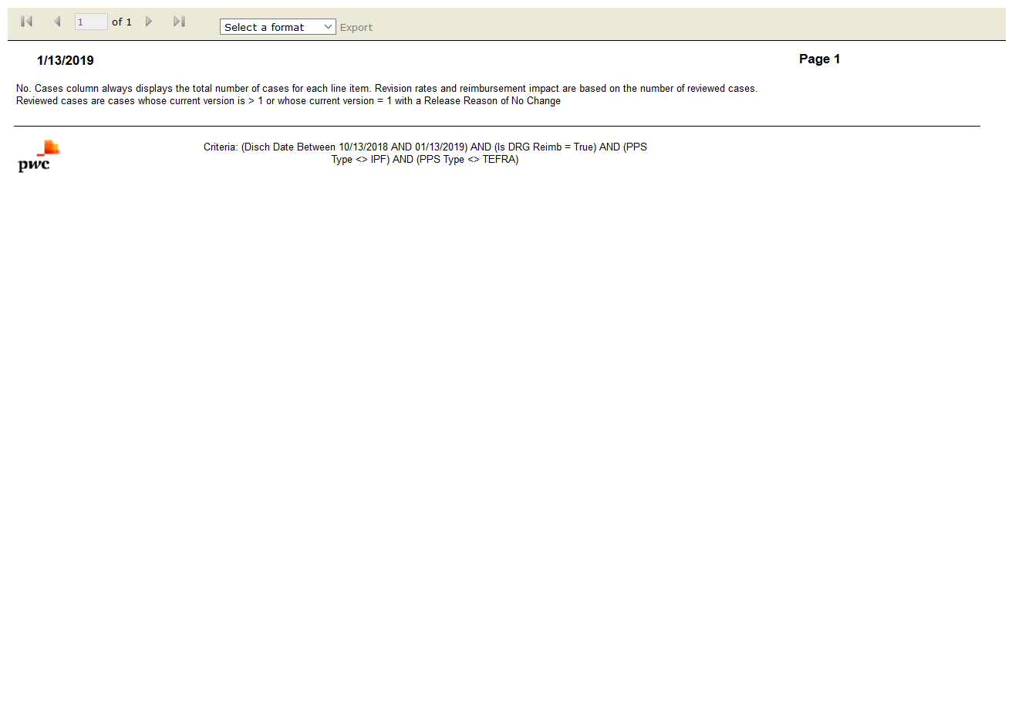

# IPSTDRG Listing by Payer: True

Test Result: Success

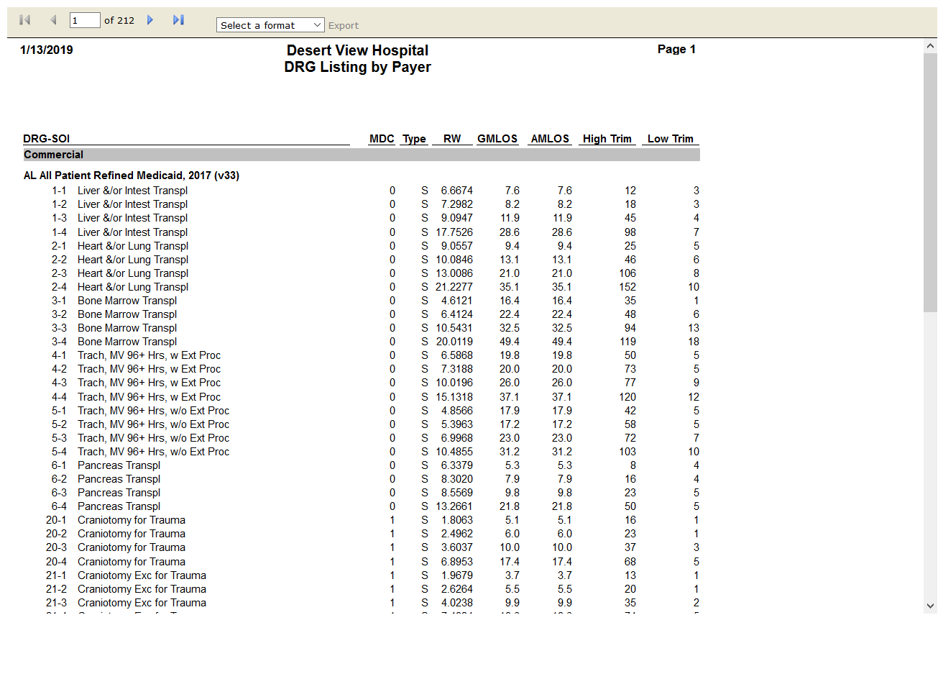

# IPSTSMART Reimbursement Activity: True

Test Result: Success

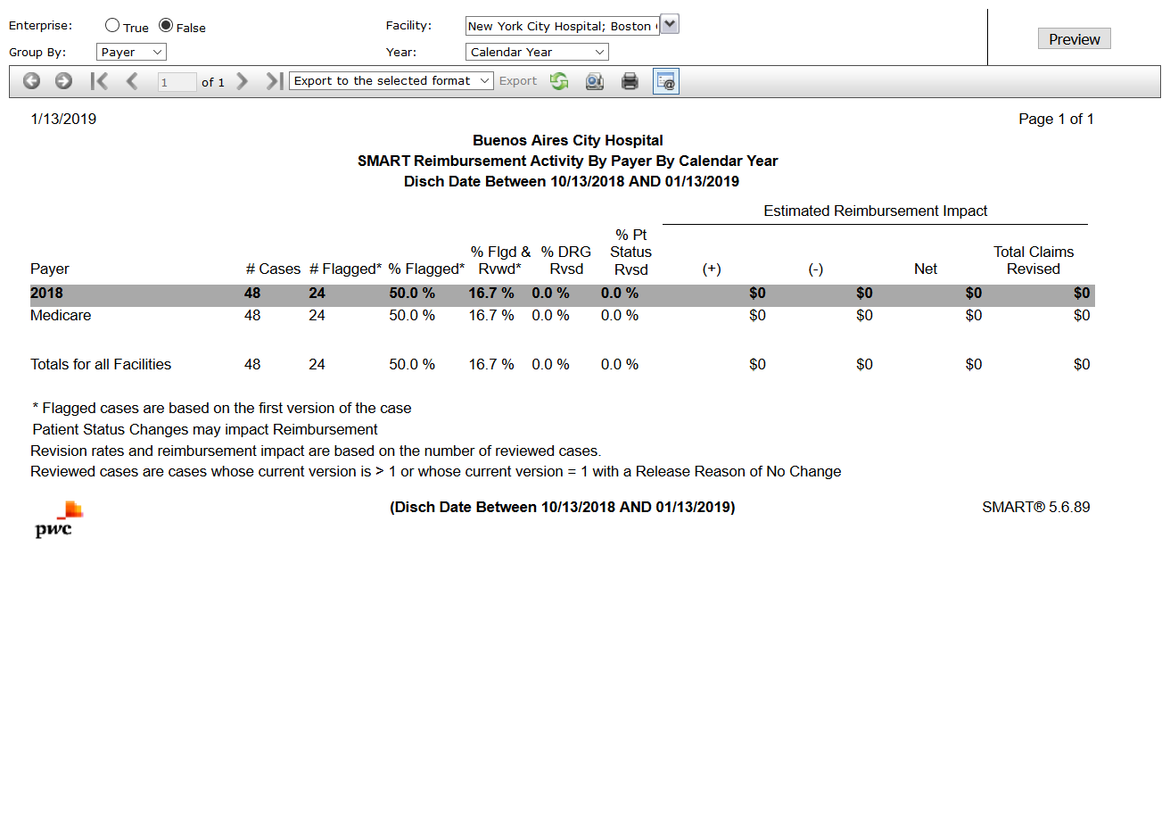

# IPENData Comparison: True

Test Result: Success

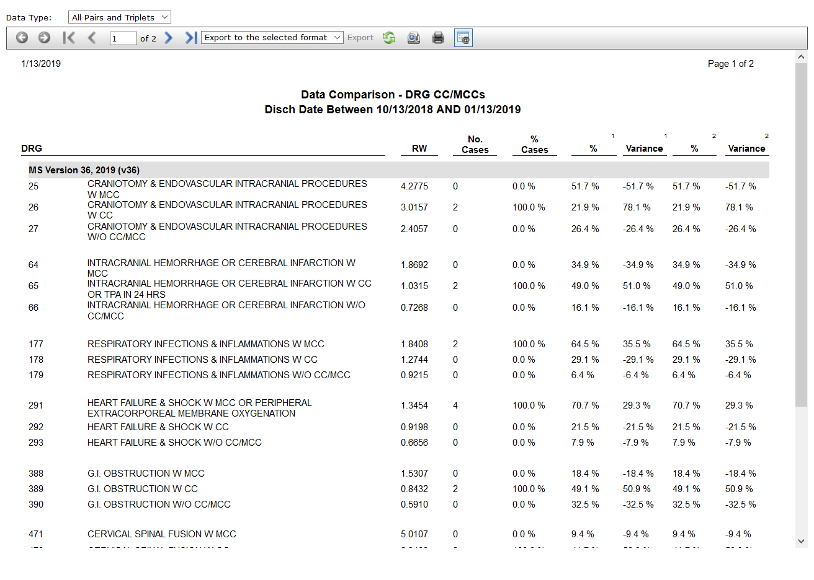

# IPENCase Mix Index (CMI) Analysis: True

Test Result: Success

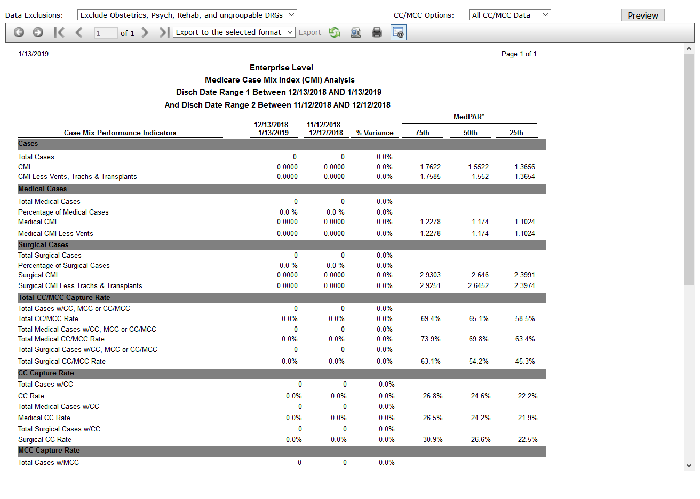

# IPENCase Mix Index (CMI) Comparison: True

Test Result: Success

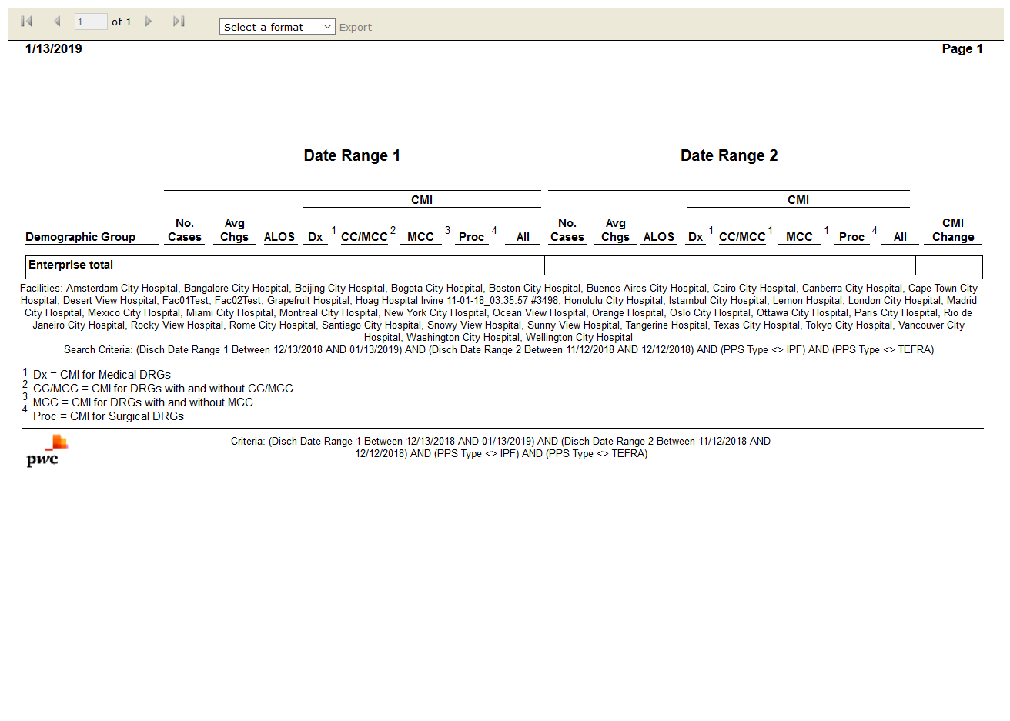

# IPENDRG Clinical Profile: True

Test Result: Success

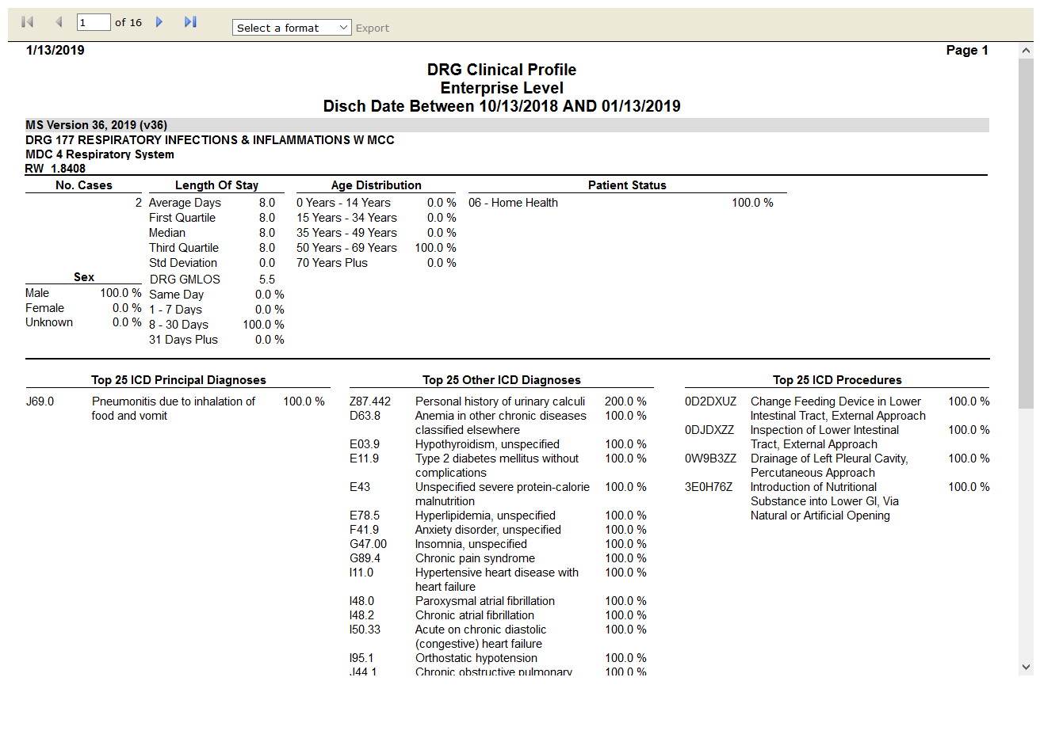

# IPENDRG Contribution to Payer CMI: True

Test Result: Success

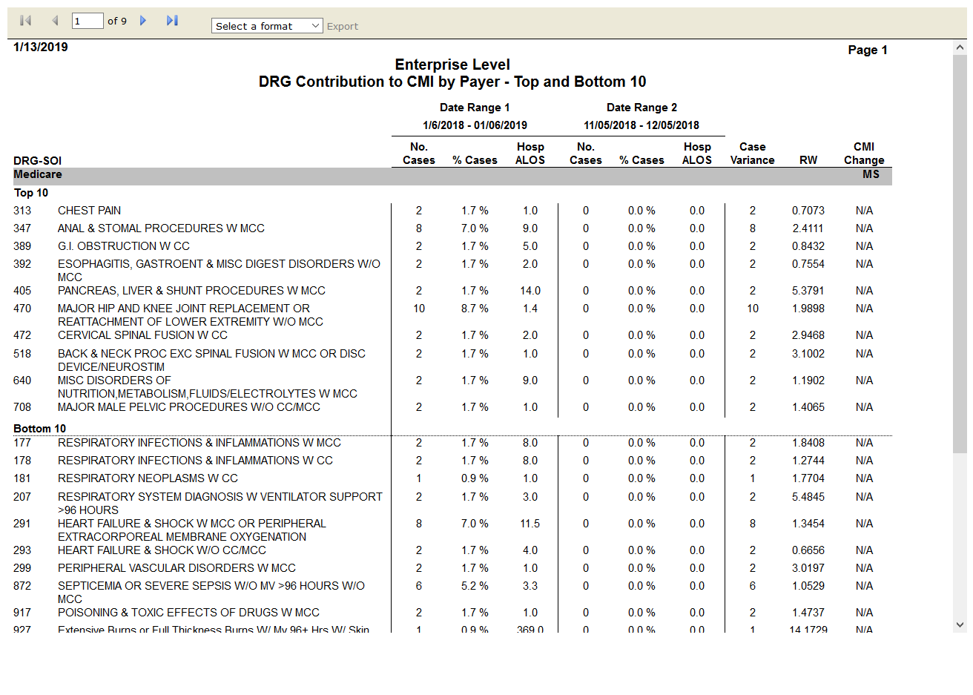

# IPENDRG Frequency: True

Test Result: Success

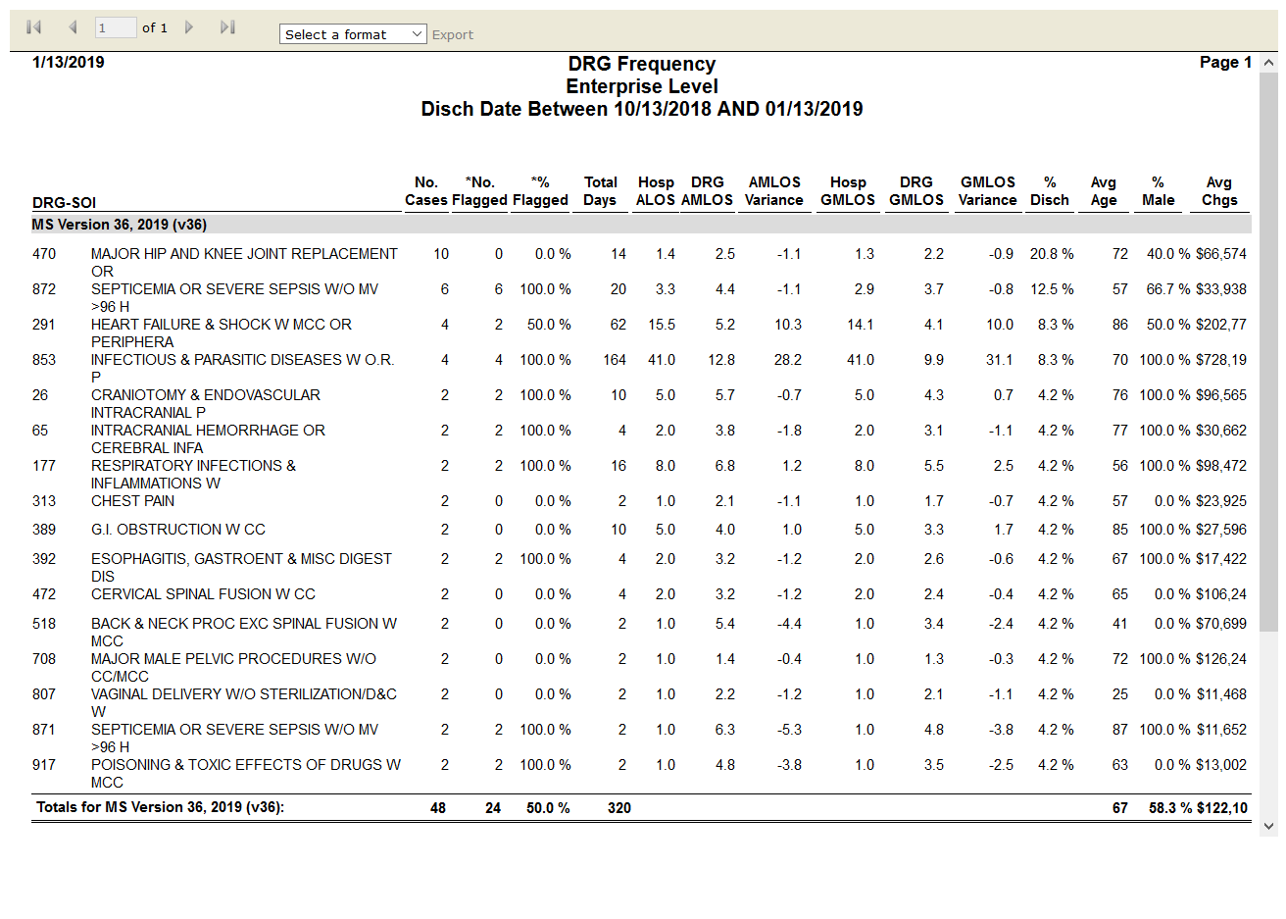

# IPENDRG Illness Severity Score Comparison by Payer: False

Test Result: Message: Unable to locate element: DRG Illness Severity Score Comparison by Payer

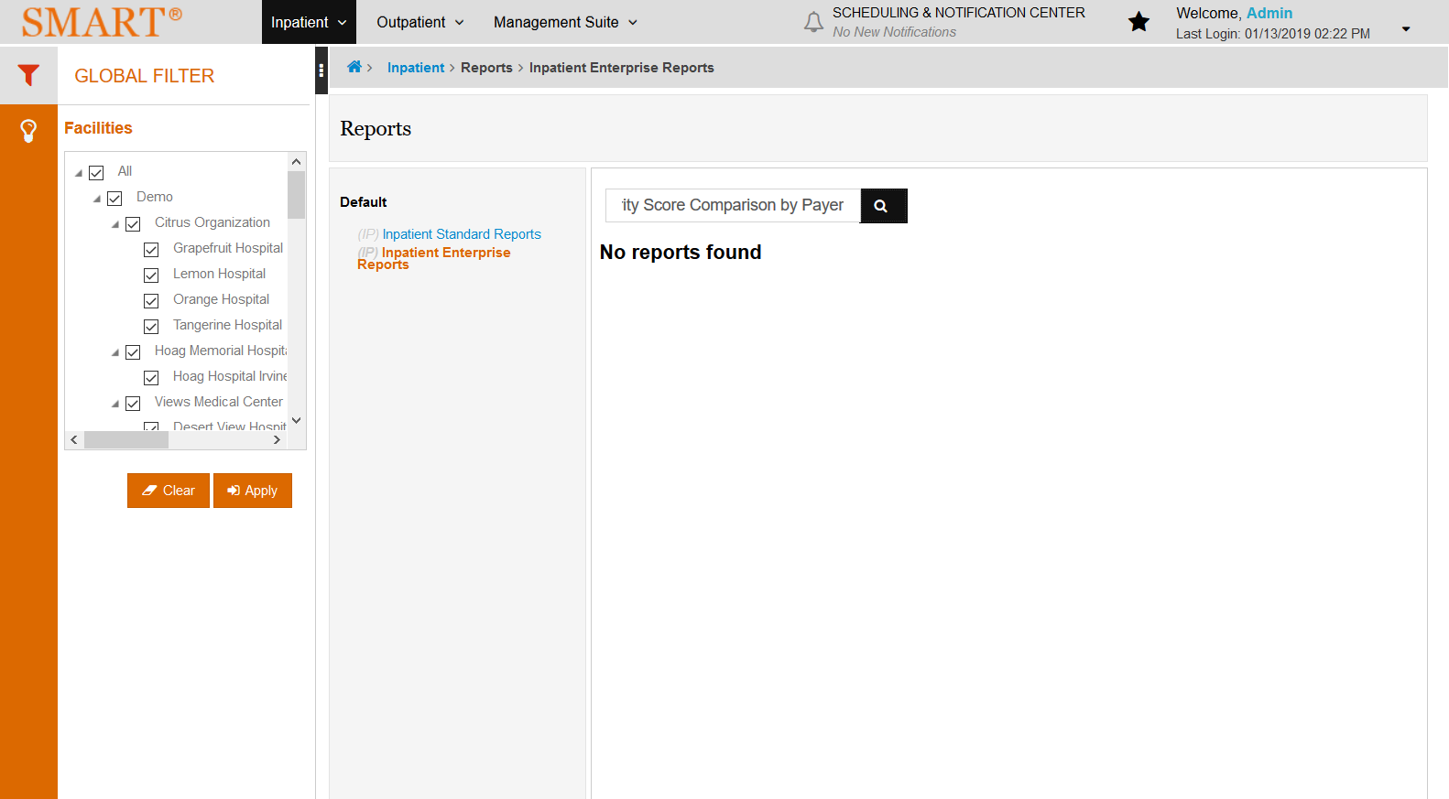

# IPENMedicare Post-Acute Care (PAC) DRG Frequency by Patient Status: False

Test Result: Message: Unable to locate element: Medicare Post-Acute Care (PAC) DRG Frequency by Patient Status

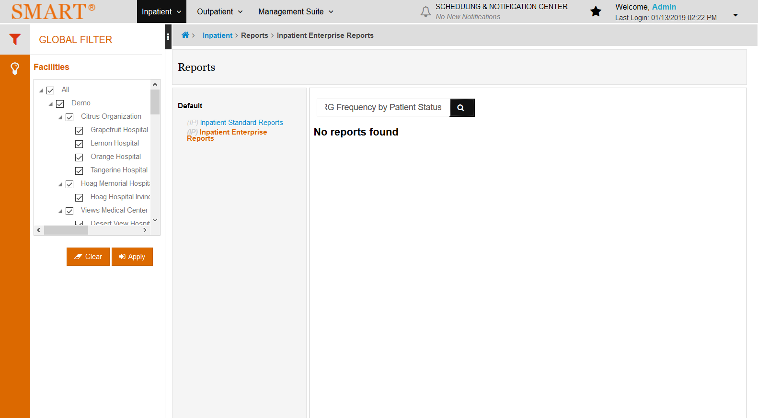

# IPENFrequency: True

Test Result: Success

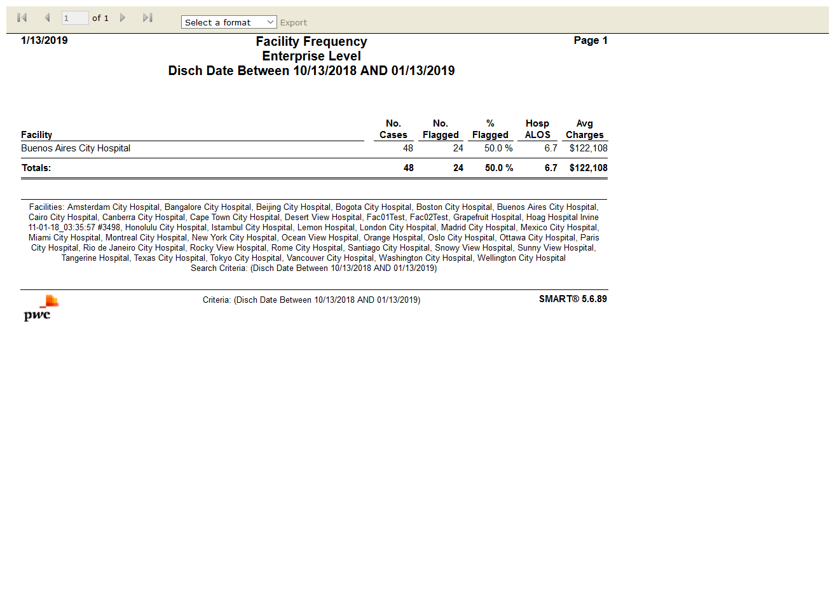

# IPSTFinancial Class Mapping Information: True

Test Result: Success

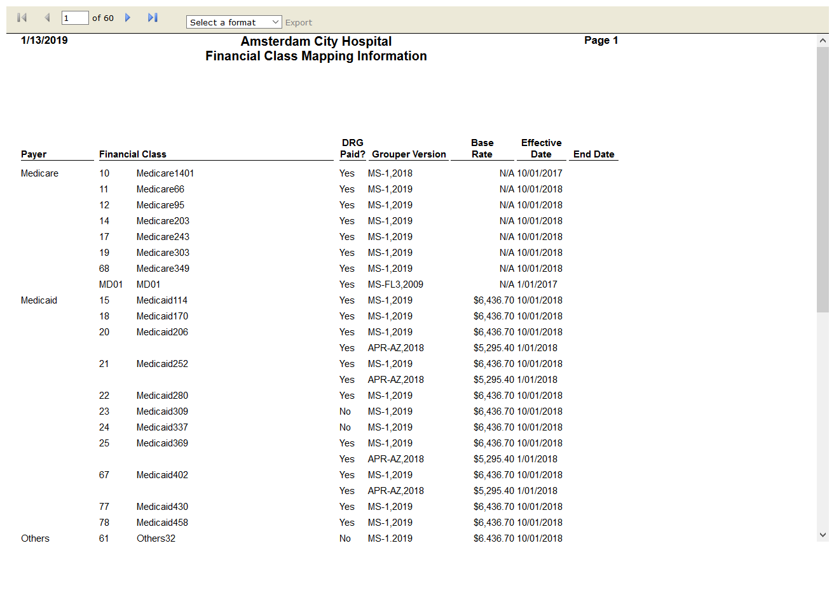

# IPENDiagnosis Analysis by Present on Admission(POA): True

Test Result: Success

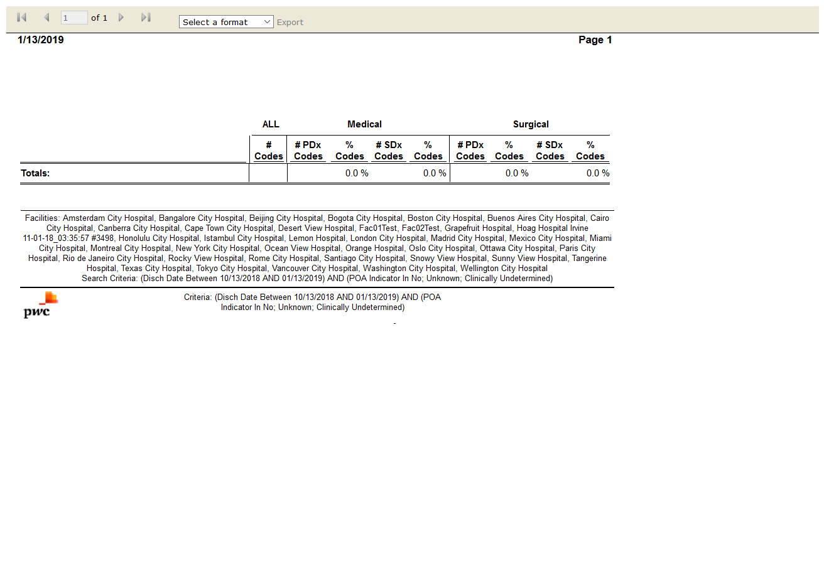

# IPENMedicare Hospital-Acquired Conditions: True

Test Result: Success

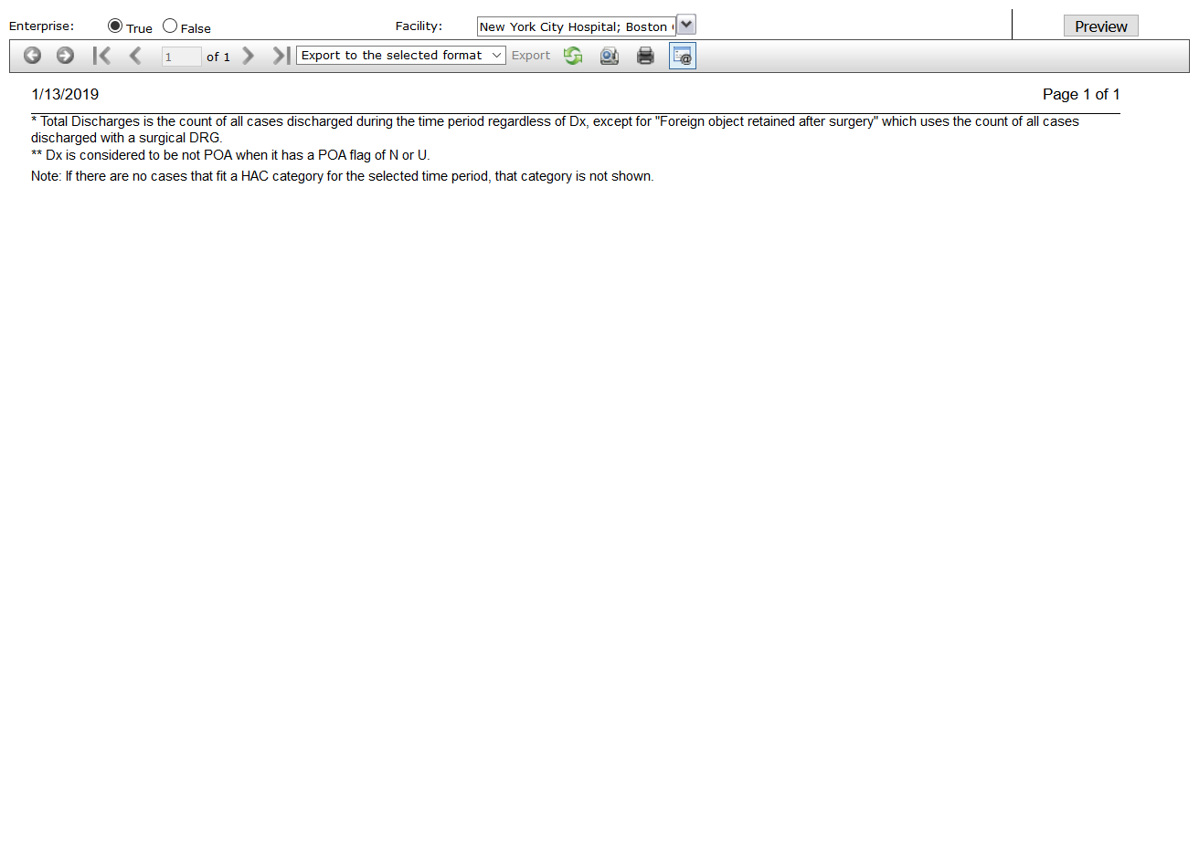

# IPENTop 50 Diagnoses by Present on Admission(POA): True

Test Result: Success

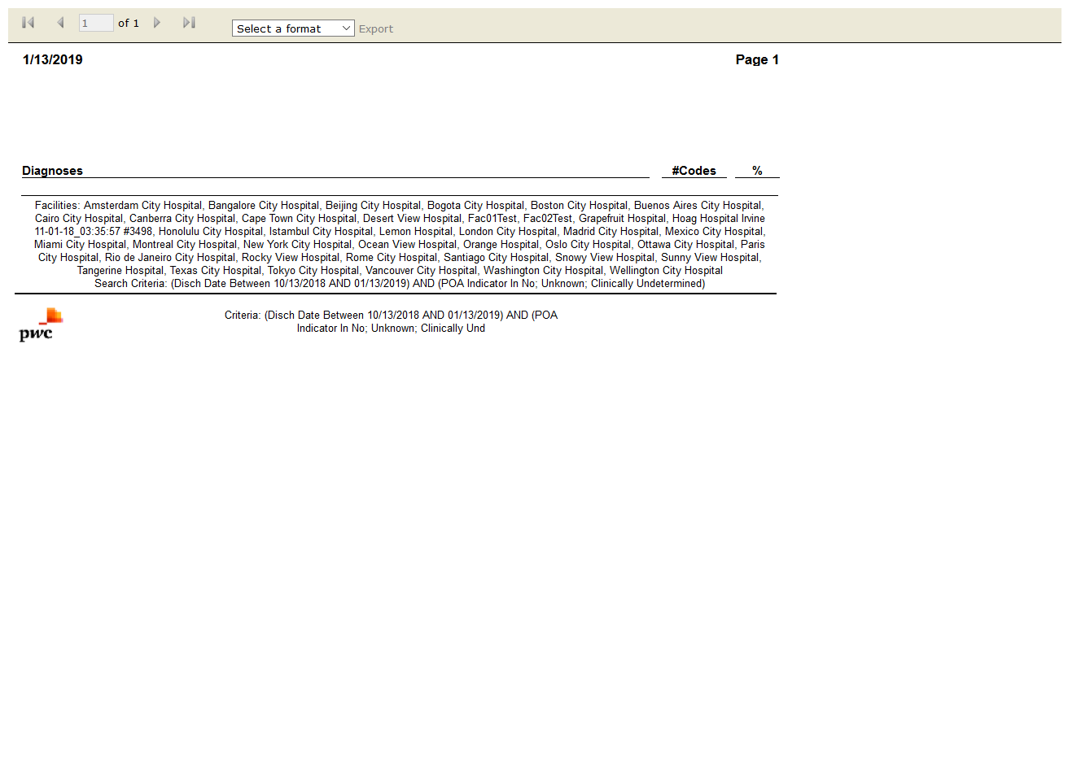

# IPENEnterprise Data Validation: False

Test Result: Message: Unable to locate element: [id="btnViewReport"]



# IPENCoding-DRG Accuracy Analysis: True

Test Result: Success

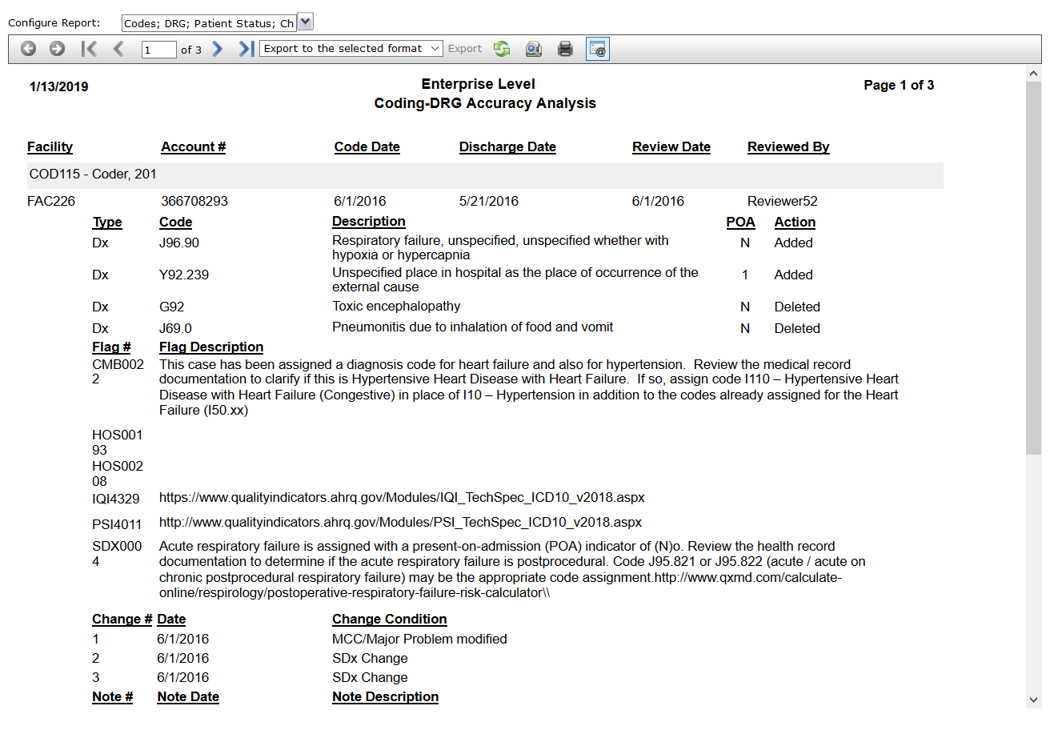

# IPENFlag Rate by Facility by Month: True

Test Result: Success

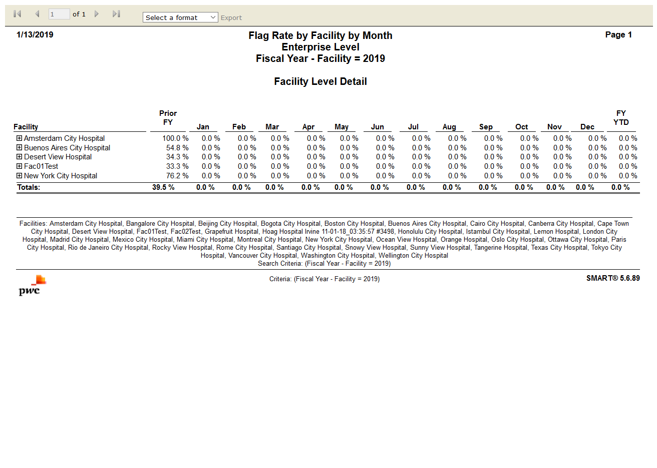

# IPENProfile: True

Test Result: Success

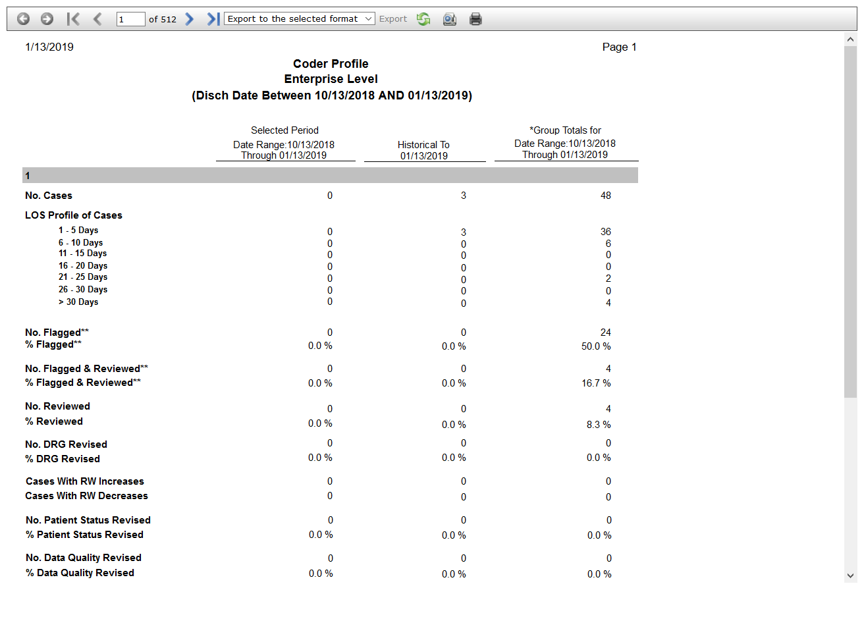

# IPENSMART Case Review Results: True

Test Result: Success

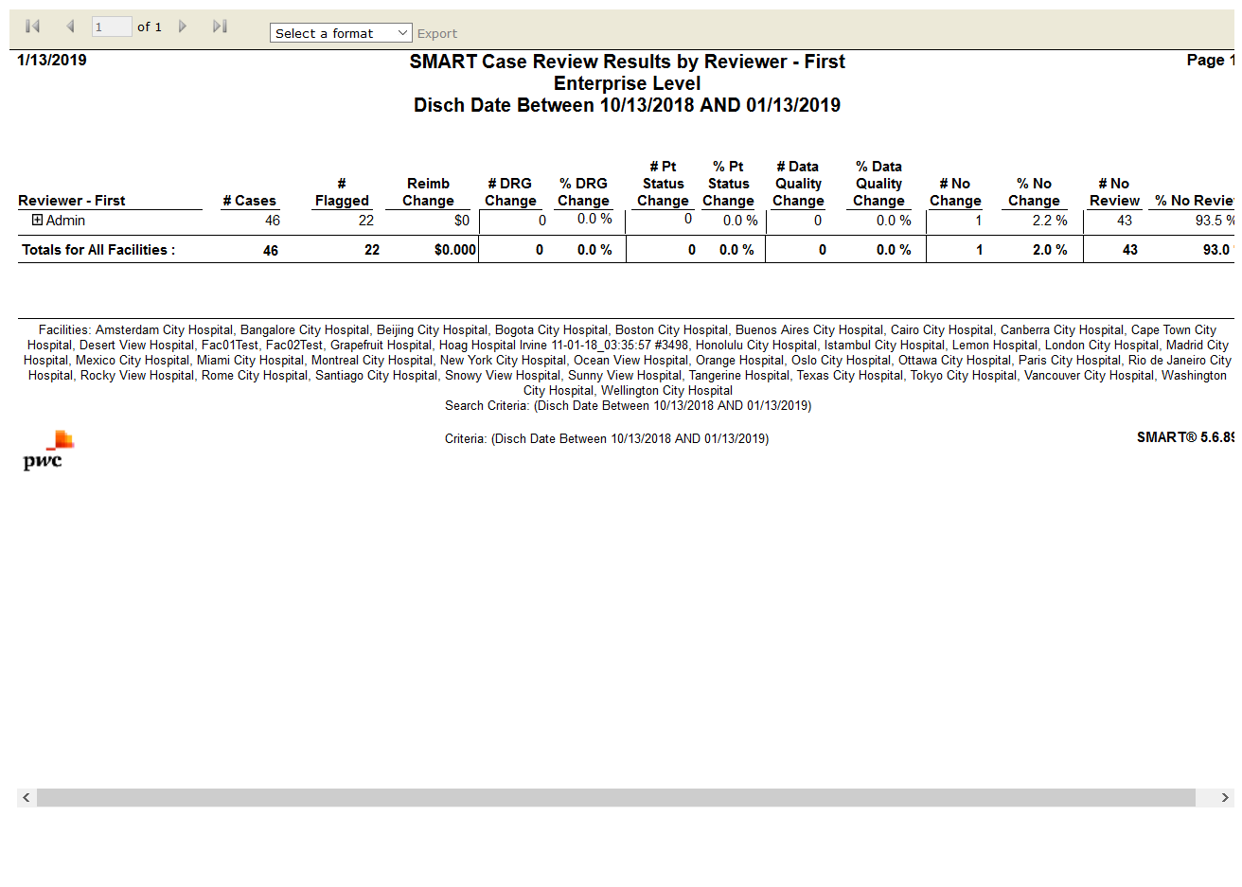

# IPENSMART Report Card: False

Test Result: Message: Unable to locate element: [id="btnViewReport"]

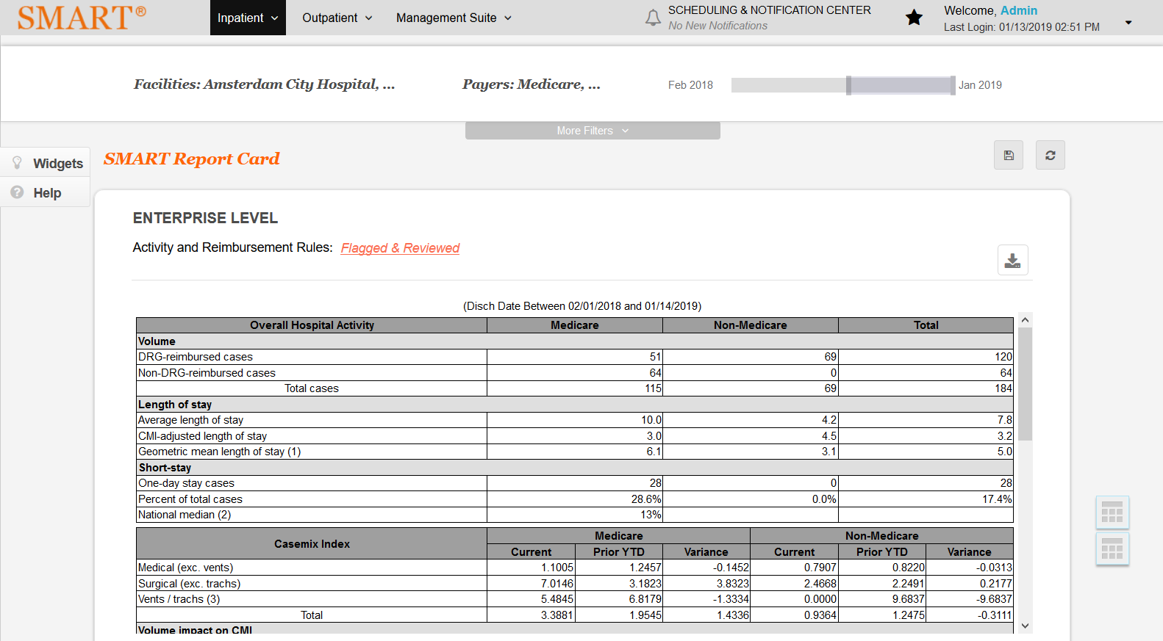

# IPSTPatient Status Mapping Information: True

Test Result: Success

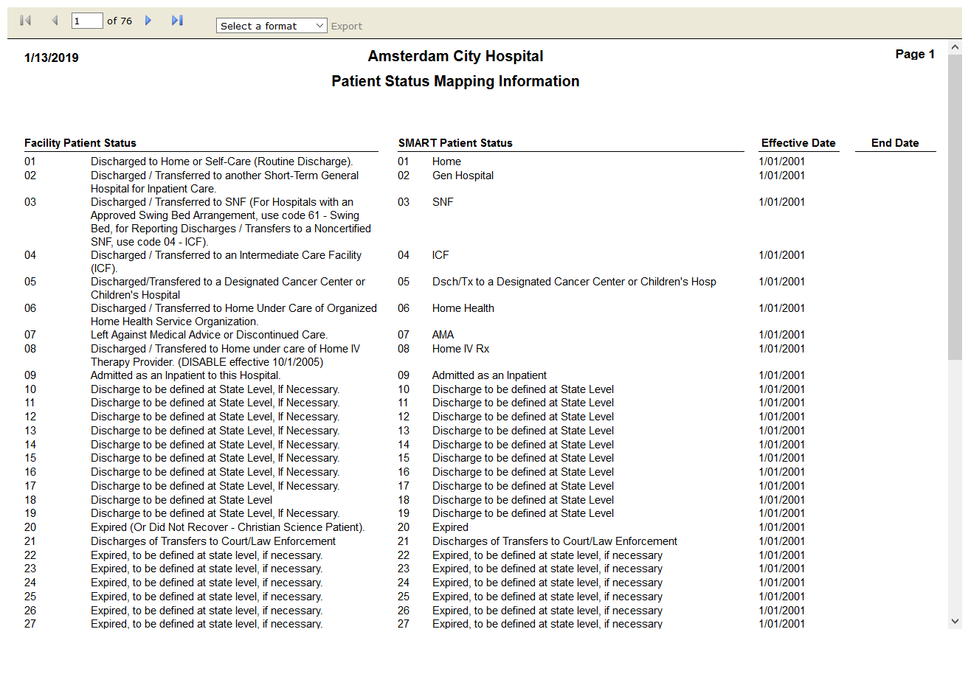

# IPENSMART Results Summary: True

Test Result: Success

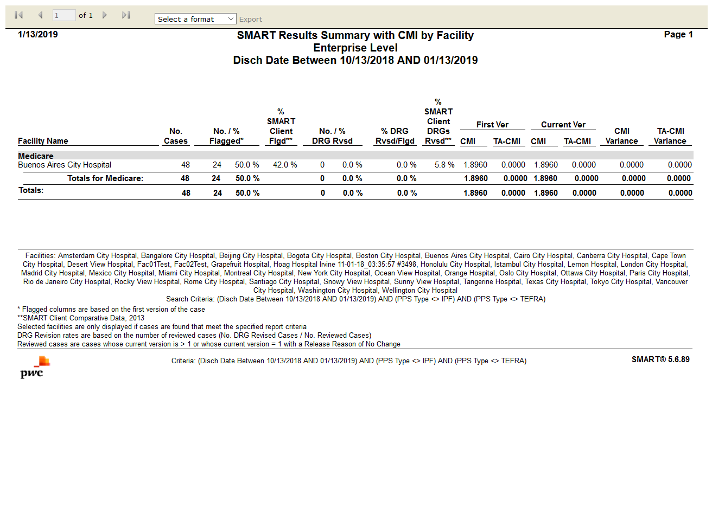

# IPENSMART Results Summary with CMI by Facility: True

Test Result: Success



# IPENSummary by Primary Flag: True

Test Result: Success

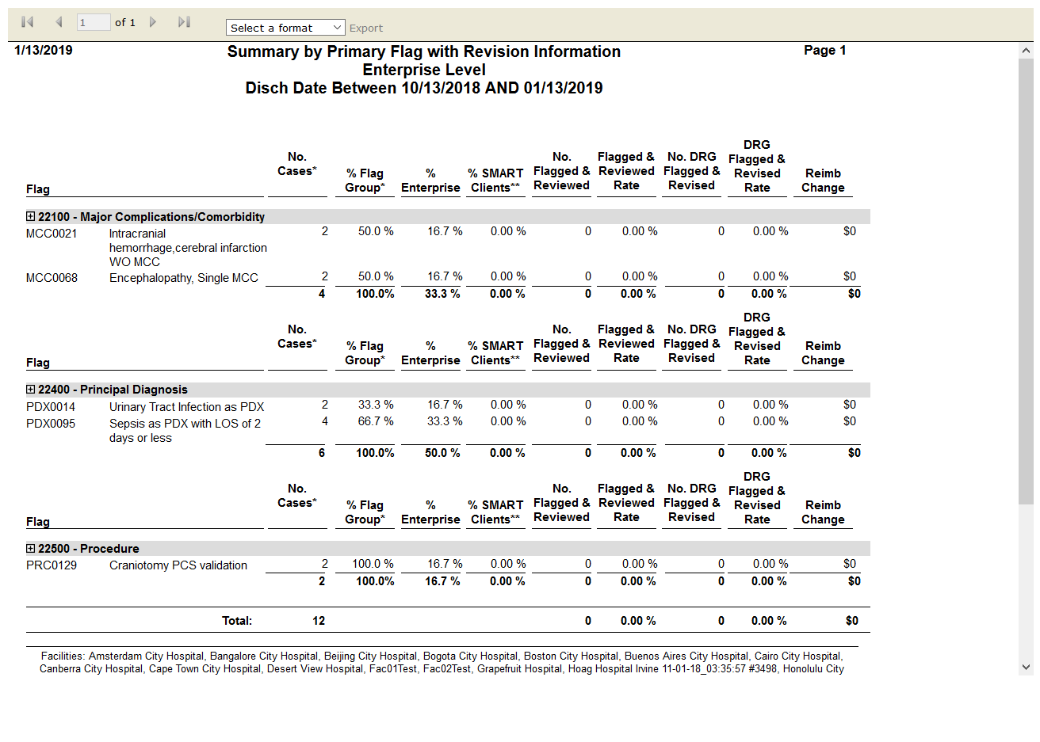

# IPENSummary by Primary Flag with Revision Information: True

Test Result: Success



# IPENCMI Reimbursement Summary: True

Test Result: Success

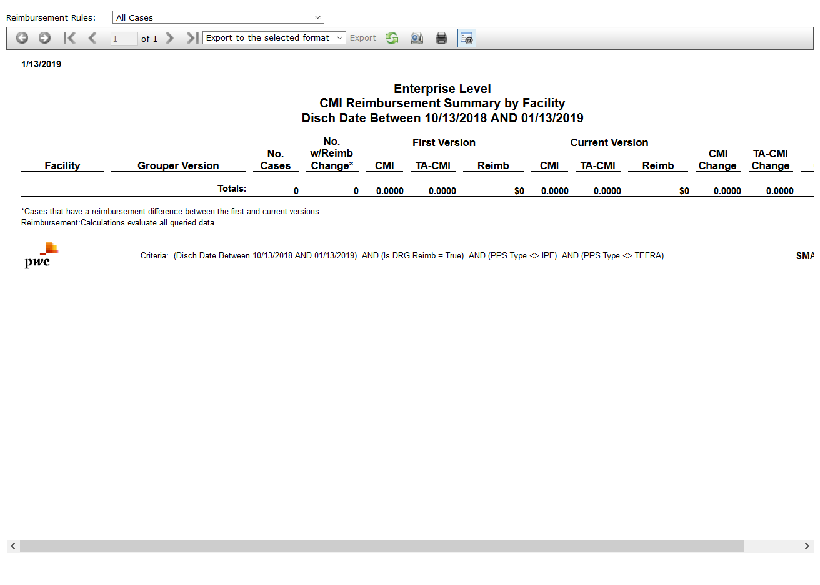

# IPENMedicare HAC Potential Impact: False

Test Result: Message: Unable to locate element: Medicare HAC Potential Impact

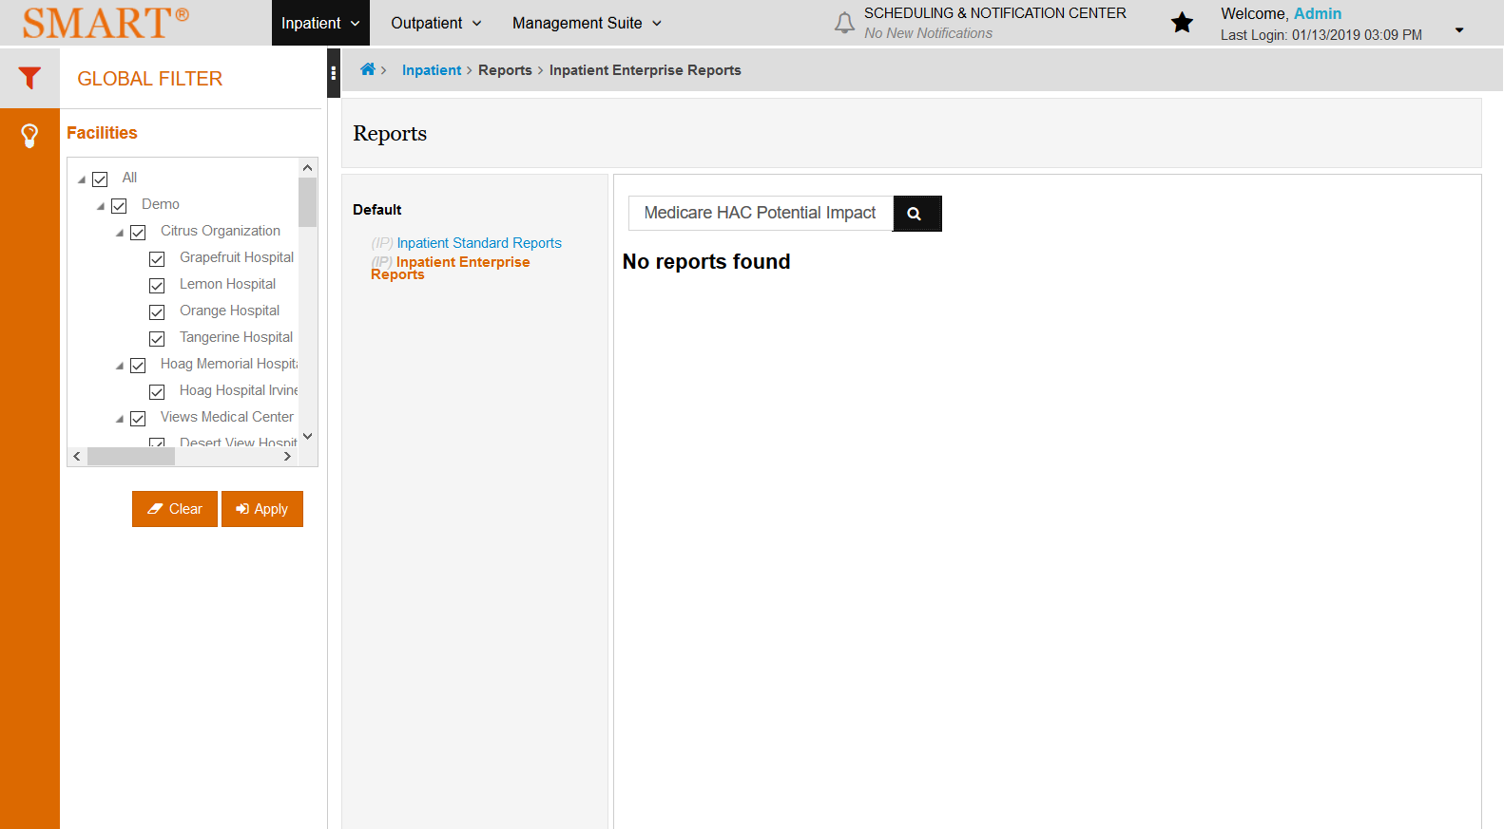

# IPENReimbursement Change Summary: True

Test Result: Success

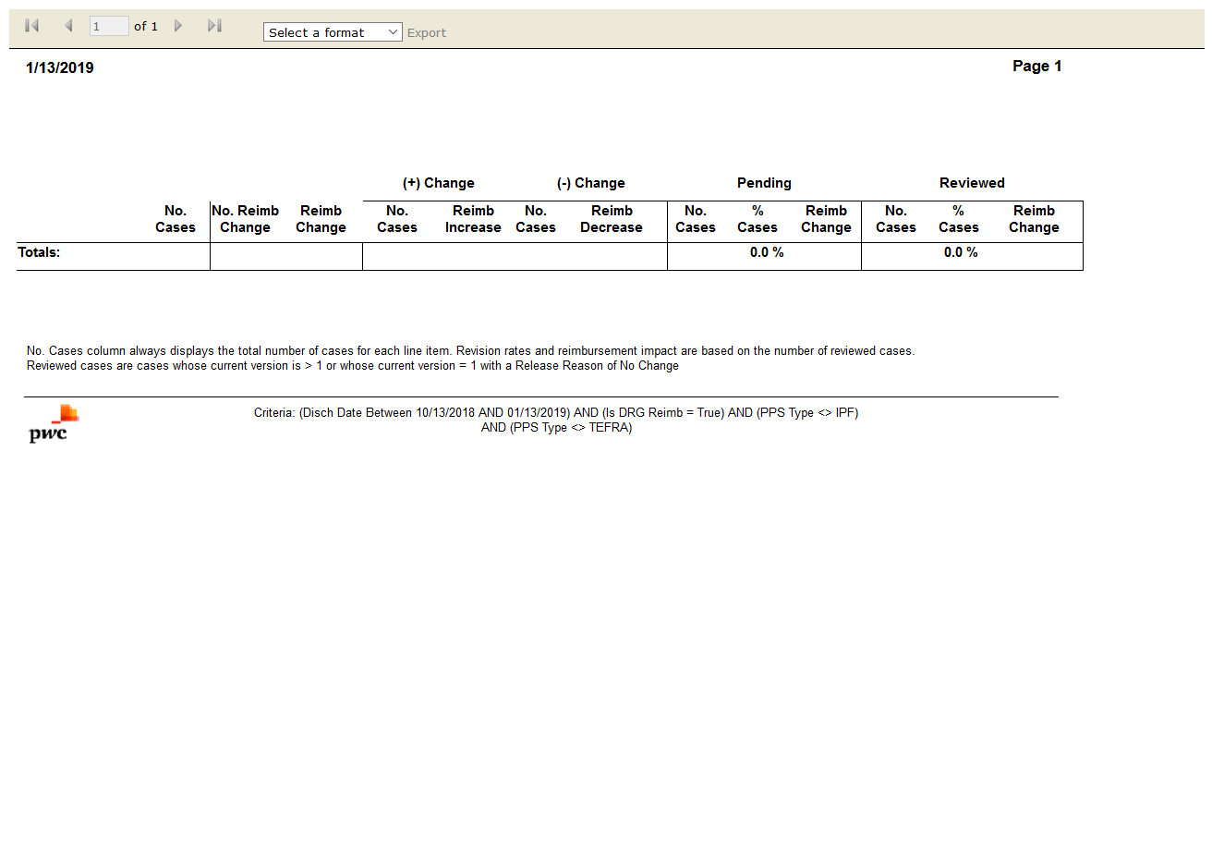

# IPENSMART Reimbursement Activity: True

Test Result: Success

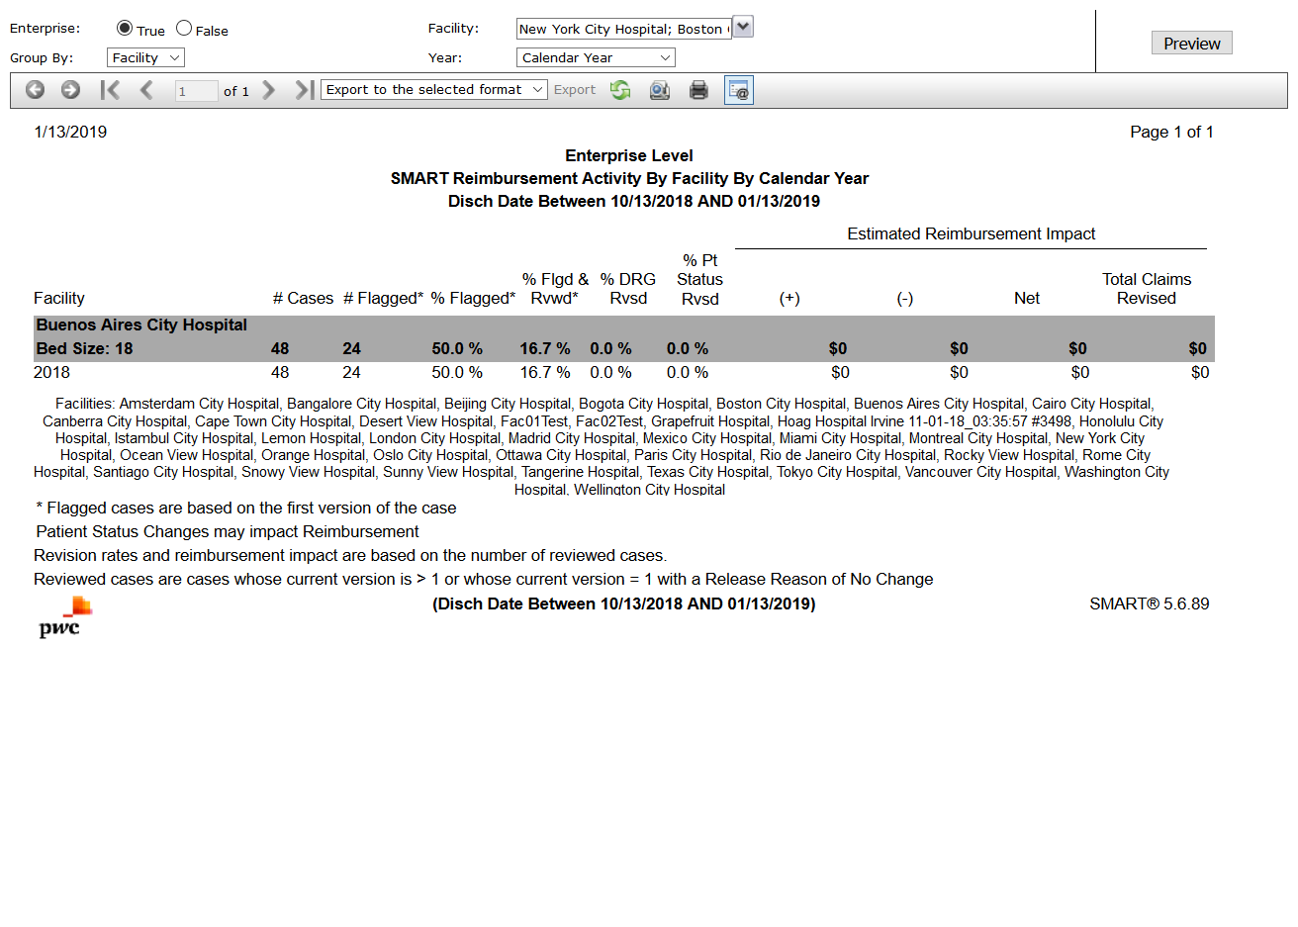

# OPSTAPC Reimbursement Information: False

Test Result: Message: Unable to locate element: APC Reimbursement Information

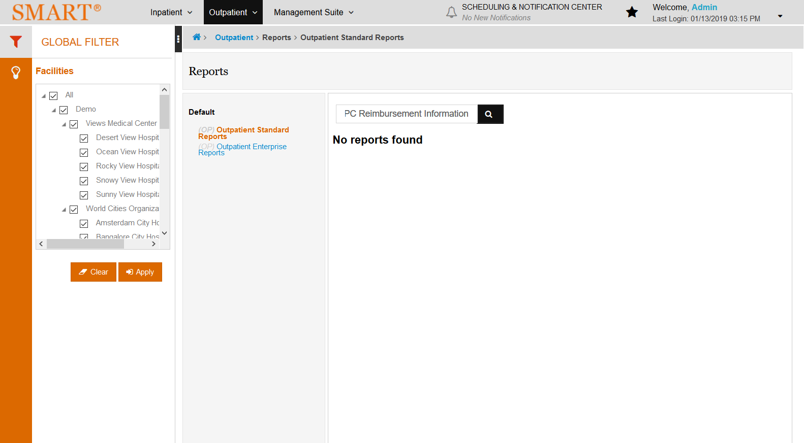

# OPSTFinancial Class Information: True

Test Result: Success

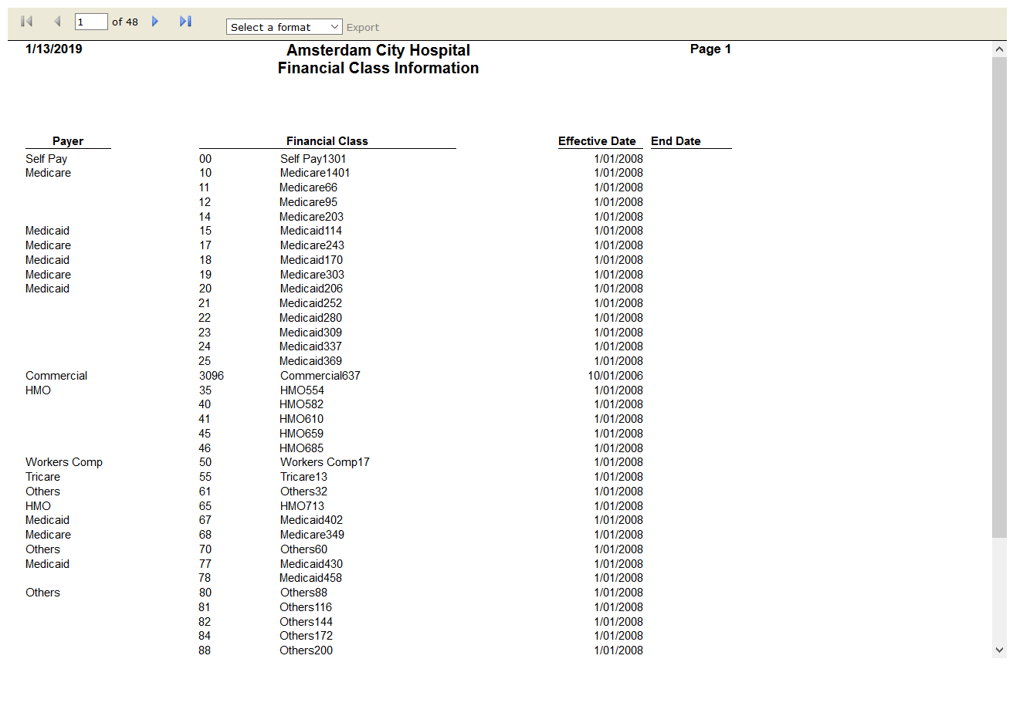

# IPSTData Comparison: True

Test Result: Success

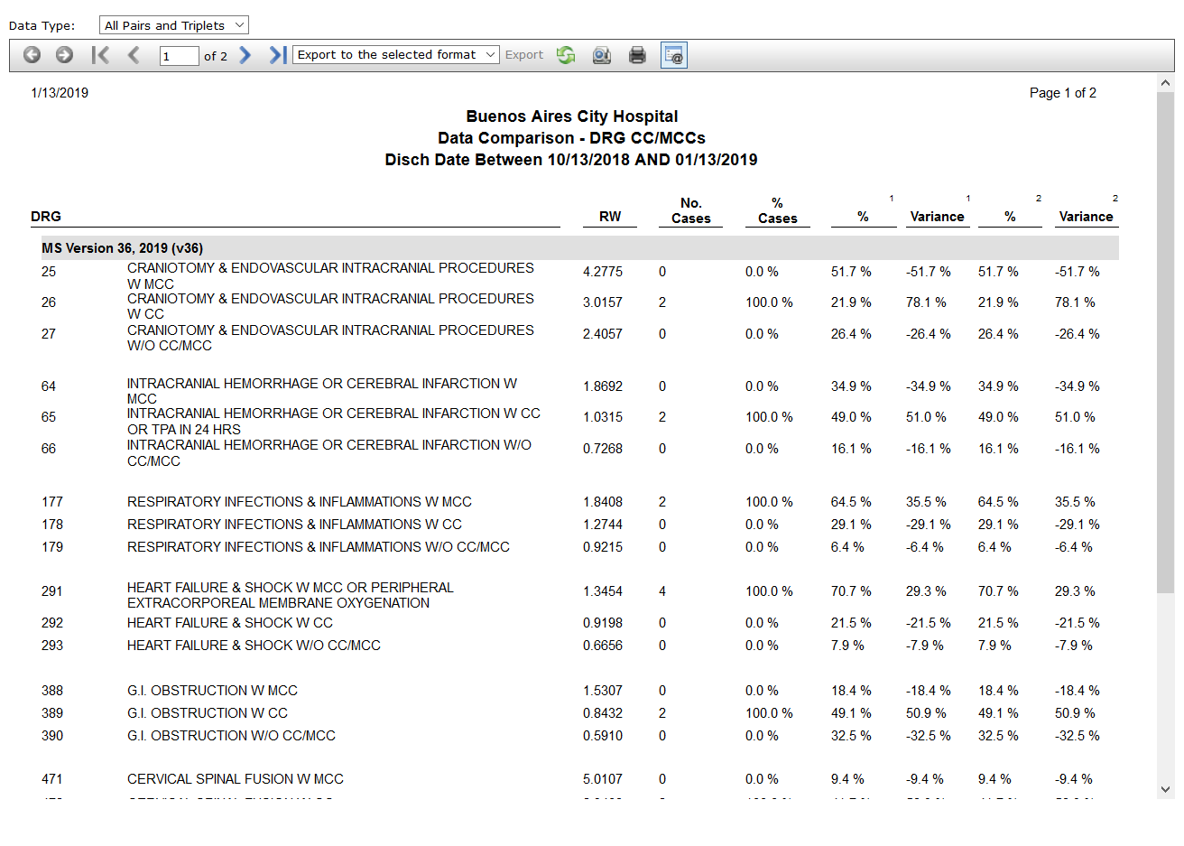

# OPSTOutpatient Flag Information: False

Test Result: list index out of range

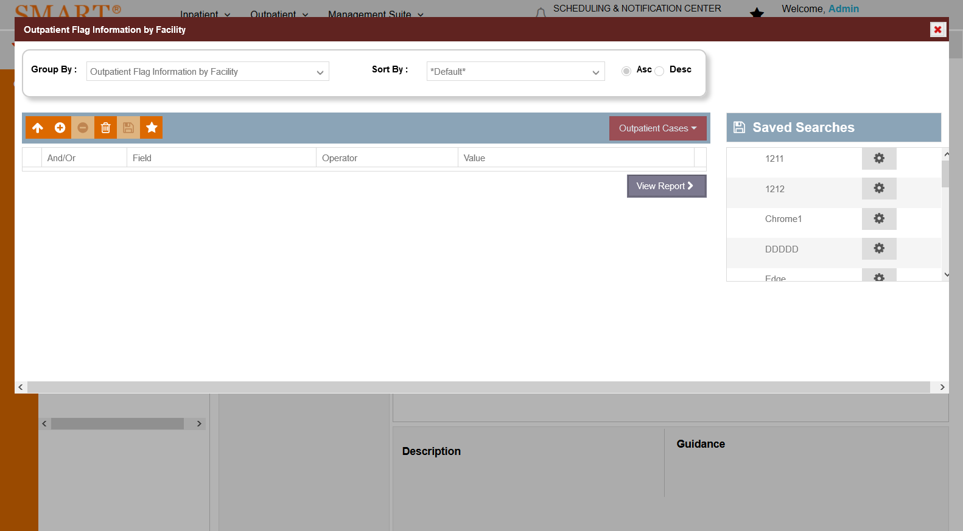

# OPSTOutpatient Flag Information by Facility: False

Test Result: list index out of range



# OPSTPatient Status Mapping Information: True

Test Result: Success

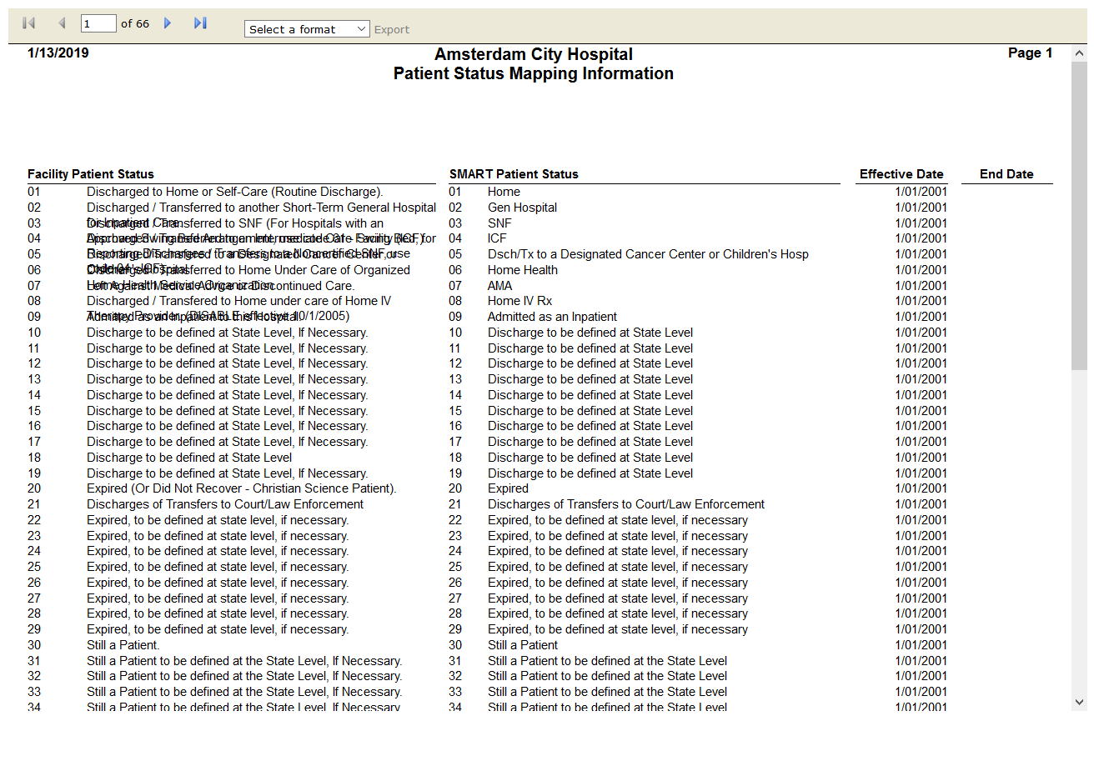

# OPSTAPC Contribution to SMI by Payer: False

Test Result: Message: Unable to locate element: APC Contribution to SMI by Payer

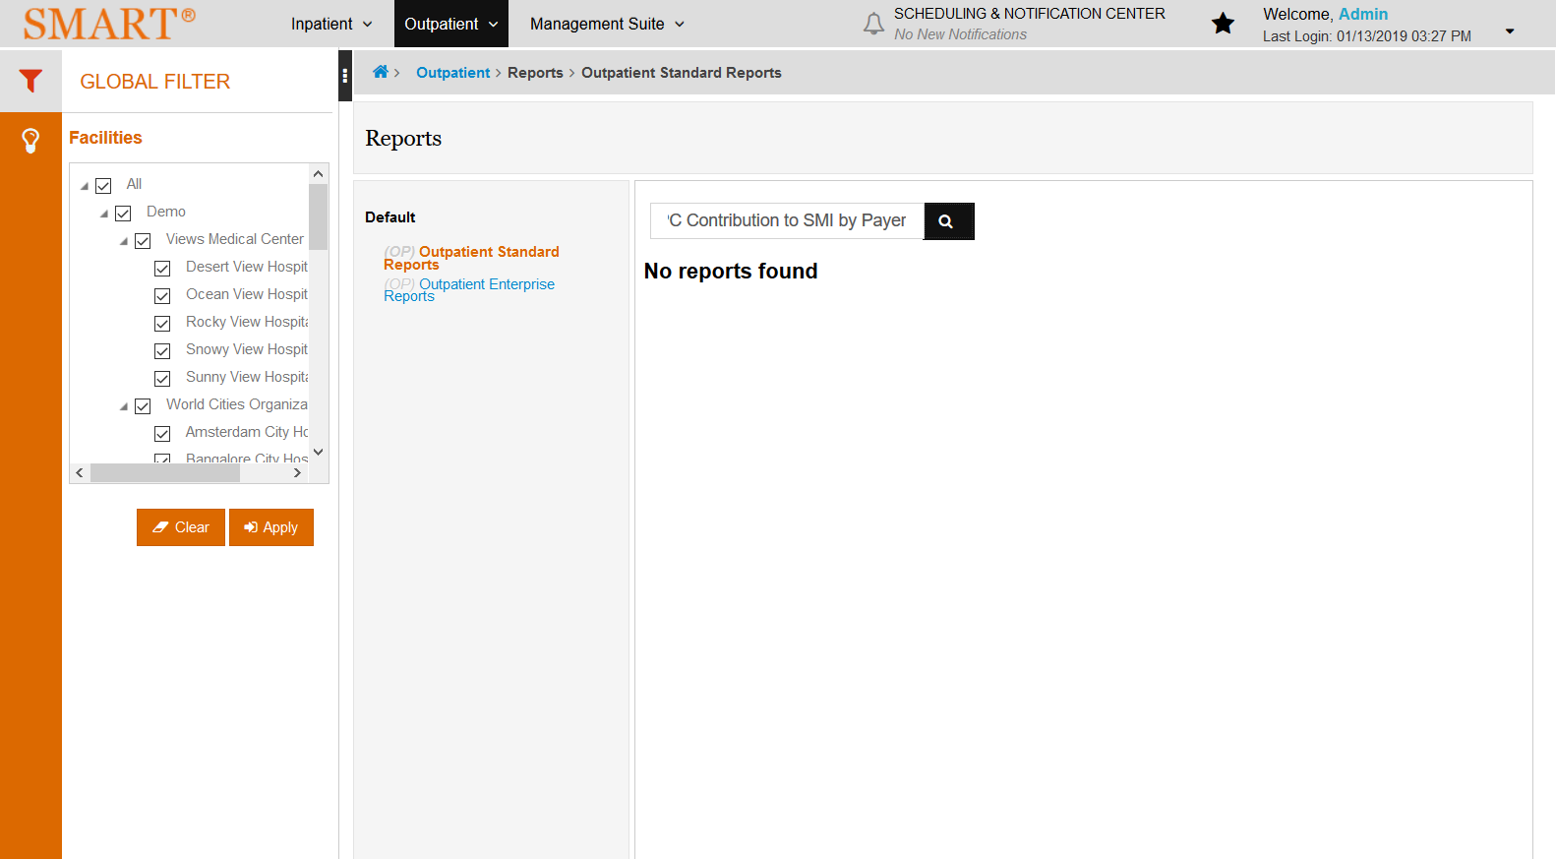

# OPSTCCI Flags by Body System: True

Test Result: Success

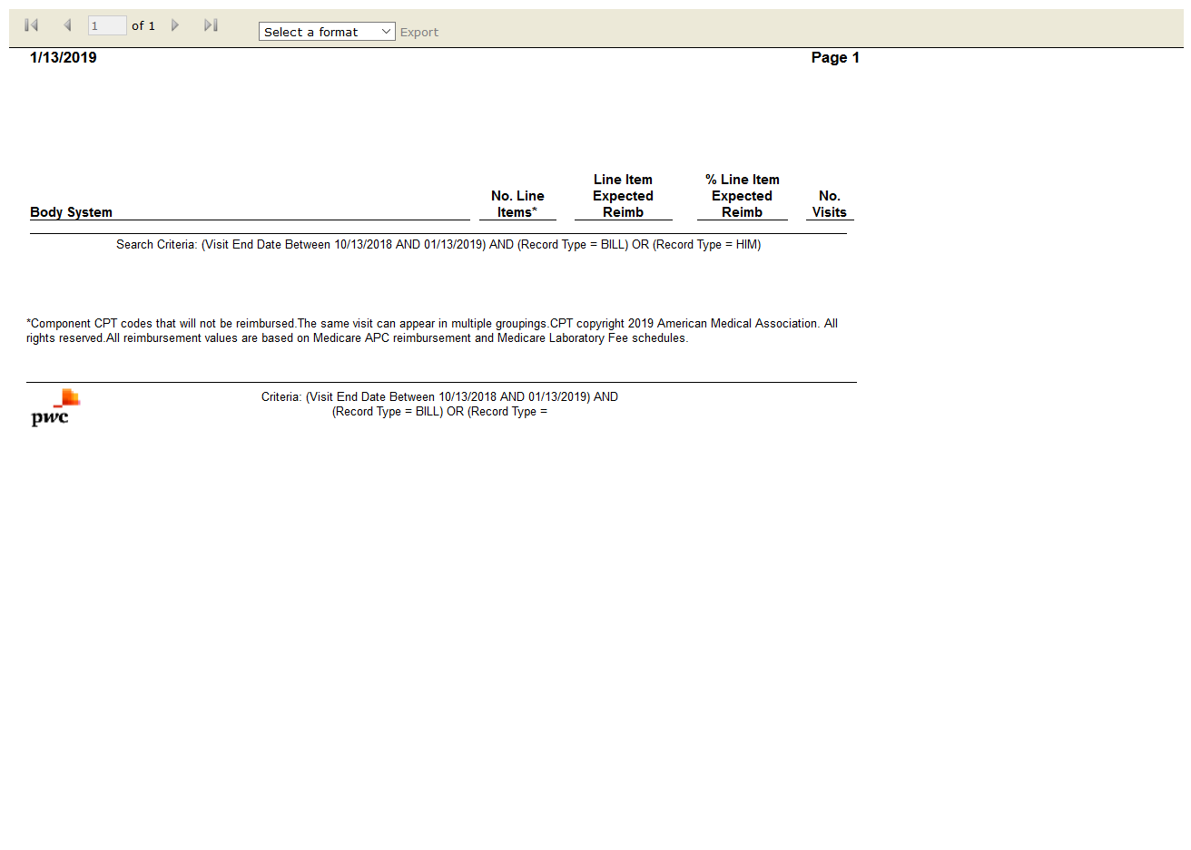

# OPSTFlag Comparison: True

Test Result: Success

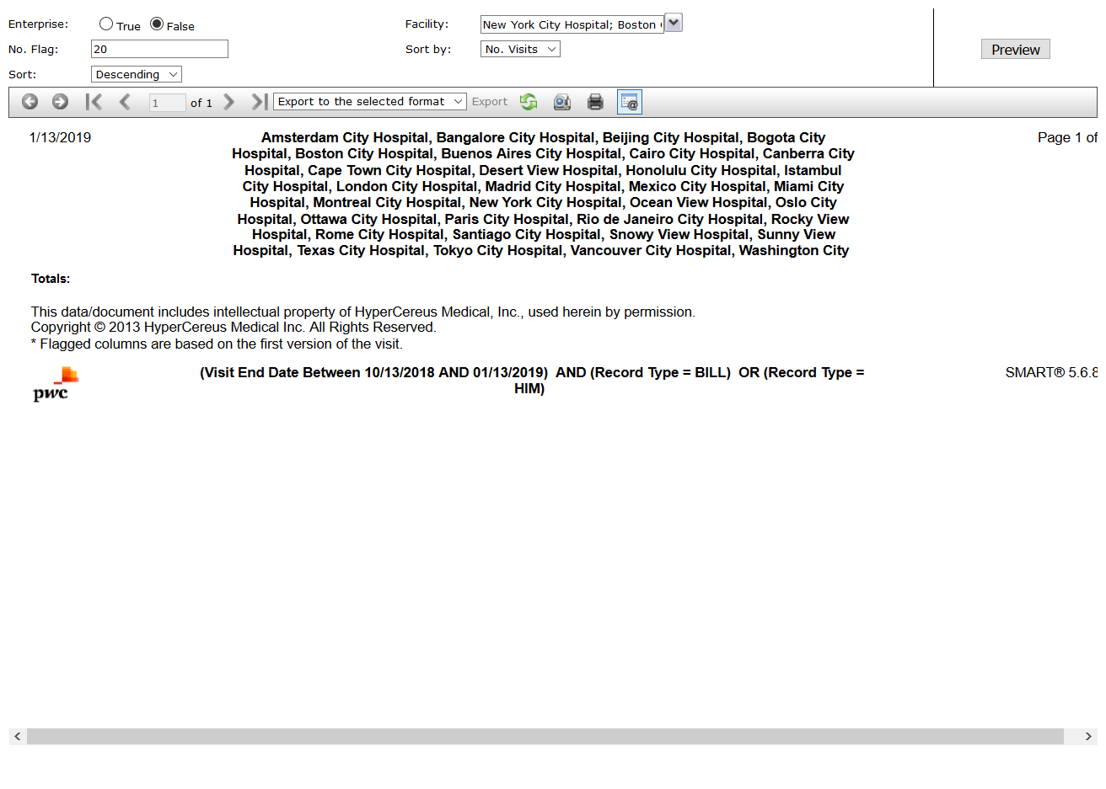

# OPSTMedicare Medical Necessity Flags: True

Test Result: Success

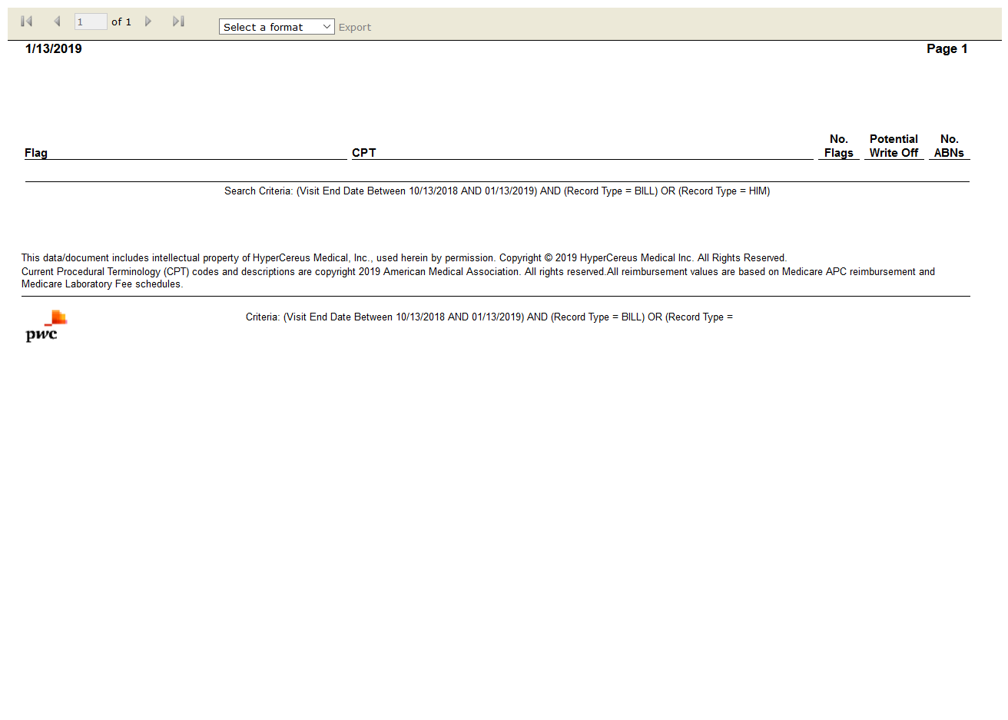

# OPSTPayer OCE Claim Disposition: False

Test Result: Message: Unable to locate element: ayer OCE Claim Disposition

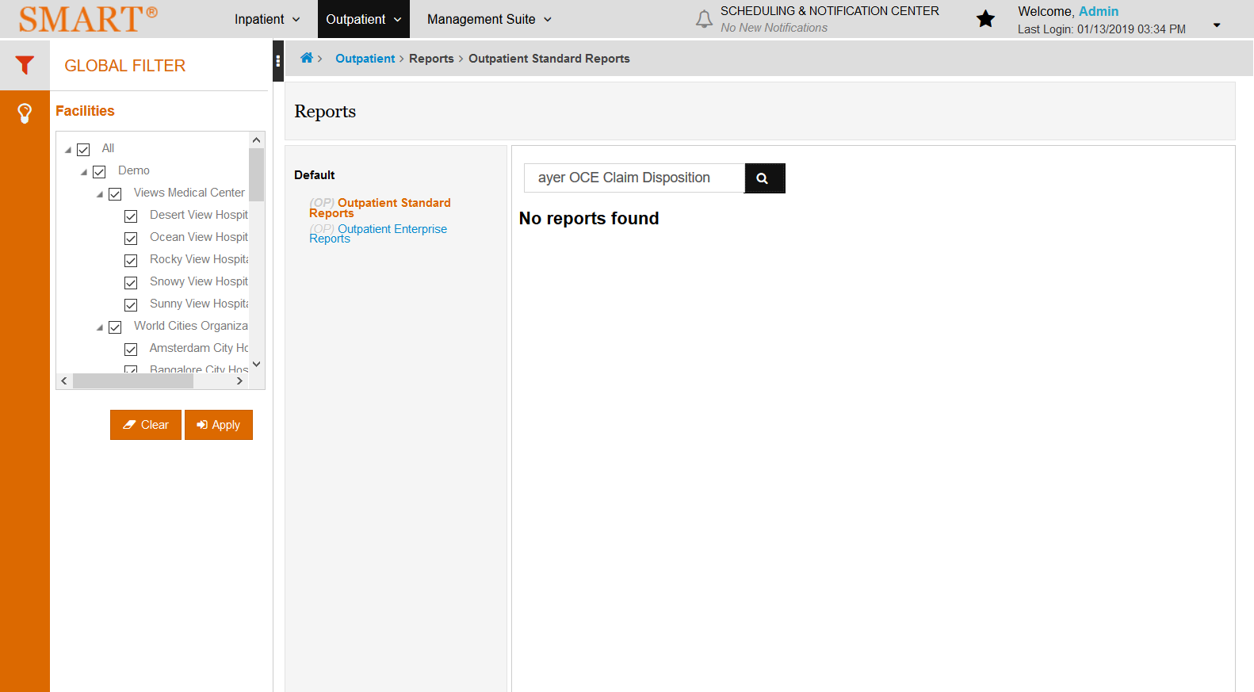

# OPSTVisit Flag Summary: True

Test Result: Success

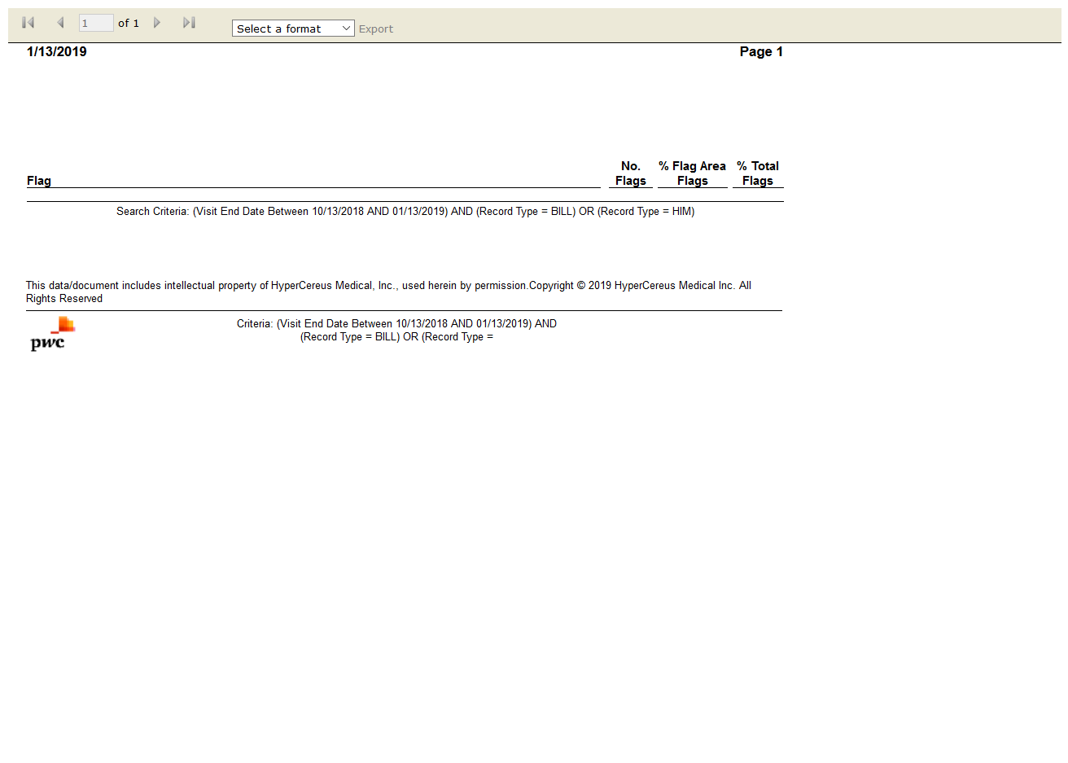

# OPSTFrequency Analysis: True

Test Result: Success

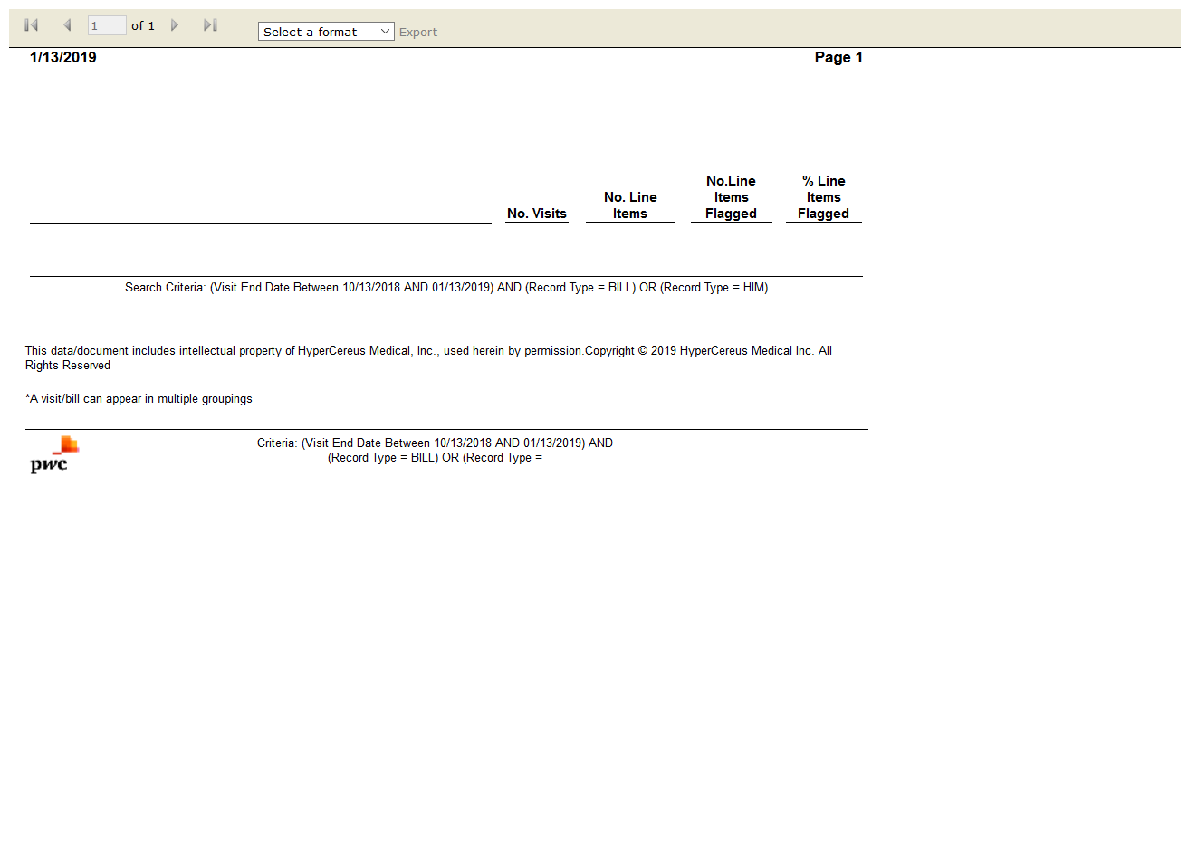

# IPSTPEPPER Report: False

Test Result: Message: Unable to locate element: [id="btnViewReport"]

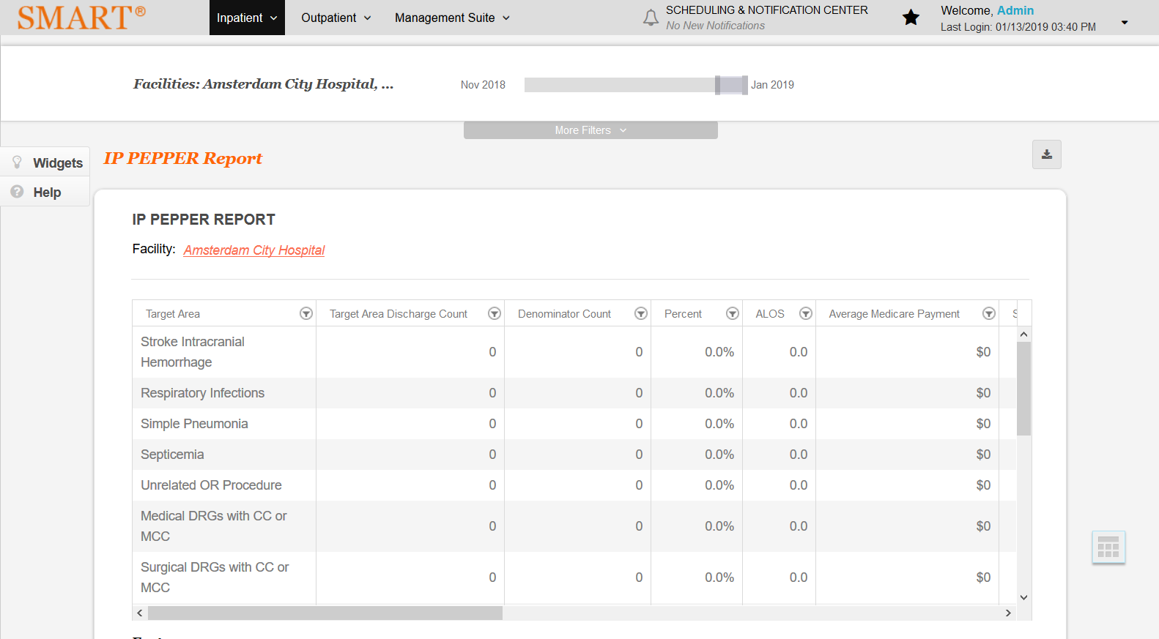

# IPSTCoder Information: False

Test Result: module 'common.statement' has no attribute 'para_seperator'



# OPSTFrequency Summary: False

Test Result: module 'common.statement' has no attribute 'para_seperator'



# IPSTCoder Information: False

Test Result: module 'common.statement' has no attribute 'error_occured_report_generate'



# IPSTCoder Information: True

Test Result: Success



# IPSTCoder Information: False

Test Result: __init__() missing 1 required positional argument: 'driver'



# OPSTFrequency Summary: False

Test Result: __init__() missing 1 required positional argument: 'driver'



# IPSTCoder Information: False

Test Result: Message: Unable to locate element: [id="aSlideMenuSelModuleSIP101"]

